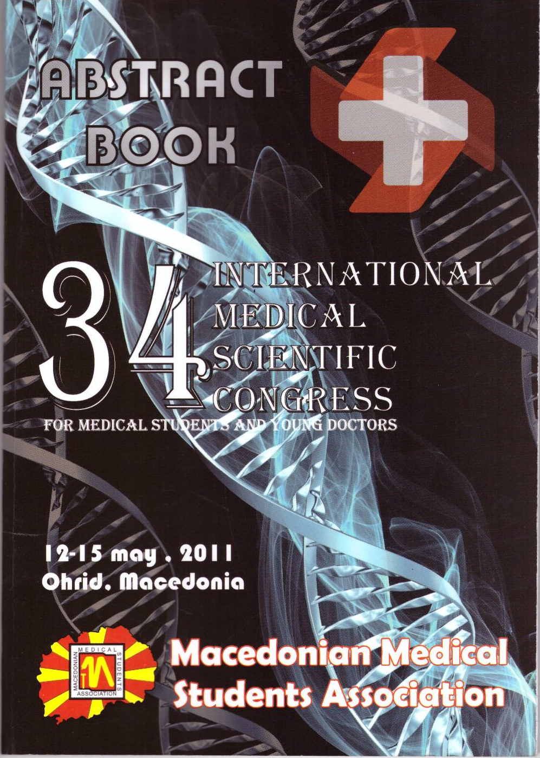

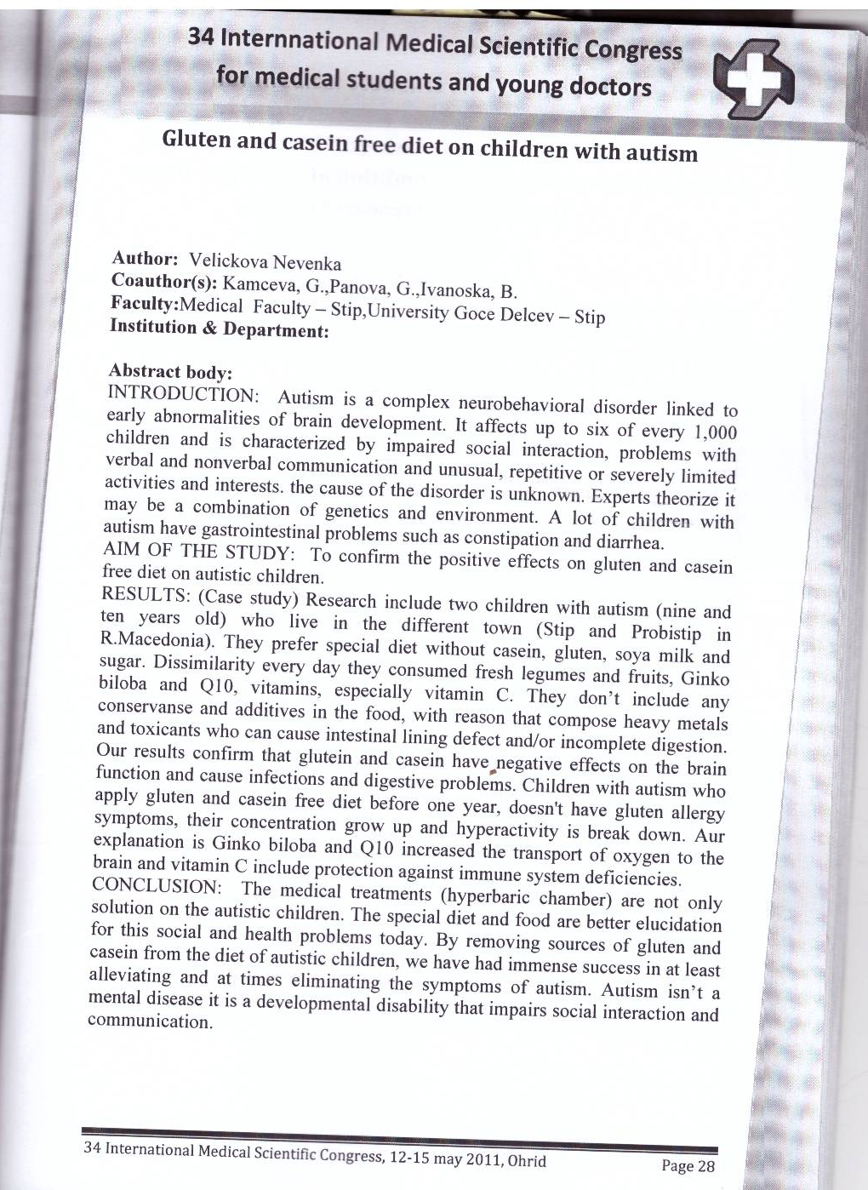

Gluten and casein free diet on children with autism

Abstract body:
Introduction:
Autism is a complex neurobehavioral disorder linked to early abnormalities of brain development. It affects up to six of every 1 000 children and is characterized by impaired social interaction problems with verbal and nonverbal communication and unusual, repetitive or severely limited actives and interests, the cause of the disorder is unknown. Experts theorize it may be a combination of genetics and environment. A lot of children with autism have gastrointestinal problems such as constipation and diarrhea.

Aim of the study:
To confirm the positive effects on gluten and casein free diet on autistic children.

Result:
Research include two children with autism (nine and ten years old) who leave in different town (Stip and Probistip in R.Macedonia). They prefer special diet without casein, gluten, soya milk and sugar. Dissimilarity every day consumed fresh legumes and fruit Ginko biloba and Q10, vitamins, especially vitamin C. They don’t include any
conservanse and additives in the food, with reason that compose heavy metals and toxicants who can cause intestinal lining defect and/or incomplete digestion.
Our results confirm that glutein and casein have negative effects on the brain function and cause infections and digestive problems. Children with autism who apply gluten and casein free diet before one year, doesn't have gluten allergv symptoms, their concentration grow up and hyperactivity is break down. Aur explanation is Ginko biloba and Q10 increased the tramsport of oxygen to the brain and vitamin C include protection against immune system deficiencies.

conclusion:
The medical treatments (hyperbaric chamber) are not only solution on the autistic children. The special diet and food are better elucidation for this social and health problems today. By removing sources of gluten and casein from the diet of autistic children, we have had immense success in at least alleviating and at times eliminating the symptoms of autism. Autism isn’t a mental disease it is a developmental disability that impairs social interaction and communication.

