TUNING PID CONTROLLING PARAMETERS FOR DC MOTOR SPEED REGULATION

Done Stojanov1

*1Faculty of Computer Science, University ,,Goce Delcev” – Stip,* [*done.stojanov@ugd.edu.mk*](mailto:done.stojanov@ugd.edu.mk)

**Abstract.** Modern robots are sophisticated and complex systems, composed of: sensors, high-speed processors and actuators. Different size DC electrical motors are used as actuators, converting electrical energy into mechanical movement. Without them, robots can’t perform movements, what is completely on the contrary on modern robotics concepts. Motor speed regulation is an important engineering task. Having appropriately tuned the controller, the desired speed is reached in a short time interval, with minimum speed overshoot. Tuning motor speed controlling parameters in order to reach the desired speed within a short time interval, keeping speed’s overshoot as small as possible is discussed in this paper. The paper demonstrates how the general Black-Box methodology can be applied for that purpose. Speed’s simulations are performed in Matlab, having connected PID controller and DC electrical motor in a closed-loop unity feedback control system.

**Keywords:** robotics, Black-Box methodology, actuator, optimal speed control.

1. **Introduction**

The parameters of the first process controller were defined by A. Callendar [2] in 1934. Callendar’s work demonstrates how *proportional-derivate* (PD) controlling parameters can be set up for control of *integration plus delay* (IDP) modeled process. Few years after, tuning rules for setting up *proportional-integral* (PI) and *proportional-integral-derivate* (PID) controller [1] were revealed. Since then PI and PID controllers have become widely used in the industry. According H. Takatsu and T. Itoh [4], approximately 95% of controllers are of PI or PID type.

Direct current (DC) electrical motors are widely used in industrial applications including mechatronics, automobile, robotics and aerospace systems [3,6]. DC motor speed control is one of the fundamental engineering tasks. It can be regulated by a PID controller, setting up appropriately: the proportional, integral and the derivate gain. The proportional term provides an overall control action proportional to the error signal. The integral term reduces steady-state errors, while the derivate term improves the settling time [5].

In this paper, DC motor speed control is considered, using as a regulator PID controller. Based on the Black-Box methodology, PID controlling parameters are dynamically changed in order to reach motor’s desired speed, holding speed’s overshoot and the settling time under certain threshold. Speed’s simulations are performed on a concrete DC motor, for different values of the proportional, integral and derivate gain, according to the presented approach.

1. **Preliminaries**

A closed-loop unity feedback control system (Fig. 1) is considered, composed of PID controller and DC motor as an actuator. Tachogenerator measures motor speed, generating speed-proportional output voltage. Its transfer function equals 1. PID controller transfer function is. Speed’s rise time, defined as the time needed for reaching 90% of the steady value for the first time, is highly influenced by the value of the proportional gain - . By changing the integral gain - , the steady-state error can be reduced or completely eliminated. Speed’s overshoot and the settling time are controlled by  - the derivate gain. Speed’s overshoot is defined as a difference between the peak and the steady value, while the setting time is the time needed for reaching steady value of the parameter being controlled, which in this case is motor speed.

Motor’s transfer function is, where  is motor’s constant,  is the moment of inertia, strictly depending of rotor’s construction and motor’s load, is motor’s inductance,  is motor’s resistance, while  is the damping ratio of the mechanical part. Motor’s transfer function is derived from equations (1) and (2), applying Laplace Transformations on (1) and (2), describing motor’s electrical and mechanical properties. Rotor’s angular displacement is, motor’s speed is the output, while the applied voltage is taken as an input.

 (1)

(2)

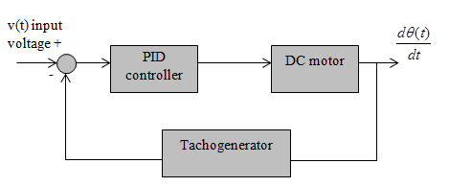

Figure 1 DC motor speed control scheme

1. **Main Results**

Motor speed should follow input voltage, holding the settling time under certain threshold, with overshoot not greater than  rad/s, where  is speed’s steady value, and  is the maximum permitted overshoot. The overshoot is calculated with the formula, where  is the peak value of the speed during the transient response.

DC motor’s characteristics are given in Table 1. The motor is controlled by a PID controller, connected in a closed-loop unity feedback control system as shown on Figure 1. PID controlling parameters should be tuned such as the settling time is less than 0.6 s and the overshoot is not greater than 0.05 rad/s. Using black-box approach, measuring motor’s speed response for different combinations of PID controlling parameters (Tab. 2), PID controlling parameters are tuned such as the previous requirements are satisfied.

For and , speed’s settling time is 3.95 s (Tab. 2, Fig. 2). Doubling PID controlling parameters, speed’s settling time equals 3.5 s (Tab. 2, Fig. 2). For  and , the settling time equals 0.576 seconds (Tab. 2, Fig. 2), what is certainly less than 0.6 s.

Regarding the speed’s overshoot, for and , the overshoot equals  rad/s (Tab. 2, Fig. 3). For  and , it equals |10.1-10|=0.1 rad/s (Tab. 2, Fig. 3). For  and , speed’s overshoot equals 0, |10-10|=0 rad/s (Tab. 2, Fig. 3), what is certainly less than 0.05 rad/s.

**Table 1** Motor properties

|  |  |
| --- | --- |
| **Property** | **Value** |
| *J-motor’s inertia* | 0.01 *Kg×m2* |
| *b-damp ratio* | 0.00003 *Nm/rad/s* |
| *K-motor’s constant* | 0.023 *Nm/W1/2* |
| *R-Resistance* | 1 *Ω* |
| *L-Inductance* | 0.5 *H* |

**Table 2** Speed’s settling time and overshoot for different combinations of PID controlling parameters

|  |  |  |  |  |  |
| --- | --- | --- | --- | --- | --- |
|  |  |  | **Settling time (s)** | **Overshoot (rad/s)** | **Satisfies constrains** |
| 5 | 5 | 5 | 3.95 | 0.3 | No |
| 10 | 10 | 10 | 3.5 | 0.1 | No |
| 100 | 10 | 10 | 0.576 | 0 | **Yes** |

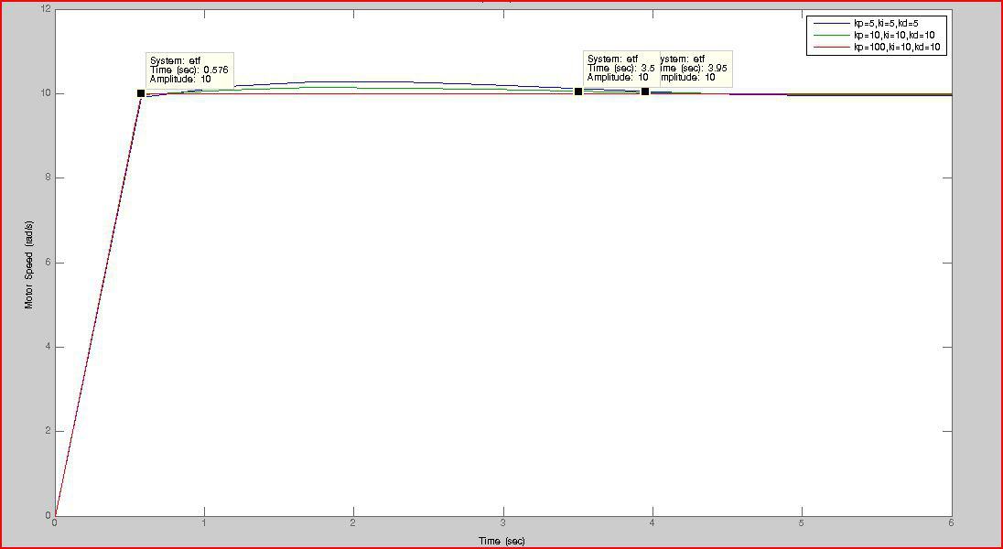

**Figure 2** DC motor’s speed settling time for tunning parameters of PID controller given in Table 2

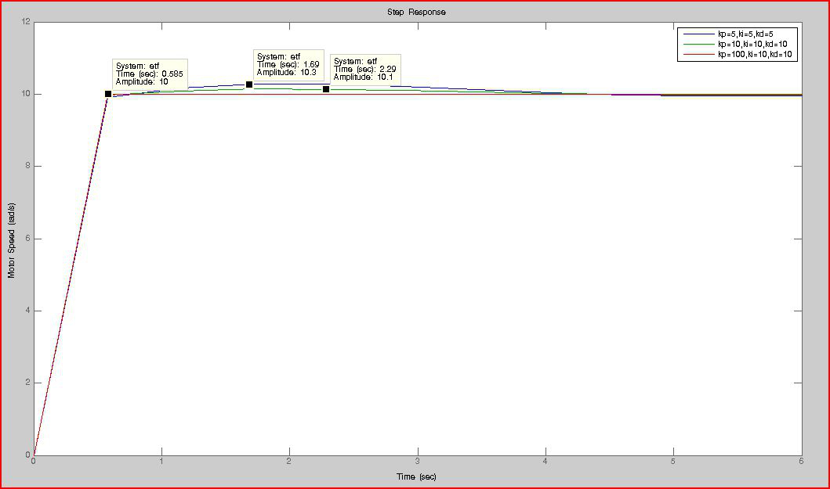

**Figure 3** DC motor’s speed overshoot for tunning parameters of PID controller given in Table 2

For all three different tunning combinations of PID controlling parameters, the desired speed has been always reached i.e. the steady-state error equals 0. The desired speed is reached within different time interval (settling time). Also the speed’s overshoot, defined as a difference between the maximum and steady value of the speed, is different, for different PID controller tunning. General engineering tendency is to reach the desired speed in a short time interval, keeping overshoot as small as possible. If the PID controller is appropriately tunned, the desired speed is reached in less than a second, without overshoot. For the DC motor being considered, tunning PID controlling parameters such as the proportional gain equals 100, the derivate and the integral gain equal 10, the desired speed is reached in approximately half second, without overshoot, what is absolutely acceptable by engineering viewpoint.

1. **Conclusion**

The Black-Box methodology, measuring system’s output for different combinations of controlling parameters, in order to reach the desired output, has been successfully implemented in the case of a closed-loop unity feedback control system, composed of PID controller and DC motor as an actuator. PID controlling parameters are dynamically changed, in order to reach the desired output – motor speed of 12 rad/s, which has to be reach in a time interval less than 0.6 s, keeping speed’s overshoot less than 0.05 rad/s. Combination of PID controlling parameters have been found  and , such as the desired speed is reached in approximately half second, without speed overshoot, if DC motor with properties given in Table 1 is used as an actuator.

**References**

[1] A. Callendar, D.R. Hartree and A. Porter (1935): *Time-lag in a control system*. Phil. Trans. Royal Society of London Series A 235, pp. 415-444.

[2] A. Callendar (1934): *Preliminary notes on automatic control*, File No. R.525/15/3. I.C.I. Alkali Ltd.

[3] B. Nguyen and J. Ryu (2009): *Direct Current Measurement Based Steer-By-Wire Systems for Realistic Driving Feeling*. Proceedings of the IEEE International Symposium on Industrial Electronics, pp. 1023-1028.

[4] H. Takatsu and T. Itoh (1999): *Future needs for control theory in industry – report of the control technology survey of Japanese industry*. IEEE Trans. Control Syst. Tech. 7(3), pp. 298-305.

[5] K. H. Ang, G. Chong and Y. Li (2005): *PID Control System Analysis, Design and Technology*. IEEE TRANSACTIONS ON CONTROL SYSTEMS TECHNOLOGY 13(4), pp. 559-576.

[6] S. C. Won, D. J. Lim and D. H. Chyung (1985): *D-C motor driven robotic manipulator control*. IEEE Decision and Control 24, pp. 330-333.