
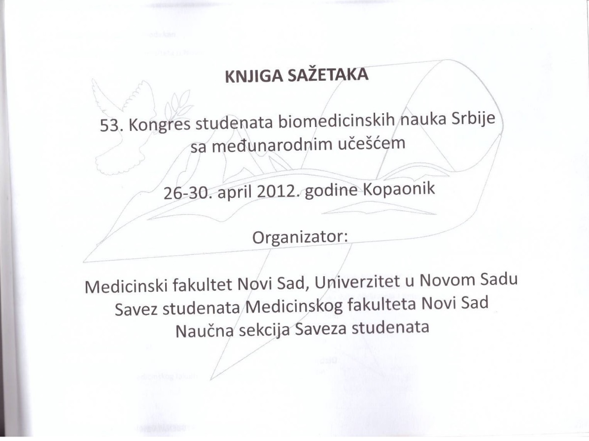
INFANTS BORN WITH RISK FACTORS IN THE PERIOD 2009-2011,IN STIP

Authors: Dz.Asanova,G.Panova,B.Panova,N.Velickova,N.Panov,L.Nikolovska,V.Dzidrova
Mentor: Gordana Panova
University,,Goce Delcev”-FMN-Stip,R.Macedonia
Introduction: The world literature annually born about 3-4% of children at risk, according to
criteria risk for children.
They need extra medical care and may have serious difficulties in adjustment over the life
hereafter.
Objectives: The aim of this paper is to show the incidence of children born at risk, the most
common risks in the last three years obstetric department the Clinical Hospital Stip, and to
show possible association with some demographic characteristics such as gender, order of
birth, age of mother.
Material and methods: The survey was conducted in the Department of Preventive health
care for children preschool,
which includes all children born in obstetric department Clinical Hospital Stip. Analyzed
were total 3277 health cards of children born between 2009-2011.The risk was compared
according to generally accepted criteria for risk factors at birth.
Results: From total of 2,200 newborns in the three-year period with risk factors were born
159 children or 7.3% with increasing in number from year to year. In terms of gender, no
significant statistical significance, the ratio male: female is 41,5:58,5%. Common risk factors
include asphyxia at birth (24,5%), SGA(23.4%) and premature, ie children
born with gestational maturity of 33-36 GN Often children were firstborn in 17.1% cases, and
mothers in 51% were aged 20-33 years.
Conclusion: The number of children born with a risk factor increases in each subsequent
year. This is probably due to the more modern medical care and treatment of maternal and
newborn. Yet the efforts of medical personnel should be greater focus on prenatal health
education of future mothers, higher health care and that preventing
the birth of children with the most common risk factors, particularly perinatal asphyxia, SGA
and prematurity.
Key words: infants, risk factors, asphyxia, SGA, premature.

