INFLUENCE OF THE PLACEMENT OF A PREVIOUSLY DERIVED ELLIPSE SHAPED APERTURE IN THE STARTING MATERIAL ON THE PROCESSING WITH DRAWING OF THE COLD ROLLED SHEET STEELS

Ass. M.Sc. Cvetkov S., Doc. PhD. Simeonov S., Ass. M.Sc. Dimitrov S.
University “Goce Delčev”- Štip, Faculty of Mechanical Engineering-Vinica,
Republic of Macedonia,
E-mail: slavco.cvetkov@ugd.edu.mk, simeon.simeonov@ugd.edu.mk, sasko.dimitrov@ugd.edu.mk

Abstract: In this paper, a research of the impact of the position regarding the main directions of the plane anisotropy of previously derived ellipse shaped aperture (opening) in starting material on the workability of the drawn cold rolled sheet steel is made. This influence is researched using hydraulic drawing of cold rolled sheet steel with previous derived ellipse shaped openings placed in the directions of plane anisotropy.
The research aims to show how the position of the previous derived ellipse holes can influence on improving the processing of the cold rolled sheet steel and that will help to solve technological problems in the production when the method of drawing the cold rolled sheet steel with previous derived holes in the starting material is used.

KEYWORDS: DRAWING, EFFECTIVE STRESS, LIMIT OF DEFORMATION, COLD ROLLED SHEET STEEL, DIRECTION OF ROLLING, ANISOTROPY, STARTING MATERIAL, ELLIPSE SHAPED APERTURE

- Introduction

On the parts made from sheet metal by drawing quite often on the walls openings without stringent requirements for their form, position and dimensions are met. These are ment for various purposes such as openings for ventilation, drainage holes for water and dirt, various exemptions for assembly tools access, forming flat surfaces near a vertical wall, etc.

Their manufacturing after the process of drawing, particularly in parts with complex forms is quite difficult, sometimes impossible, requiring preparation of complex and expensive tools, increases the time of manufacture and therefore the cost of the product. That is why, it's much better and more economical if these openings are made before the drawing process..

In such cases the process of drawing is different from the process of drawing with continuous surfaces. Many years of work experience with the technological processes of drawing showed that openings very often become a critical point in the process of drawing. Cracks, starting from the surface of the openings appear. Therefore it is necessary to study the factors of influence on the workability of cold rolled sheets by drawing from the starting material with a previously derived openings on it..

- Experimental research

In the publication "Impact of previously derived opening in the starting material on the workability with drawing of the cold rolled sheets" among the other, the influence of the position of ellipse shaped opening is researched.

The studies were performed with cold rolled steel sheet Č 0147 (RSt 13 according to DIN 17006) with 1mm thickness. On three previously prepared circular sheet metal plates ellipse shaped opening
with dimensions of axes 14.2 and 10.2 mm is made, so the centre of the aperture coincides with the centre of the plates.

Fig. 1 shows the position of the openings in terms of the direction of rolling of plates, marked with 5.2, 5.3 and 5.4. On these plates, a measuring grid of concentric circles, radial directions and circles with diameter d₀ = 5 mm are applied.
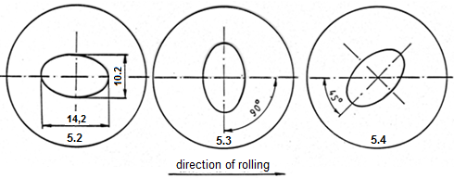
Fig. 1. Position of the ellipse shaped aperture considering the direction of rolling of a sheet metal

These plates using the hydraulic drawing procedure are drawn up to the limit of deformability. As a criteria for limit of deformability the moment of occurrence of cracks in the material was taken.

Fig. 2 shows photo of the piece drawn from the starting material with ellipse shaped aperture derived in the direction of rolling.

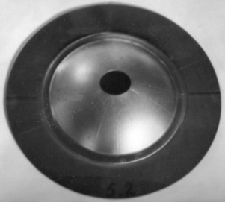
Fig. 2. Photo of the piece drawn from the starting material with ellipse shaped aperture derived in the direction of rolling

After the drawing is performed, the dimensions of the ellipses' axes obtained from the circles of the circular grid in the three specific directions of the plane anisotropy, are measured as follows: in the direction of rolling (0⁰), angle of 45⁰ from the direction of rolling (45⁰) and perpendicular to the direction of rolling (90⁰).

The changes in the experimentally determined effective stress $σ_{e}$ as a function of the radius r of concentric circles from the measurement grid, for the piece drawn from the starting material 5.2 for the characteristic directions of plane anisotropy are given on Fig. 3.
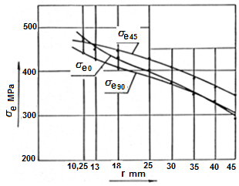
Fig. 3. Experimentally determined effective stress σ_{e} for the characteristic directions of the plane anisotropy, in a function of the radius r of the concentric circles from the measurement grid, for the piece 5.2 drawn from the starting material in which the longer axis of the ellipse shaped aperture lies in the direction of rolling

With$σ_{eо}$, $σ_{e45}$ and $σ_{e90}$ are marked the changes in effective stresses in the directions of the plane anisotropy: 0⁰, 45⁰ and 90⁰ respectively. Analyzing the position of the curves of the effective stress in the diagram leads to the conclusion that, for a radius r from the measuring grid the maximum effective stress occurs in the direction at angle of 45⁰, while from a radius r 12 mm to the aperture the effective stress increases in the direction of the larger axis of the ellipse shaped aperture, which coincides with the direction of rolling. The minimum effective stress is gained in the direction of the small axis of the ellipse shaped aperture or better said, in the direction perpendicular to the direction of rolling.
The visual analysis shows that the crack does not start from the aperture (opening), but the centre of the development lies on the concentric circle with a diameter 20.5 mm and covers an angle of 23⁰ with the direction of rolling. Two localized deformations occupy an angle of 30⁰ and 22⁰ with the direction of rolling. The angle of the direction of the crack and the localized deformations shows that the maximum stress occurs in the segment limited by the directions that cover an angle of 22⁰-30⁰ with the larger axis of the ellipse shaped aperture. There are four such segments.

The changes in the effective stresses $σ_{e}$ as a function of the radius r of the measuring grid for the piece drawn from the staring material 5.3 are shown in Fig. 4.
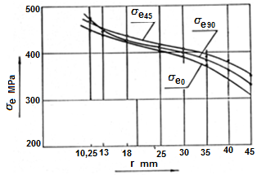
Fig. 4. Experimentally determined effective stress σ_{e} for the characteristic directions of plane anisotropy, as a function of radius r of the measuring grid, for the piece 5.3 drawn from the starting material with an ellipse aperture placed perpendicular to the direction of rolling

Considering the position of the curves of the effective stress in the diagram it can be concluded that for a radius from the measuring grid, the maximum effective stress occurs in the direction with an angle of 45⁰. From a radius r ≈12 mm to the aperture, the effective stress increases in the direction of the larger axis of the ellipse shaped aperture, which lies perpendicular to the direction of rolling. Minimum effective stress is obtained in the direction of the smaller axis of the ellipse shaped aperture.

Ther location of the crack and the localized deformations show that the maximum effective stresses arise in radial direction that occupies an angle of 25⁰ with the larger axis of the ellipse aperture.

The alteration of the effective stress $σ_{e}$ as a function of radius r for the piece number 5.4 drawn from a starting material with an ellipse aperture set at an angle of 45⁰ from the direction of rolling for the characteristic directions is shown in Fig. 5.

The diagram shows that when drawing up to the border position, the most effective stress $σ_{e}$ from the crown to the aparture (opening) occurs in the direction of the larger axis of the ellipse aperture, i.e. in radial direction at an angle of 45⁰ from the direction of rolling. The fact that in this case the stress remains at its maximum along the radial direction in the direction of the larger axis of the ellipse shaped aperture, shows that the stress is affected by the size of the previously derived aperture. The smallest effective stress $σ_{e}$ appear in a direction that is perpendicular to the direction of rolling.
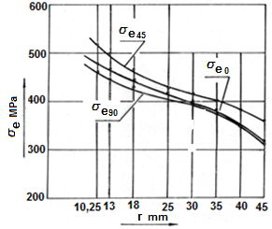
Fig. 5. Experimentally determined effective stress σ_{e} for the characteristic directions of plane anisotropy, as a function of radius r of the measuring grid, for the piece 5.4 drawn from the starting material with an ellipse aperture set at an angle of 45⁰ with the direction of rolling

The location of the crack shows that the maximum effective stress $σ_{e}$appears in the radial direction that occupies an angle of 19⁰ with the larger axis of the ellipse aperture.

The alterations of the maximum effective stress for all three pieces are shown on Fig.6. As well, the curves of the maximum stresses $σ_{e}$ are marked respectively for the pieces 5.2, 5.3 and 5.4.
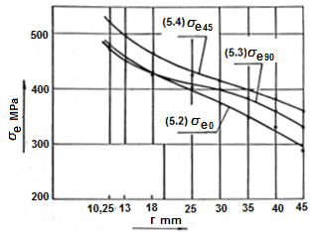
Fig. 6. Alterations of the maximum effective stress $σ_{e}$ for the three pieces

The diagram shows that the maximum effective stress $σ_{e}$ appears when the axis of the ellipse aperture occupies an angle of 45 ° with the direction of rolling, while the minimum effective stress $σ_{e}$ appears when the lager axis of the ellipse aperture lies in the direction of rolling. From the concentric circle with radius r≈16 mm to the surface of the aperture, the minimum effective stress appears when the larger axis of the ellipse aperture lies perpendicular to the direction of rolling.

3. Conclusion
• The position of the previously derived ellipse aperture in starting material concidering the direction of rolling affects the size of the effective stress, and thus the utilization of available plastic properties of cold rolled sheet.

• Alterations in the size of the aperture and the plane anisotropy of the material affect the location of the maximum stress-deformational condition.

• Border stress deformacional condition occurs in the segment defined by the radial direction at an angle 19⁰ to 30⁰ concidering the larger axis of the ellipse aperure. There are four such segments.

• The plastic properties of the material are smallest used when the larger axis of the ellipse aperture is placed perpendicular to the direction of rolling.

• Maximum effective stresses occur when the ellipse aperture with its lager axis is placed in the radial direction, at an angle of 45⁰ from the direction of rolling.

4. Literature
1. Strezov, V. Tehnologija na obrabotka so deformacija, Mašinski fakultet, Skopje 1982.
2. Сторожев, M., Попов, E., Теория обработки металлов давлением, Машиностроение, Москва 1977.
3. William Hоsford, Robert Cadell, Metal Forming Mechanics аnd Metallurgy Cambridge University Press New York 2007.
4. Marciniak, Z., Dunkan, J., Hu, S., Mechanics of Sheet Metal Forming published Butterwort-Heinemann 2002.
5. Devedjič, B. Obrada materijala I deo, Skopje 1982.
6. Lazarev, J., Merni metodi, merenja i obrabotka na podatoci, Mašinski fakultet, Skopje 1981.
7. Musafija, B., Obrada metala plastičnom deformacijom. Svetlost Saraevo 1979.

