**RISK ASSESSMENT OF TAILINGS FACILITY DAM FAILURE**

**Marija Hadži-Nikolova1, Dejan Mirakovski1, Violeta Stefanova1**

*1Faculty of Natural and Technical Sciences, University “Goce Delcev”-Stip, R.Macedonia*

**Abstract:**

This paper presents the consequences of tailings facility dam failure and therefore the needs for its risk assessment.

Tailings are fine-grained wastes of the mining industry, output as slurries, due to mixing with water during mineral processing. Tailings dams vary a lot as it is affected by: tailings characteristics and mill output, site characteristics as: topography, hydrology, geology, groundwater, seismicity and available material and disposal methods.

The talings which accumulates a large amount of crushed material mixed with chemically contaminated water a technological necessity, but a real danger to the environment. On the other hand the need for rehabilitation of the tailings increases the costs of the company.  
Much of the mining companies have closed due to unsafe working conditions, largely due to the tailings problems.

**Introduction**

There are three methods for building the tailing dams which depends of the geological features on the ground and soil mechanics (figure 1).

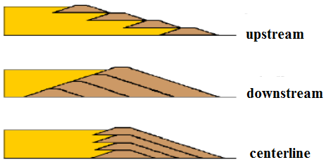

Figure 1. Tailing dams types

The safety for different types:

* The upstream construction method, while available at low cost, implies a number of specific hazards for dam stability. These hazards require a thorough assessment and continuous monitoring and control during siting, construction, and operation of the dam.
* Downstream-type and water-retention type embankments provide for better safety margins for dam stability.
* Another option for a safer tailings management is paste disposal rather than slurry disposal (Nilsson, 2001).

The tailings have negative environmental impacts on the environmental safety, land productivity and on the aesthetics.

**Tailings dam failures by dam type**

The figure 2 shown a tailings dam failures by dam type.

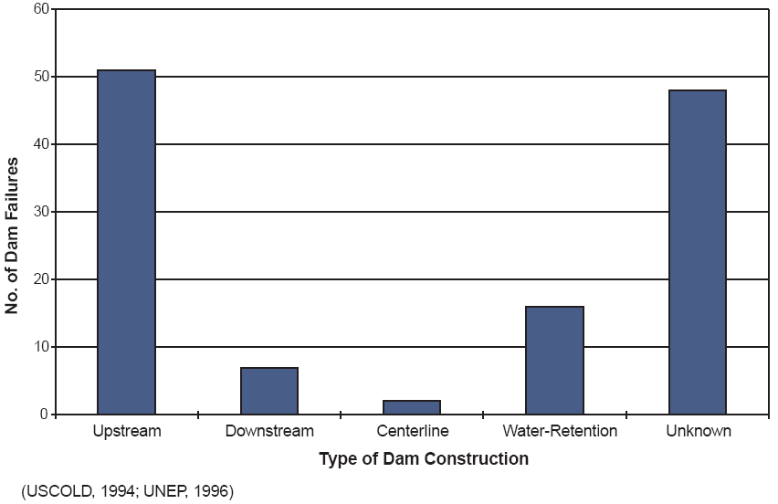

Figure 2. Tailings dam failures by dam type

Serious hazards posed by failing tailings facilities include:

* + floods and flood waves
  + spills of sometimes toxic sludge and waters
  + spills of sludge and rubble, burying houses or settlements and their inhabitants or destroying cropland
  + contaminant spills into the environment (e.g. cyanide)
  + pollution of rivers and their flood banks
  + poisoning of aquatic life including massive fish kills. (Meggyes et al., 2003)

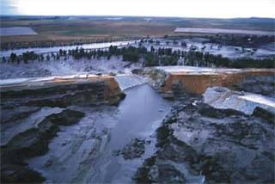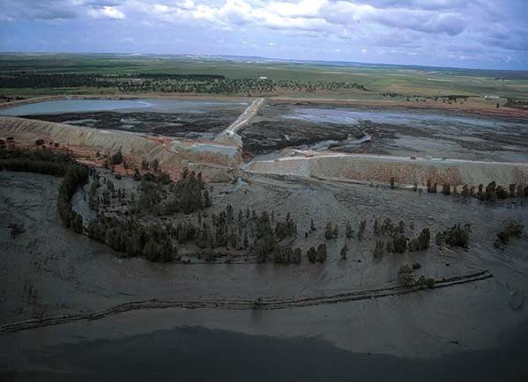

Figure 3.Outpouring of slag as a result of tailings dam failure

**Hazards arising from the possibility of tailings dam failure**

* The first one is land contamination and groundwater pollution as a product of minerals extraction and direct emission of contaminants from the pond.
* The occurring phenomena and the risk presented in terms of damage to the ecosystem can be managed by the common source-pathway-target frameworks used to quantify the harm posed by contaminated land.
* The main contaminants are radioactivity, remnant cyanide and formation of acid seepage.
* The second type of hazard is the failure of tailings dams, which are traditionally constructed of tailings using the upstream method.
* Dam failure happens suddenly or within a short period, often with little warning.
* The well known effects are flood, slurry and mudflow that move downslope.
* The typical modes of failure are affected by different causes such as dam overtopping, seismic impacts, landslides within the valley of the basin or structural dam failure due to instability and unexpected seepage forces. (Meggyes et al., 2003)

In table 1 are shown the categories of severity of effects and consequences.

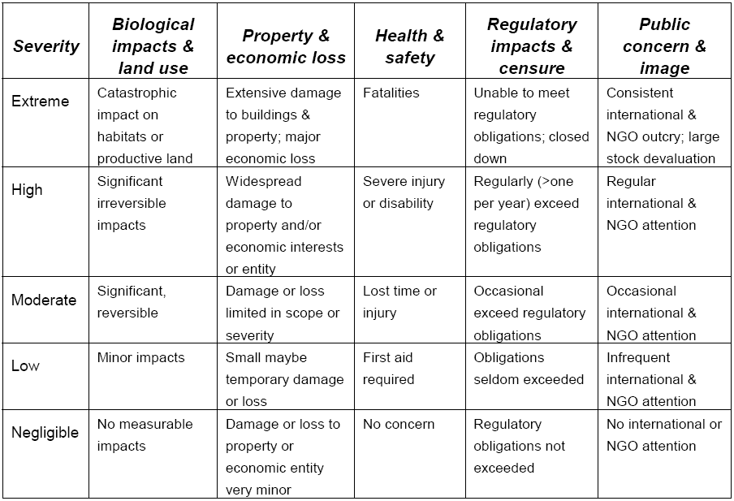Table 1. Categories of severity of effects and consequences

**Dam safety management of tailings facility**

Dam safety management of tailings facilitycovers the procedures shown in figure 4.



Figure 4. The procedures of tailing dams safety management

**Risk assessment stages**



Figure 5. Risk assessment stages

Scope and purpose of risk assessment is to determine and identify all stakeholders in the risk assessment.

Risk assessment is a structured methodology aimed at:

* Identifying the hazardous substances inventory
* Identifying possible accidents
* Estimating the Frequency of each Event
* Defining the causes for each event
* Estimating the frequencies of each scenario
* Assessing the magnitude of the consequences of each scenario

Risk assessment methodologies:

* Qualitative analysis (HAZard Operability Study)
* Quantitative analysis (CPQRA – Chemical Process Quantitative Risk Analysis)

**Qualitative risk analysis**

* **Preliminary Hazard Analysis (PHA),** was developed according to military standards in this field, and can be applied in the preliminary project phases. It focuses on the main areas that might contain dangerous substances, and on the main equipments, and monitors the possible failure points where dangerous substances or energies could be released.
* **“What If?”** method, poses a series of questions in order to determine unexpected events in the system.
* **Checklists** identify known and predictable risks using standards. Some of the more relevant techniques are: DSF – Diagnosis Safety Form, DCT – Diagnostique et Conditions de Travail, SDQ – Safety Diagnosis Questionnaire.
* **Hazard and Operability studies (HAZOP),** is designed to identify safety and operability problems using a systematic and structured approach by a multidisciplinary team. Using brainstorming and certain keywords deviations in the process from the normal functioning are identified, their causes and consequences on the process, humans and environment are evaluated qualitatively. HAZOP is one of the most used methods in technological hazard evaluation.
* **Failure Modes and Effects Analysis (FMEA)** determines how the failures of certain system components affect the optimum system performance. This ensures that proper safety measures are taken and safety systems are installed. The FMEA is a complementary analysis of Layer Of Protection Analysis (LOPA).

The qualitative methods focus mainly on identifying the possible hazards and express the level of risk as low-L, medium-M, high-H and extreme-E.

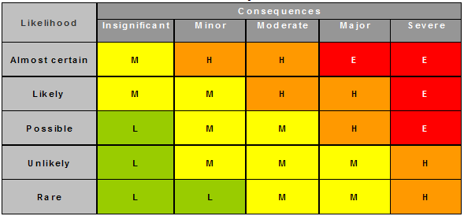

Figure 6. Qualitative risk analysis

**Risk management**

Risk assessment provides a basis for the development of risk management (figure 7):

* + communication,
  + contingency,
  + mitigation and
  + emergency response plans.

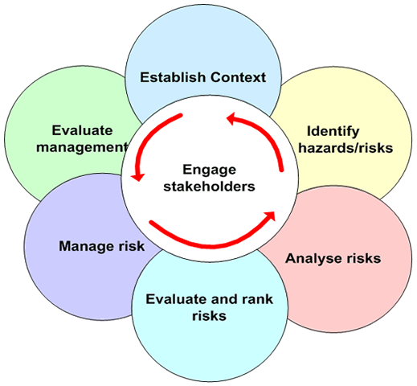

Figure 7. Development of risk management

Risk management goals are:

* minimize the likelihood of adverse safety or environmental impacts;
* detect and respond to potential failures;
* establish contingency and emergency preparedness plans to deal with significant events. (The Mining Association of Canada, 1998).

**Hazard assessment methodology for tailing dams**

The hazard associated to a dam is appreciated by the RB index:

RB = CA/(a * BA + b * CB)

in which the weight coefficients a and b have the values:

a = 1 for dams and deposits that have been established according to the current provisions;

a = 0.8 for dams and deposits that have been established based on older regulations;

a = 0.4 for situations in which there is a lack of adequate data regarding the project;

b = 1 for dams or deposits that have had no problems during or since construction;

b = 0.7 for dams or deposits that had incidents or accidents during or since construction, resolved through supplementary works.

The BA index the dam’s or deposit’s characteristics (dimensions, type, discharge, importance class), it’s location (the nature of the ground and seismicity), and the condition of the lake or waste deposit;

The CB index is determined by the situation of the dam, the sophistication of the operational controls and monitoring system(s), the level of maintenance, the dam’s behaviour over time, the conditions of the accumulation lake, and the level of site-specific knowledge; and

The CA index quantifies the consequences of damage to the dam/deposit, taking into consideration: the possibility of loss of lives, potential effects on the environment, potential social-economical effects, etc. (Mara et al., 2007)

Depending on the value of the RB index, the dams are assigned to one of four hazard categories (A, B, C, or D):

RB>0.8 a dam of exceptional importance (A)

0.8 ≥RB >0.15 a dam of special importance (B)

0.15 ≥RB >0.05 a dam of normal importance (C)

RB ≤ 0.05 a dam of low importance (D)

**The importance of risk assessment**

* Risk assessment helps to focus on cost effective approaches to improving the performance of tailing systems.
* Depending on the available data, risk assessment can be carried out in a more or less quantitative manner, starting from a qualitative identification of possible hazards to a quantitative risk evaluation concerning the probabilities of failure and its economic consequences.
* Risk assessment needs to occur before and during an operation, and must also address closure issues, particularly since tailings dams outlast mines and their stability has to be guaranteed "in perpetuity".
* Risk management is an ongoing process rather than a one-off activity.
* Risk assessment may not cover well, some very low-probability/high consequence events, such as those which characterize certain tailings failures.

**Conclusion**

Actions to reduce risk:

* Improving quality control;
* Documenting construction and quality control by more use of as-built records;
* Improving construction procedures consistent with recommendations from well-qualified geotechnical engineers familiar with the mining industry;
* Utilizing more third party reviews;
* Ensuring that there is no conflict between short term profitability and long term integrity of containment;
* Ensuring that the responsibility for failure of waste containment structures is understood at the highest corporate levels and that the standard of care is set by senior mine management (Morgenstern, 2001).

**References:**

* Alexandru Ozunu, Institutional Practitioner Training in Risk Management in Mining 7-11 December 2009, Tirana, Albania
* Bruce, Iain G., Logue, Clint, Wilchek, Lori-Ann , 1997, Trends in Tailing Dam Safety
* Hartford, D.N.D., 1998, Risk assessment in environmental risk management of tailings dams, in ICME/UNEP Workshop on Risk Assessment and Contingency Planning in the Management on Mine Tailings, Argentina
* Meggyes, Tamás, McDonald, Chris, Roehl, Karl Ernst, Witt, Karl Josef, Debreczeni, Ákos, Niederleithinger, Ernst, 2003, Reducing the risk for tailings facilities, Proceedings of Consoil
* Morgenster, Norbert, 2001, Geotechnics and mine waste management – update, Seminar on safe tailings dam constructions, Technical Papers
* Nilsson, Åke, 2001, Safe dam constructions, Seminar on Safe Tailings Dam Constructions, Technical Papers
* The World Bank Environmentally and Socially Sustainable Development Unit, 2003, Romania Hazard and Risk Mitigation and Emergency Preparedness Project: Setting Priorities for the Mining Sector
* The Mining Association of Canada, 1998, A Guide to the Management of Tailings Facilities