Basic Time Series Models in Financial Forecasting

ISSN 1857-9973 UDC 658.14/.17-021.57:303.733.3

Ilija Gruevski¹, Stevan Gaber²
¹Goce Delcev University, Faculty of Economics, Krste Misirkov St., 10-A, RepublicofMacedonia, e-mail: ilija.gruevski@ugd.edu.mk
²Goce Delcev University, Faculty of Economics, Krste Misirkov St., 10-A, RepublicofMacedonia, e-mail: stevan.gaber@ugd.edu.mk

Forecasting is inevitable process of modern day life. It is about predictions of the future based on a set of historical or present information and most commonly accompanied by analysis of trends. Forecasting employs different forecasting techniques depending on the source of information and the objective of forecast. The main interest of this article are the basic time series methods used in financial forecasting, in particular, simple moving average method, weighted moving average method and the exponential moving average method. A version of the simple moving average is the cumulative moving average, which is also presented in a short term. These are generally used to forecast time series without trend manifestation or seasonal component. The analysis of the forecasting methods include reviews of the basic forecasting concepts, suggestions for possible application and comparison of the featuring limitations.
Keywords
Forecast, Time Series, Simple Moving Average (SMA), Weighted Moving Average (WMA), Cumulative Moving Average (CMA) and Exponential Moving Average (EMA).

1. Introduction
It is hard to believe, but it is true, that a modern tale word such as the forecasting, to be ever-present in the human societies since the ancient times. Indeed, forecasting has fascinated people for thousands of years, sometimes being considered a sign of divine inspiration, and sometimes being seen as a bad thing or maybe, a criminal activity. For example, in ancient Babylon, forecasters would foretell the future of a person based on the distribution of maggots in a rotten sheep’s liver. People in ancient Greece desperate for revelation of their fate would journey to Delphi in Greece to consult the Oracle, who would provide them forecasts and predictions while intoxicated by ethylene vapors. And while for some predictions of the future was considered as magical, mystical or worshipful, for others it was thought as a crime, deceit and dangerous. The emperor Constantine issued a decree forbidding anyone ”to consult” a soothsayer, a mathematician, or a forecaster to foretell the future to be silenced forever. A similar ban on forecasting occurred in England in 18-th century when it became an offence to defraud by charging money for predictions and the sentence for the “notorious” act was three months imprisonment with hard work [1].
The forecasting concept. The previous sentences capture the timeless dimension of the forecasting phenomenon, and since today we cannot imagine living normally without planning and predicting things in near or distant future, we must understand the concept of forecasting. In general, forecasting is about predicting the future as accurately as possible, given all of the information available, including historical data and knowledge of any future events that might impact the forecasts [2]. Forecasting is the process of making predictions of the future based on past and present data and most commonly by analysis of trends (for example, estimation of some variable of interest at some specified future date). Prediction deals with the same issues, but it is more general in terms. Risk and uncertainty are central to forecasting and prediction; it is generally considered good practice to indicate the degree of uncertainty attaching to forecasts. In any case, the data must be up to date in order for the forecast to be as accurate as possible. In some cases, the data used to predict the variable of interest is itself forecast [2]. To generalize, forecasting is a technique that uses historical data as inputs to make informed estimates that are predictive in determining the direction of future trends [3].
Economic vs financial forecasts. Forecasting is required in many cases, from prediction of earthquakes, political, sales or technology forecasting via weather, flood and land use forecasting. But most notably, it is used in economics and finance. Economic forecasting is the process of attempting to predict the future condition of the economy using a combination of important and widely followed indicators. Economic forecasting involves the building of statistical models with inputs of several key variables, or indicators, typically in an attempt to come up with a future gross domestic product (GDP) growth rate. Primary economic indicators include inflation, interest rates, industrial production, consumer confidence, worker productivity, retail sales, and unemployment rates [4]. On the other hand, financial forecasting is the process by which a company prepares itself for the future. It involves determining the expectations of future results by estimation of future financial outcomes for the specific company or project.
Financial modeling. Financial forecasting is very similar to financial modeling, but yet there are some differences. Actually, financial modeling incorporates the forecast's assumptions and apply them to calculate the financial variables using a company's financial data. Financial modeling is the task of building an abstract representation (a model) of a real world financial situation [5]. This is a mathematical model designed to represent a simplified version of the performance of a financial asset or portfolio of a business, project, or any other investment. As it can be seen, financial modeling is the process by which a company builds its financial representation and use it to make business decisions. The modeling process involves developing a series of a company's financial information in the form of numerical spreadsheets such as Excel. These can be used to modify the variables to see how the changes could affect the financial results or help the company to determine the impact of a management decision or a future event. Both, financial forecasting and financial modeling can be used in budgeting, investment research and project financing, raising capital and most importantly, in securities valuation and trading.
Classification of forecasts. Explained in simple terms, forecasting is the estimation of the value of a variable (or set of variables) at some future point in time. A forecasting exercise is usually carried out for solving different forecasting problems and to provide an aid to decision-making and in planning the future. One way of classifying forecasting problems is to consider the timescale involved in the forecast. If we consider the time horizon associated with business decisions, the forecasts can be classified in three major groups [6]:
- Short-term (operating) forecasts. The time scale is 3 to 6 months and they deal with problems such as inventory control, production planning, distribution etc.;
- Medium-term (tactical). Here the horizon is usually from 6 months to 2 years months predicting leasing of plant and equipment, employment changes and similar; and
- Long-term (strategic) forecasts with time frame stretching above 2 years. Such decisions must take account of market opportunities, environmental factors and internal resources. The specific problems may include research and development, acquisitions and mergers, product changes etc.
The major reason for the above classification is that different forecasting methods apply in each different situation, e.g. a short-term forecasting method that is appropriate for forecasting sales next month, would probably be an inappropriate method for the long-term forecasting of sales in five years’ timescale. Of course, some areas can encompass short-term, medium-term and long-term forecasting like stock market and weather forecasting.
The basic steps in forecasting. This process commonly involves 5 (five) important basic steps [7]:
- Step 1: Problem identification. This is the most difficult part of forecasting. To identify the problem, the forecaster needs to understand the way the forecasts will be used and who requires the forecasts and how the forecasting function fits within the organization requiring the forecasts. He must spend sufficient time talking to everyone who will be involved in collecting data, maintaining databases, and using the forecasts for planning and decision making.
- Step 2: Gathering information. There are at least two kinds of information required for forecasting: (a) statistical data, and (b) the accumulated expertise of the people involved (who collect the data and use the forecasts). Sometimes, it will be difficult to assemble enough historical data to fit a reliable statistical model, in which case, the qualitative (judgmental) forecasting methods would be preferred option. Or maybe, old data will be inappropriate for forecasting and the predictions will be based on utilization of the most recent data.
- Step 3: Preliminary analysis. The third step includes preliminary graphing and decomposition of data. This is done for explanatory purposes: Are there consistent patterns in graphs? Is there a significant trend? Is there any seasonality in data? Are business cycles obvious? Are there any outliers that need to be explained? How strong are the relationships among the variables?
- Step 4: Choosing and fitting models. The reliability of a forecasting model commonly depends on the availability of historical data and the strength of relationships between the forecast and explanatory variables. The purpose of the forecast and the way in which it will be used are very important also. Comparison of at least two or three potential models is recommended. A model is an artificially constructed representation of the reality based on a set of explicit and implicit assumptions. It is consisted of one or more parameters which must be estimated using the available historical data.
- Step 5: Applying and evaluating a forecasting model. Once a model has been selected and its parameters estimated, the model can be used to make forecasts. Usually, the performance of the applied forecasting model can be measured by the forecasting errors. A number of methods have been developed to help in assessing the accuracy of forecasts. These may include the mean absolute deviation (MAD), the mean squared errors (MSE) and others.

2. Forecasting methods
There are many forecasting methods but the appropriate one depends largely on what data are available. If there are no data available, or if the data available are not relevant to the forecasts, then qualitative forecasting methods must be used. The other specific term for these is judgmental methods. Regardless the name, they are not purely guesswork—there are well-developed structured approaches to obtaining good forecasts without using historical data [8].
Qualitative (judgmental) methods. There is no formal mathematical model, often because there is no data available at all, or the available data is not thought to be representative of the future [9]. Most frequently are used for long-term forecasting and ocasionaly, for intermediate decisions. Sometimes judgmental forecasting is the only option, such as when a new product is being launched, or when a new competitor enters the market. Qualitative forecasting techniques are subjective, based on the opinion and judgment of consumers and experts. Judgmental forecasting methods incorporate intuitive judgement, opinions and subjective probability estimates. Some of the formal forecasting tools include: Composite forecasts, Delphi method, Forecast by analogy, Scenario building, Technology forecasting and others [10].
Quantitative methods. Quantitative forecasting models are used to forecast future data as a function of the past (historical) data. Most quantitative prediction problems use either time series data (collected at regular intervals over time) or cross-sectional data (collected at a single point in time). They can be applied when two conditions are satisfied: 1.Numerical information about the past is available; and 2. It is reasonable to assume that some aspects of the past patterns will continue into the future [11]. Some forecasting methods use only information on the variable to be forecast, and make no attempt to discover the factors that affect its behaviour. Based on the historical time series data of the observed vaiable, they will extrapolate trend and seasonal patterns, but they will ignore all other information such as changes in economic conditions. Others are more sophisticated trying to predict the variable of interest taking into account the determinants that affect it (explanatory, dynamic or cause and effect models). So if we draw a dividing line here, quantitative forecasting models could be categorized further as time series models and explanatory time series models.
Time series forecasting models. A time series is a series of observations collected over evenly spaced intervals of time. Most of the time series data has a sequence of a regular intervals of time (e.g., hourly, daily, weekly, monthly, quarterly, annually), although irregularly spaced observations can also occur, but they are very rare. Examples of time series data include: daily GM stock prices, monthly rainfall, quarterly sales for Tesla, annual Microsoft profits etc. Time series methods use historical data of a variable as the basis of estimating future outcomes of the same variable. The models are consisted of a single variable that changes over time and whose future values are related in some way to its past values [12]. For example, time series model of an observed stock price assumes that past historical prices are a good indicator of the future stock price. Here, the aim of forecasting is actually, to estimate and project how the sequence of observations will continue into the future. The most popular and widely used time series forecasting methods are: Simple moving average, Weighted moving average, Single exponential smoothing, Double exponental smoothing Holt’s method), Triple exponental smoothing (Holt-Winter’s method), Autoregressive moving average (ARMA), Autoregressive integrated moving average (ARIMA e.g. Box–Jenkins method); Seasonal ARIMA or SARIMA, Drift model, Naive model etc.
A common future of the models from above is that prediction of the observed variable is based on past values of the same variable. No other external variables are included in the system, but the equations of such models display “error” term on the right side allowing for random variation and the effects of relevant variables that are not included in the model. Lets assume that we want to forecast the stock price of Amazon. Because daily stock prices of Amazon (Pam) form a time series, we could also use a time series model for forecasting. In this case, a generalized time series forecasting model could take the form of:
$$\left[1\right] {Pam}_{t+1}=f\left({Pam}_{t}, {Pam}_{t-1},{Pam}_{t-2},{Pam}_{t-3},…,error\right);$$
Meaning that tomorrow’s stock price of Amazon is a function of its previous daily prices. Explanatory time series models. Sometimes the time series model may include one or more external (predictor) variables when the forecasting is done. We call this an explanatory model because it helps explain what causes the variation in observed variable of interest. In our example, we now assume that the future stock price of Amazon is determined by the volume of sales, Dow Jones stock market index and the reference interest rate. The simplified explanatory model is now a function of all three predictor variables as follows:
$$\left[2\right] Pam=f\left(Sales Volume, Dow Jones, Reference Rate, error\right);$$
There is also a third (hybrid) explanatory model which combines the features of the previous two models. This means that historical stock prices would represent the additional predictor variable in forecasting of the future stock price, besides sales volume, market index and interest rate:
$$\left[3\right] {Pam}_{t+1}=f\left({Pam}_{t},Sales Volume, Dow Jones, Reference Rate, error\right);$$
An explanatory model is useful because it incorporates information about other variables, rather than only historical values of the variable to be forecast. Yet, there are several reasons why a single variable time series model could outperform an explanatory or mixed time series model [13]:
- First, the forecaster may not fully understand the system, and even if it was understood it may be extremely difficult to measure the relationships between the predictors and the forecasted variable;
- Second, sometimes it would be necessary to estimate or measure the future values of the various predictors in order to be able to forecast the variable of interest;
- Third, the main objective may be only to predict what will happen, not to know why it happens; and
- Finally, it is not unusual that time series model may generate more accurate forecasts than an explanatory or hybrid model.
The final words here would be, that the choice of a forecasting model may depend on the accuracy of the alternative models, the resources and data available and the objective of forecasting procedure.

3. Basic time series forecasting methods
The focus in this article is put on the basic time series methods used in financial forecasting, nevertheless, they present signifficant forecasting tools in every field including economics. These include simple moving average method, weighted moving average method and the exponential moving average method. Another simple, but usefull method is the so-called naive forecasting method, but we shall discuss it in another occasion. These methods are generally used to forecast time series without trend and seasonal component. Before we describe the methods involved here, first we must define the concept of accuracy in the forecasting.
Аccuracy of the forecasting method. The accuracy of the forecasting method is measured by the forecasting errors. A time series is a series of observations collected over evenly spaced intervals of some quantity of interest. e.g. number of phone calls per hour, number of cars per day, number of students per semester, daily stock prices etc [14]. If y₁, …, y_{n} represents a time series, then ŷ_{t} represents the i_{th} forecasted value, where t ≤ n. For the forecasted variable ŷ_{t}, the forecasted error e_{t} is defined as:

$\left[4\right] e_{t}=y_{t}-{\hat{y}}_{t}$

The goal here is to find a forecast that minimize the errors. A number of measures are commonly used to determine the accuracy of a forecast, including the mean absolute deviation (MAD, also caled mean absoulte error MAE), mean squared error (MSE) and root mean squared error (RMSE) [15]. There are also others, but these are the simplest and the most popular.
The mean absolute deviation (MAD) is the sum of errors divided by the number of periods in the forecast:

$$\left[5\right] MAD=\frac{1}{n}\sum_{t=1}^{n}{e_{t}}$$
Similarly, the mean squared error MSE is defined as the sum of squared errors divided by the number of periods in the forecast:

$$\left[6\right] MSE=\frac{1}{n}\sum_{t=1}^{n}{e_{t}^{2}}$$
And the third one, the root mean squared error RMSE is simply, the root of MSE:

$$\left[7\right] RMSE=\sqrt{MSE}$$

We must notice that the standard version of Excel software is capable of performing these calculations through multilple operating steps.The extension real statistics data analysis tool, enables the user to accopmlish the same task by selecting the forecast accuracy option from the resulting menu of the instaled extension. You can use also excel solver to calculate the weights which produce the lowest mean squared error MSE. For that purpose you need to select Data > Solver and fill in the dialog box that apears.

3.1. Simple moving average
This simplest form of forecasting method is the simple (or single) moving average forecast. The method simply averages of the last m observations and then uses the average of the m most recent observations to forecast the next period observation. It is useful for time series with a slowly changing mean. From one period to the next, the average “moves” by replacing the oldest observation in the average with the most recent observation. In the process, short-term irregularities in the data series are “smoothed out” [16].
To repeat, using a simple moving average model, we forecast the next observation ŷ_{t} based on the average of a fixed finite number m of the previous observations from the time series variable:

$$\left[8\right] {\hat{y}}_{t}=\frac{1}{m}[y_{t}+y_{t-1}+…+y_{t-m+1}]$$

With simple words, if we want to forecast tomorrow’s stock price of Amazon with the simple moving average method, based on the last 3 daily prices, the forecast value will be the arithmetic average from today’s, yesterday’s and the day before yesterday’s price of the observed stock. A 10-day moving average would average out the closing prices for the first 10 days as the first data point. The next data point would drop the earliest price, add the price on day 11, and then take the average, and so on. Likewise, a 50-day moving average would accumulate enough data to average 50 consecutive days of data on a rolling basis. The trickiest part of this method is how you choose m. One rule of thumb is that we want the value of m that gives us the best forecasting accuracy i.e. minimizes MAD or MSE [17]. Or we may choose the number of m according to the purpose of the applied forecasting method (a 50 or 200 days simple moving average forecasts to determine the possibilities of death cross or golden cross in price trend patterns).
Potential for use. In technical analysis, a simple moving average is a technical indicator that can aid in determining if an asset price will continue or if it will reverse a bull or bear trend. This is true because short-term averages respond quickly to changes in the price of the underlying security, while long-term averages are slower to react. Actually, it is an important analytical tool used to identify current price trends and the potential for a change in an established trend. The simplest form of application of a simple moving average is to quickly identify if a security is in an uptrend or downtrend. Another popular and yet significantly analytical use is to compare a pair of simple moving averages with each covering different time frames. If a shorter-term simple moving average is above a longer-term average, an uptrend is expected. On the other hand, if the long-term average is above a shorter-term average then a downtrend might be the expected outcome [18].
The last is consistent with the identification of the popular trading patterns in stock markets. Two popular trading patterns that use simple moving averages include the death cross and a golden cross [19]. The death cross appears on a chart when a stock’s short-term moving average, usually the 50-day, crosses below its long-term moving average, usually the 200-day. The death cross is indicating bearish price movement and the potential for a major selloff. It has proven to be a reliable predictor of some of the most severe bear markets of the past century, including 1929, 1938, 1974, and 2008.

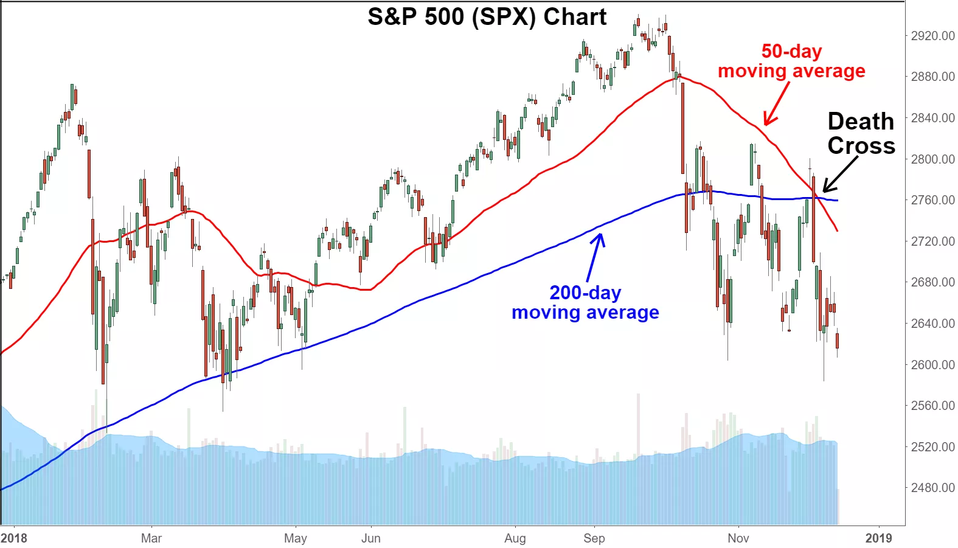
Chart 1 Illustration of a death cross on the S&P 500 in December of 2018
Source: Trading view 2018

On the other hand, the golden cross appears on a chart when a stock’s short-term 50-day moving average crosses above its long-term 200-day moving average. The golden cross is a bullish signal indicating the potential for a major rally. There are three stages to a golden cross. The first stage requires that a downtrend eventually bottoms out as selling is depleted. In the second stage, the shorter moving average forms a crossover up through the larger moving average to trigger a breakout and confirmation of trend reversal. The last stage is the continuing uptrend for the follow through to higher prices [20].
We must bear in mind that most of the indicators are “lagging,” and no indicator can truly predict the future. Many times, an observed golden cross produces a false signal, and a trader placing a long at that time could subsequently find himself in some near-term trouble. Unlike the death crosess, history has revealed that golden crosses generally fail to manifest. Therefore, a golden cross should always be confirmed with other signals and indicators before putting on a trade [21].

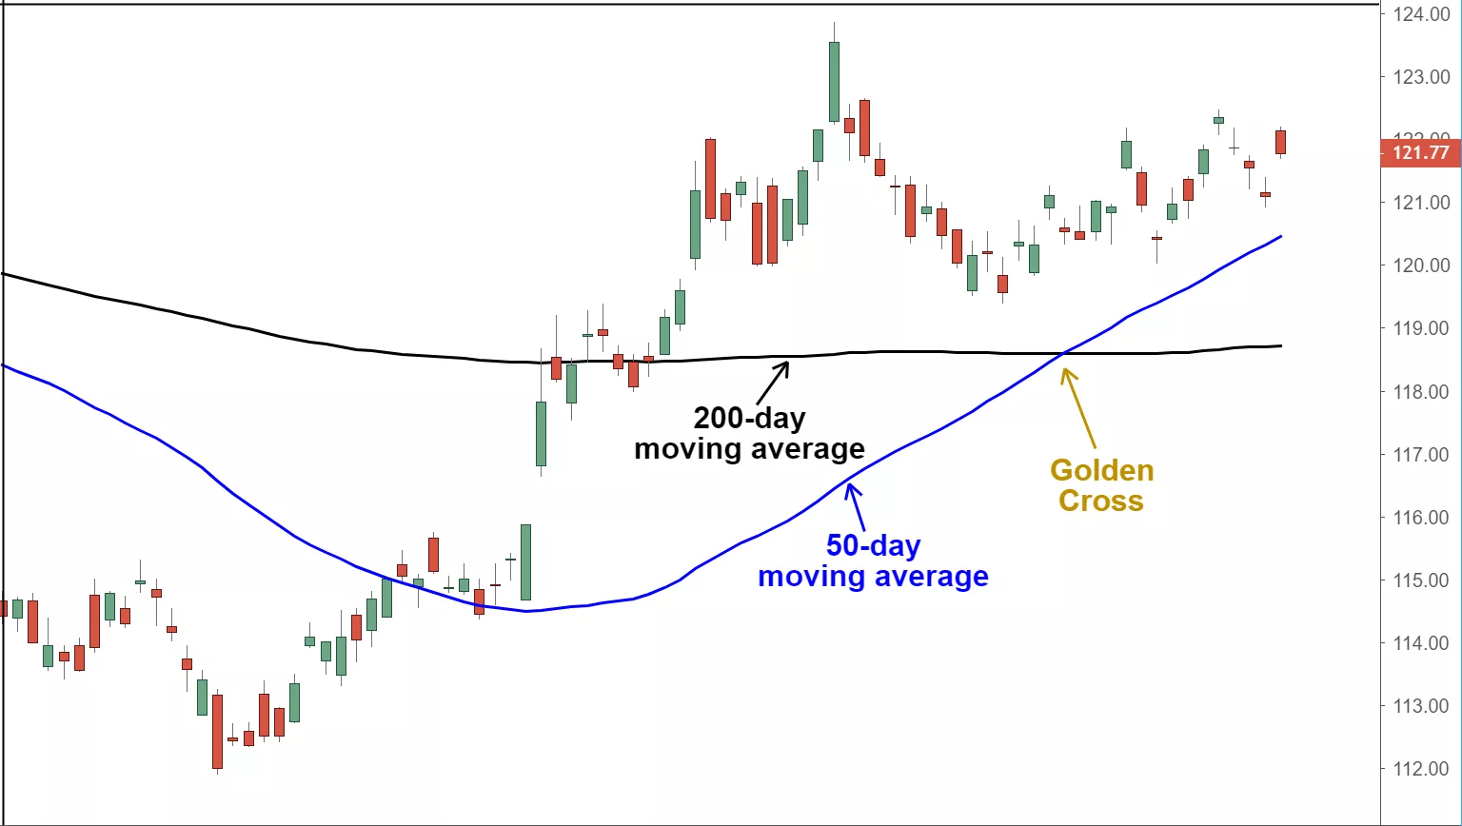
Chart 2 Illustration of a golden cross
Source: Trading view 2020

Limitations of the simple moving average method. First, its the uncertainty whether or not more emphasis should be placed on the most recent data in the time period or on more distant data. Some believe that new data will better reflect the current trend the security is moving with, others claim that privileging certain dates will bias the trend. As a cosequence, the simple moving average may rely too heavily on outdated data. Another limitation is the reliability on historical data in a whole. This is in contradiction with the efficient market hypothesis. If markets are indeed efficient, using historical data should tell us nothing about the future direction of asset prices [22].
Excel provides the moving average data analysis tool to simplify the calculations described above.To use this tool, select Data > Data Analysis and choose Moving Average from the menu that appears.

3.1.1. Cumulative moving average
Unofficially, this method could be considered as a version of the (simple) moving average method. Usually, the number of observations that define the average in simple moving average is a finite number smaller that the number of all observations in the time series m < N. In cumulative moving average, the average is determined by all the relevant observations from the time series observed at any point of time m = t. As the data arrives in an ordered time stream, the user may like to get the average of all of the data up until the current section of time. For example, the average price of all of the stock transactions from the begining up until the present time. As each new transaction occurs, the average price at the time of the transaction can be calculated for all of the transactions up to that point using the cumulative average method. Conceptually, if we have a sequence of t observations from the first, up to the last (y₁.....y_{t}), the cumulative average at time section t can be expressed as an equally weighted average of the sequence of all t observations:
$$\left[9\right] {\hat{y}}_{t(CMA)}=\frac{y_{1}+…+y_{t}}{t}$$
However, if a new observation y_{t+1} becomes available, the cumulative average could be easely updated following the formula:
$$\left[10\right] {\hat{y}}_{t+1(CMA)}={\hat{y}}_{t\left(CMA\right)}+\frac{y_{t+1}-{\hat{y}}_{t(CMA)}}{t+1}$$

This means that the current cumulative average for a new datum point is equal to the previous cumulative average, plus the difference between the latest datum point and the previous cumulative average, all this together divided by the number of points or observations received so far, t+1. The implication from this is when all of the datum points arrive (t = N), then the cumulative average will equal the final average.

3.2. Weighted moving average
In the simple moving averages method above, each observation in the average is equally weighted to 1/m. We now consider the case where these weights can be different. This type of forecasting is called weighted moving average. If in the formula from above we assign m different weights analogous to each of the m observed variables, where the sum of weights is equal to 1 (w_{t} + w_{t-1} +…+ w_{t-m+1} = 1), than we can write for the weighted moving average method the following:

$$\left[11\right] {\hat{y}}_{t}=[{w_{t}y}_{t}+{w_{t-1}y}_{t-1}+…+{w_{t-m+1}y}_{t-m+1}]$$

In simple terms, this approach allows the forecaster to avoid the trap with the uncertainty of data and to give more weights to the data he preffers or anticipates its appropriate. Typically the most recent observation carries the most weight in the average. In our example with the Amazon‘s stock price, we may give 0,50 weight for the present day price, 0,30 weight for the yesterday’s price and only 0,20 weight for the before yesterday’s price and carry the forecast for tommorow’s stock price.
In technical analysis of financial data, a weighted moving average (WMA) has the specific meaning of weights that decrease in arithmetical progression. Weighted moving averages assign a heavier weighting to more current data points since they are more relevant than data points in the distant past. In this example, the recent data point was given the highest weighting out of an arbitrary15 points. The arbitrary points (denominator) is a triangle number equal to m*m₊₁/2 or else could be calculated as (1 + 2 + ... + m), in our case (1 + 2 + 3 + 4 + 5 = 15). So the distribution of weights is the following: the most recent data gets weight 5/15 ... and the last date observation gets 1/15. You can weigh the values out of any obseravtion you can fit in this matrix.

Table 1 Example of weighted moving average in technical analysis

Date | Closing price of Amazon’s stock | Weights
July 15 | 91$ | 5/15
July 14 | 93$ | 4/15
July 13 | 92$ | 3/15
July 12 | 89$ | 2/15
July 11 | 90$ | 1/15
Source: Own calclations according to investopedia.com.

The weighted average is calculated by multiplying the given price by its associated weighting and totaling the values. In addition, the forecasted price on July 16-th will be:

$$\left[12\right] {\hat{y}}_{t}=\left[\frac{5}{15}91\$+\frac{4}{15}93\$+\frac{3}{15}92\$+\frac{2}{15}89\$+\frac{1}{15}90\$\right]=91,4\$$$

The weights with the simple moving average would have been the same 1/5 for every observation, and the forecasted value would have been exactly 91$. The difference is due to the grater weigths from the recent time points when the stock price is higher in comparison of the older data points.
The specific distribuition of weights in weighted moving average is illustrated below. This graph assumes m = 15. It clearly demonstrates the decrease of weights with arithmetical progression.

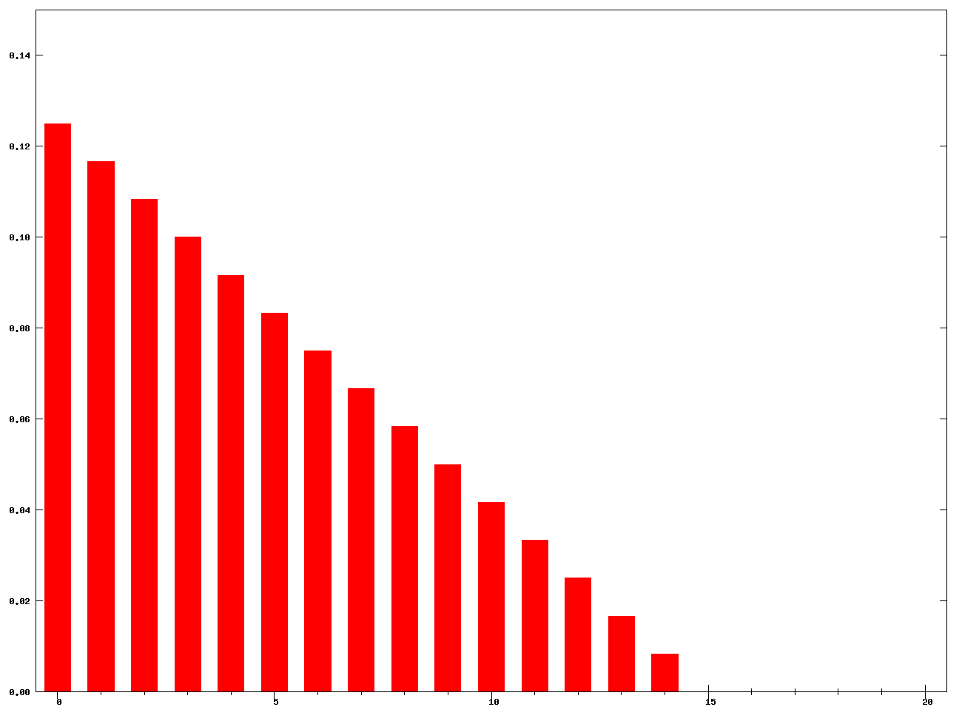
Picture 1 Illustration of the specific distribuition of weights in weighted moving average (m = 15)
Source: wikipedia.com

Excel doesn’t provide a weighted moving averages data analysis tool. Instead, you can use the weighted moving averages real statistics data analysis tool. To use this tool, choose the time series option from the main menu and then the basic forecasting methods option from the dialog box that appears and after choose the weighted moving averages option.

3.3. Exponential moving average
Naturally, the simplest of the exponentially smoothing methods is called simple exponential smoothing and this method is suitable for forecasting data with no clear trend or seasonal pattern. It is also known as single exponential smoothing or exponential moving average method. It is thought in forecasting, that the naïve method assumes that the most recent observation is the only important one, and all previous observations provide no information for the future. This is equivalent as all of the weight is given to the last observation. On the other hand, the average method assumes that all observations are of equal importance, and gives them equal weights when generating forecasts [23]. So if we want a forecast between these two extremes, the exponential smoothing is the best candidate: it enables the forecaster to attach larger weights to more recent observations than to observations from the distant past. There are similar possibilities in weighted moving average as you can give more weight to recent events, but you are limited to the last m observations. Exponential smoothing improves this method as well, by taking all previous observations into account, while still favoring the most recent observations [24].
Forecasts with simple exponential smoothing are calculated using exponentially decreasing weights as the observation get older. In other words, recent observations are given relatively more weight in forecasting than the older observations. For that purpose, there are one or more smoothing parameters to be determined (or estimated) and these choices determine the weights assigned to the observations [25]. To recal, if y_{t} is the observation from the current period t and y^_{t} is the predicted observation in period t, than for the forecasted observation in the next period t+1 can be written:

$$\left[13\right] {\hat{y}}_{t+1}=αy_{t}+(1-α){\hat{y}}_{t}$$

where α is the smoothing parameter or the smoothing constant with value 0 ≤ α ≤ 1.
According to the formula, the forecast at time t+1 is equal to a weighted average between the most recent observation and the previous forecast. The previous forecast is actually, the forecast for the current period or with other words, the exponential moving average at time point t.
The smoothing parameter α.The table below gives the observation weights for four different values of α. It is visible that the sum of weights even for a small value of α will be approximately 1 if the sample is with reasonable size. The bigger the value of α, and the weights drop values subsequently faster, the smaller the value of α and their values drop with slower rate.

Table 2. Different values of parameter α
 | α = 0,80 | α = 0,60 | α = 0,40 | α = 0,80
y_{t} | 0,2000 | 0,4000 | 0,6000 | 0,2000
y_{t-1} | 0,1600 | 0,2400 | 0,2400 | 0,1600
y_{t-2} | 0,1280 | 0,1440 | 0,0960 | 0,0320
y_{t-3} | 0,1024 | 0,0864 | 0,0384 | 0,0064
y_{t-4} | 0,0819 | 0,0518 | 0,0154 | 0,0013
y_{t-5} | 0,0655 | 0,0311 | 0,0061 | 0,0003
Source: Hyndman, R.J., & Athanasopoulos, G., Forecasting: principles and practice, 2nd edition.

For any α between 0 and 1, the weights attached to the observations decrease exponentially as we go back in time, hence the name “exponential smoothing.” In situation if α is small or close to 0, more weight is given to the observations from distant past. If eventually α is large or close to 1, more signifficance is given to the more recent observations. In extreme case where α is exactlly 1, the results will be identical to the forecasts from naive forecasting method.
Generally, there is no "accepted" value that should be chosen for α, although there are some recommended values based on the application. A commonly used value for α is α = 2 / (N+1).This is because the weights of an simple moving average and exponential moving average have the same "center of mass" when both are related to the number of observations N. The approach is utilized in the technical analysis when the exponential moving average is involved in forecasting of stock prices. The forecaster must concider the variation of the parameter‘s values if he wants to use this approach. Particularly, the weighting given to the most recent price is greater for a shorter-period average than for a longer-period average. For example, an 18.18% multiplier is applied to the most recent price data for a 10-day EMA, whereas for a 20-day EMA, only a 9.52% multiplier weighting is used. There are also slight differences correlated depending wheather the open, high, low, or median price are used instead of using the closing price [26]. Another possible way of choosing α is the optiization method that minimizes MAD and MSE.
Illustartion of the specific distribuition of weights in exponential moving average is given below with n = 21. As we can see clearly, the observational weights decline exponentially, as as the older observations step by.

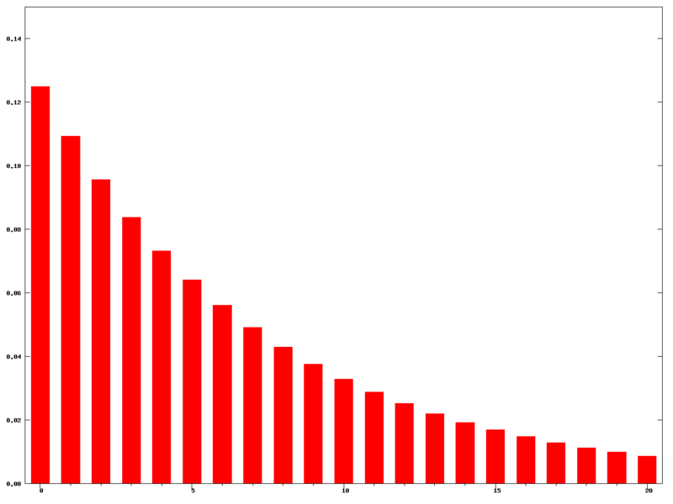
Picture 2 Illustration of the specific distribuition of weights in exponential moving average (n = 21)
Source: Wikipedia.com
Possibilities for use. Like all moving average indicators, EMAs are much better utilized for trending markets. When the market is in a strong and sustained uptrend, the EMA indicator line will also show an uptrend and vice-versa for a downtrend. The most quoted short-term averages are the 12- and 26-day exponential moving averages. They are quite useful to create indicators like the moving average convergence divergence (MACD) and the percentage price oscillator (PPO). As a long-term trending indicators, the 50- and 200-day EMAs are mostly preferable [27].
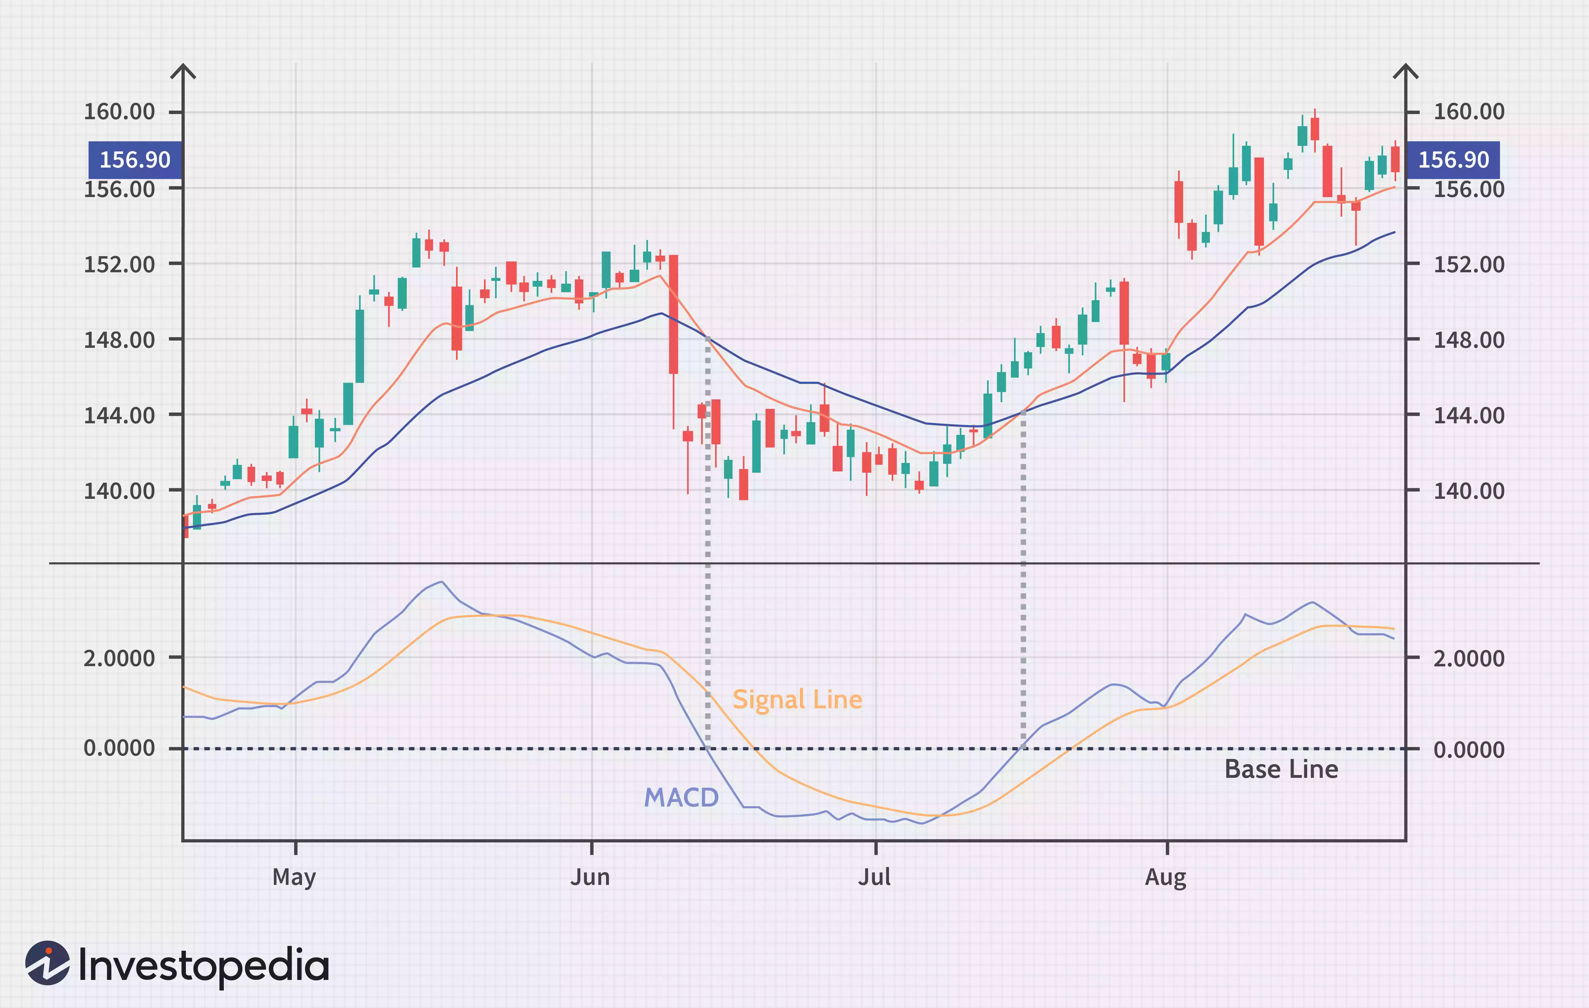
Chart 3 Presentation of moving average convergance divergance (MACD)
Source: Jiang S., investopedia.com

In technical analysis, moving average convergence divergence - MACD is a trend-following momentum indicator that shows the relationship between two moving averages of a security’s price. The MACD is calculated by subtracting the 26-period exponential moving average from the 12-period EMA. The result of that calculation is the MACD line. A nine-day EMA of the MACD called the "signal line" is then plotted on top of the MACD line, which can function as a trigger for buy and sell signals. Traders may buy the security when the MACD crosses above its signal line and sell the security when the MACD crosses below the signal line [28].
Very similar to MACD is PPO - the percentage price oscillator, a technical momentum indicator that measures the relationship between a 26-period and 12-period EMA in percentage terms. Some traders prefer the PPO because readings are comparable between assets with different prices, whereas MACD readings are not comparable because measurements are in absolute (dollar) terms. Typically, PPO contains two lines, the PPO line, and the signal line. The signal line is an EMA of PPO, so it moves slower than the PPO. Usually, PPO above zero indicates an uptrend (the short-term EMA is above the longer-term EMA). Otherwise, PPO below zero indicates a downtrend (as the short-term average is under the longer-term average). The moment PPO crosses the signal line is viewed by some traders as a trade signal. When it crosses above the signal line, it’s a trigger to buy, when it crosses below the signal line, it’s a trigger to sell.
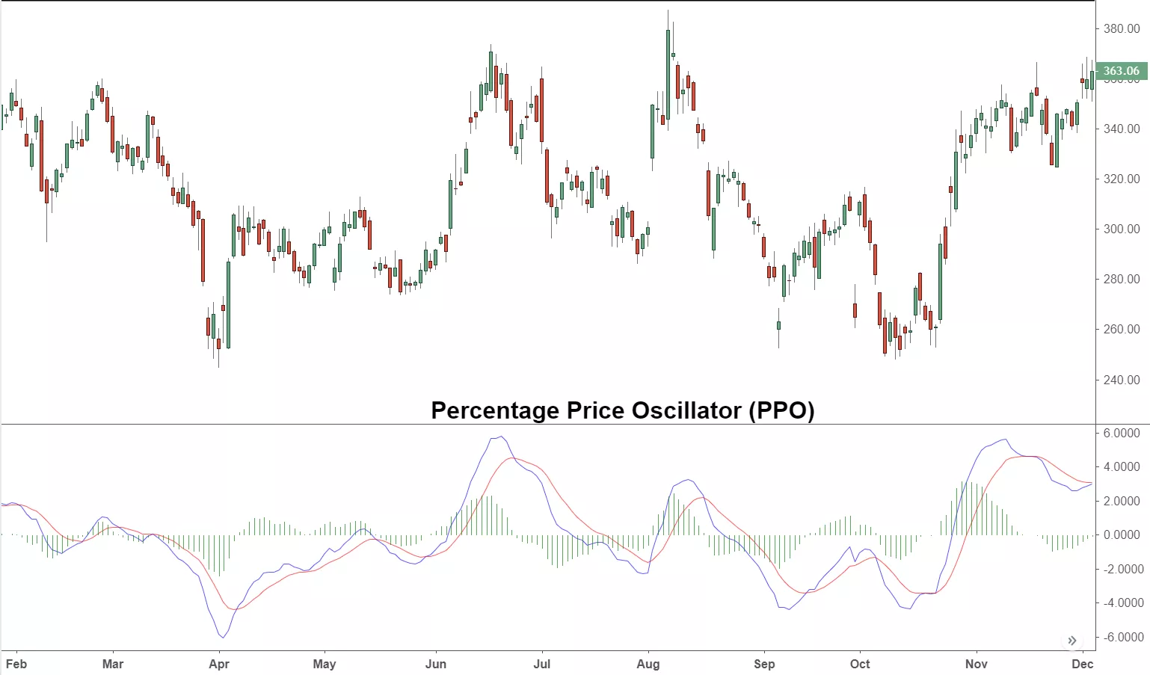
Chart 4 Presentation of percentage price oscillator (PPO)
Source: Trading view
In general terms, both the simple moving average and the exponential moving average are fundamentally resembling. The difference between an EMA and an SMA is the sensitivity to changes in the data used in its calculation. Since EMAs place a higher weighting on recent data than on older data, they are more responsive to the latest price changes than SMAs. Because EMA places more weight on the latest data, it “grips” the price action a bit more tightly and detects the trend more quickly. This future does serve to alleviate the negative impact of lags to some extent and at the same time is very prudent in derivation of an underlying trading signal.
Constraints of exponential moving average. Traders and forecasters who employ exponential moving averages find it very useful when applied correctly. Nevertheless, these signals can be misinterpreted if it’s not fully understood. The true nature of all moving averages, including exponential moving average, is that they are lagging indicators. A lagging indicator is a technical indicator that lags the current price of an asset, which occurs after a certain price move has already happened. As a consequence, the trader may enter a position too late, as the significant change may have already happened [30]. The longer the moving average, the more the lag. Short moving averages are like speedboats - nimble and quick to change. In contrast, a long moving average contains lots of past data that slows it down. They appear like ocean tankers - lethargic and slow to change, requiring a bigger and longer price oscillation to change its course.
Excel provides the exponential smoothing data analysis tool to simplify the calculations associated with exponential moving average. In order to use this tool for select Data > Data Analysis and choose exponential smoothing from the menu that appears. A dialog box now appears which is similar to that of simple moving average, except that a damping factor field is used in place of the interval field.

4. Discussion

In simple terms, we may understand the forecasting as an estimation of a value of a variable of interest at some future point in time. In technical terms, forecasting is a technique that uses historical data as inputs to make informed estimates that are predictive in determining the direction of future trends. Forecasting is needed in many cases, such as prediction of earthquakes or forecasting the weather, but most commonly, in prediction of financial and economic variables. Modeling is helpful in forecasting, as it builds an abstract representation, a simplified model of a real world situation. Many classifications exists in the literature, but most practical is the one according to the time span of decisions. Namely, operational decisions require short-term forecast, tactical decisions intermediate forecast, while the long-term (strategic) business decisions go hand-in-hand with the long-term forecasts. The forecasting process also requires strictly ordered action steps:
- Problem identification;
- Gathering information;
- Preliminary evaluation:
- Choice of the fitting model; and
- Using the forecasting model.
There are many forecasting methods depending on the goal of forecast and the availability of information. Fundamentally, there are 3 different groups of forecasting methods: qualitative (judgmental) forecasting methods, quantitative forecasting method and time series forecasting method. Usually, time series models are consisted of a single variable models that changes over time and whose future values are related in some way to its historical values. Sometimes these models may include one or more external (predictor) variables when the forecasting is done, which is why they are known as explanatory time series models. Our interest in this article are the basic time series methods used in financial forecasting, in particular, simple moving average method, weighted moving average method, the exponential moving average method and eventually, the cumulative moving average model.
With simple moving average model, we forecast the next observation based on the average of a fixed number of the previous observations from the time series variable. It ebanles the forecaster immediately to identify if a security is in an uptrend or downtrend. Another popular appliacation is detection of the popular trading patterns in stock markets. The trading patterns that use simple moving averages may reffer to the death cross and a golden cross. Simple moving avrege is a lagging model and may rely too heavily on outdated data. Another possible limitation is the reliability on historical data in a whole. A moddified version of the (simple) moving average is the cumulative moving averge method. Here, the average is determined by all the relevant observations from the time series observed at any point of time m = t, instead of the last m observations.
The model of weighted moving average assigns m different weights analogous to each of the m observed variables, where the sum of weights is equal to one. This gives opportunity to the forecaster to place more weights to the data he preffers or thinks its relevant. Majorly, the most recent observation receives the most weight in the average. The accepted rule in technical analysis is determination of the weights that decrease in arithmetical progression. This is done by a denominator eqivalent to the triangle number of m.
Forecasts with the exponential smoothing average method are calculated using exponentially decreasing weights as the observation get older. As a result, the most recent observations are given relatively more weight in forecasting than the older observations. This reqires one or more smoothing parameters, generating the observational weights to decline exponentially, as the older observations step by. They are suitable for creating trend pattern indicators like the moving average convergence divergence (MACD) and the percentage price oscillator (PPO). Like simple moving average, they are a lagging indicator, and if not interpreted correctly, the trader may be tricked to enter a position too late, bringing himself into an unpleasant trading situation.

5. References

- Hyndman, R.J., & Athanasopoulos, G., Forecasting: principles and practice, 2nd edition, OTexts: Melbourne, Australia, 2018;
- French, Jordan, "The time traveller's CAPM". Investment Analysts Journal. 46 (2): 81–96, 2017;
- Tuovila A., Forecasting: Technical analysis basic education, Investopedia, 2020;
- Liberto D., Economic Forecasting, Investopedia, 2020;
- Carol M., Kopp, Financial modeling: Financial Analasys, Investopedia, 2020;
- Choong J., Powerfull forecasting with MS Excel, An interacting electronic book, 2020;
- Hyndman, R.J., & Athanasopoulos, G., Forecasting: principles and practice, 2nd edition, OTexts: Melbourne, Australia, 2018;
- Hyndman, R.J., & Athanasopoulos, G., Forecasting: principles and practice, 2nd edition, OTexts: Melbourne, Australia, 2018;
- Choong J., Powerfull forecasting with MS Excel, An interacting electronic book, 2020;
- Hyndman, R.J., & Athanasopoulos, G., Forecasting: principles and practice, 2nd edition, OTexts: Melbourne, Australia, 2018;
- Hyndman, R.J., & Athanasopoulos, G., Forecasting: principles and practice, 2nd edition, OTexts: Melbourne, Australia, 2018;
- Choong J., Powerfull forecasting with MS Excel, An interacting electronic book, 2020;
- Hyndman, R.J., & Athanasopoulos, G., Forecasting: principles and practice, 2nd edition, OTexts: Melbourne, Australia, 2018;
- Choong J., Powerfull forecasting with MS Excel, An interacting electronic book, 2020;
- Zaiontz. C., real-statistics.com/time-series-analysis/forecasting-accuracy, 2021;
- Choong J., Powerfull forecasting with MS Excel, An interacting electronic book, 2020;
- Choong J., Powerfull forecasting with MS Excel, An interacting electronic book, 2020;
- Hayes A., Simple moving average, Investopedia, 2021;
- Chen J., Death cross deffinition, Investopedia, 2021;
- Chen J., Golden cross deffinition, Investopedia, 2021;
- Chen J., Golden cross deffinition, Investopedia, 2021;
- Hayes A., Simple moving average, Investopedia, 2021;
- Hyndman, R.J., & Athanasopoulos, G., Forecasting: principles and practice, 2nd edition, OTexts: Melbourne, Australia, 2018;
- Zaiontz. C., real-statistics.com/time-series-analysis/forecasting-accuracy, 2021;
- Choong J., Powerfull forecasting with MS Excel, An interacting electronic book, 2020;
- Maverick B.J., How is the exponential moving average formula calulated, Investopedia, 2021;
- Hayes A., Exponential moving average, Investopedia, 2021;
- Fernando J., Moving average convergance divergance, Investopedia;
- Mitchel C., Persentage price oscilator, Investopedia, 2021;
- Potters C., Lagging indicators, Investopedia, 2021;

