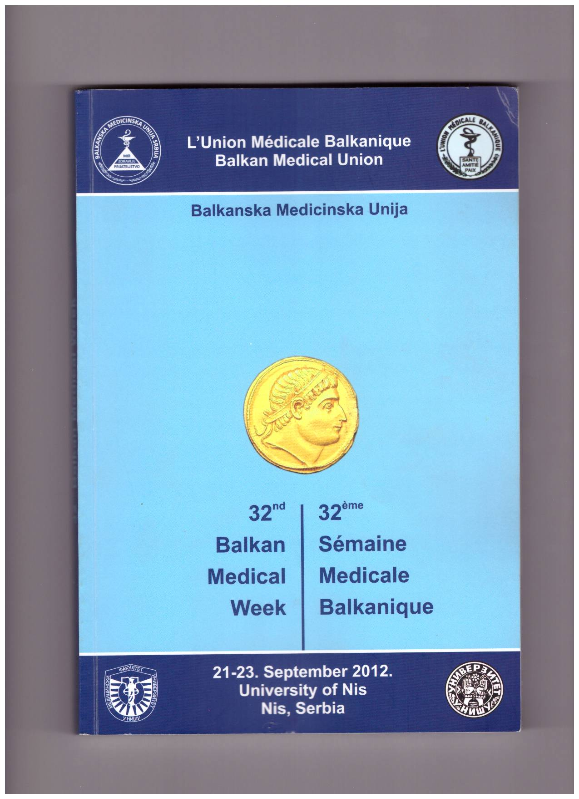
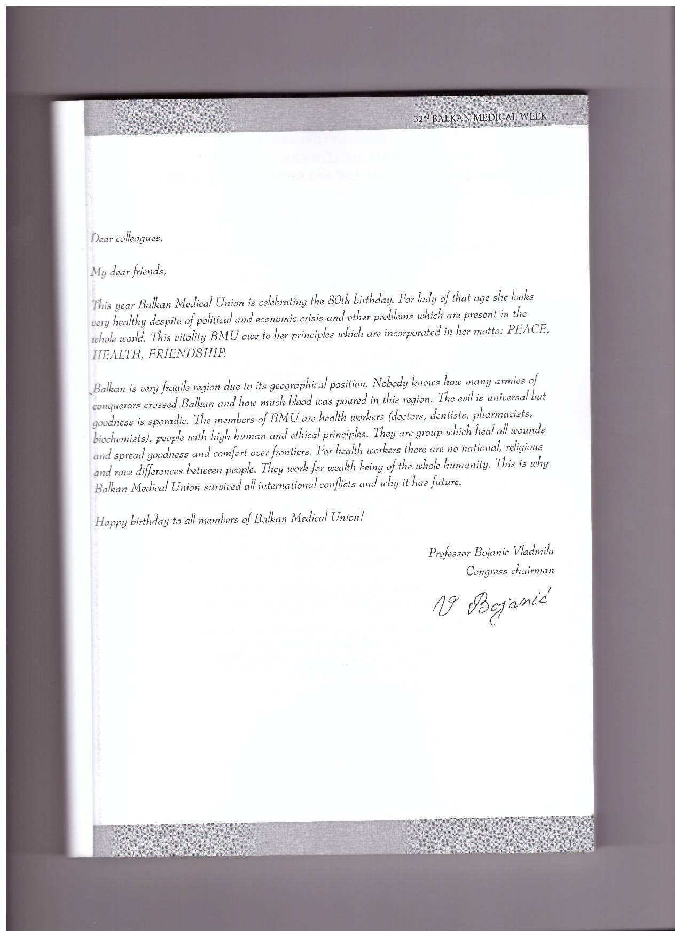

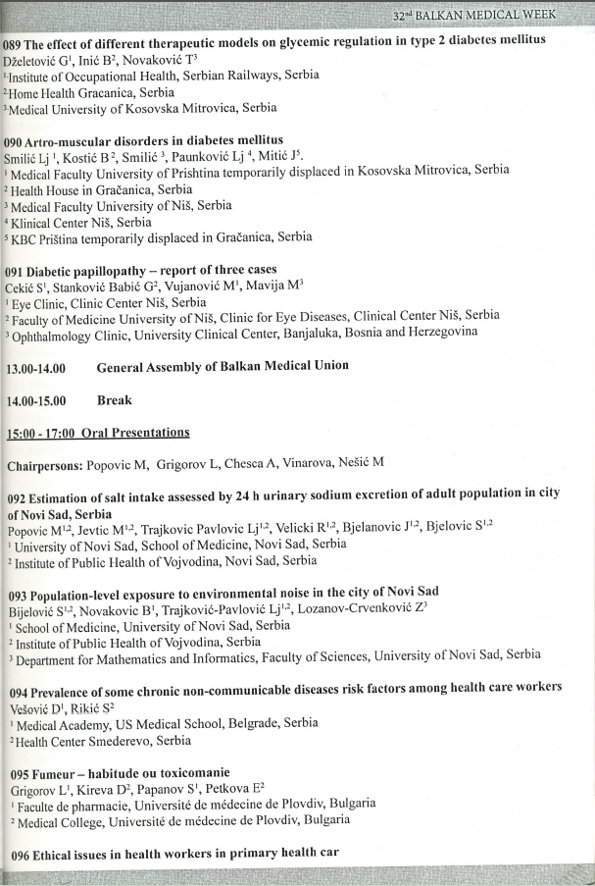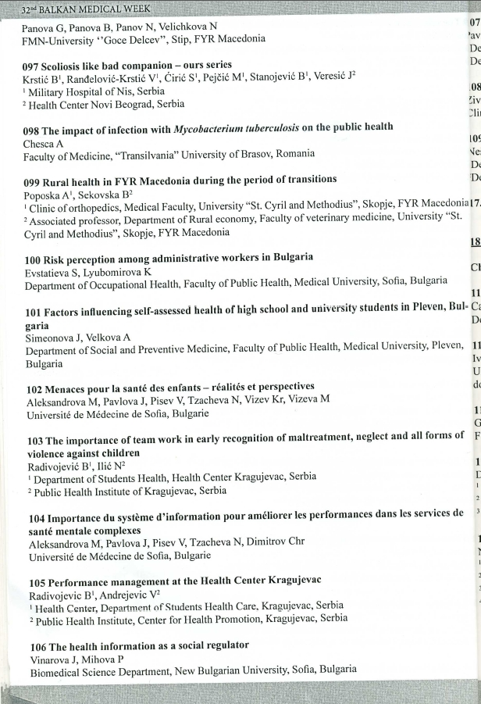

ETHICAL ISSUES IN HEALTH WORKERS IN PRIMARY HEALTH CARE
G.Panova, B.Panova, N.Panov, N.Velichkova
FMN-University, Goce Delcev''-Stip, Macedonia
www.gordana.panova @ ugd.edu.mk
Introduction: The medical ethics as an important part of clinical practice, and its application in practice in primary health care facilities.
Aims: The ethical dilemma is part of everyday clinical practice in health institutions in R.Makedonija. Purpose the paper is to determine the existence of ethical dilemmas in primary care and use of the content Bioethical science.
Methods: There were 164 anonymous questionnaires doctors respondents :Doctors H-87, women 79.4% of the median age from 42.2 years. nurse: H-167, 96.5% women, mean age 40.3 years.The goal of this paper was examining the current education and confidence in their knowledge in the field of medical ethics, increased weight in ethical dilemmas, access to the contents of bioetichks knowledge.
Results: Education in the field of medical ethics during medical studies.Doctors 32.5% and nurses 58.6%. Learning permanent education: Doctors 85.6% and 81.7% among nurses.
Professional medical associations: Doctors and nurses 74.3% 70.6%
The majority of respondents are confident in the knowledge of medical ethics: Doctors-84, 3%, nurses 69.3%.
Common ethical dilemmas encountered in communicating the diagnosis: Doctors 37.1% nurses-42, 6%, reduced capacity for decision making: physicians-36, 1% sesrite-33, 1%, disagreement over the method or course of treatment : doctors-29, 9%, sisters-47, 9%.
Most difficult ethical ethical dilemma is when helping suicide / euthanasia: doctors-21, 6%, sestrite24, 4%, for termination of maintain life: doctors-10, 1%, sisters-11, 3%. Representation of bioethical help: doctors-18, 6% and 15 nurses, 4%.
Discussion: The ethical dilemma is part of everyday work doctors and nurses in primary health care activities of the perception of ethical dilemmas, and using their knowledge and need further research the field of medical ethics.
Key words: ethical dilemma, primary health care within the Bioethical aid questionnaire euthanasia.

