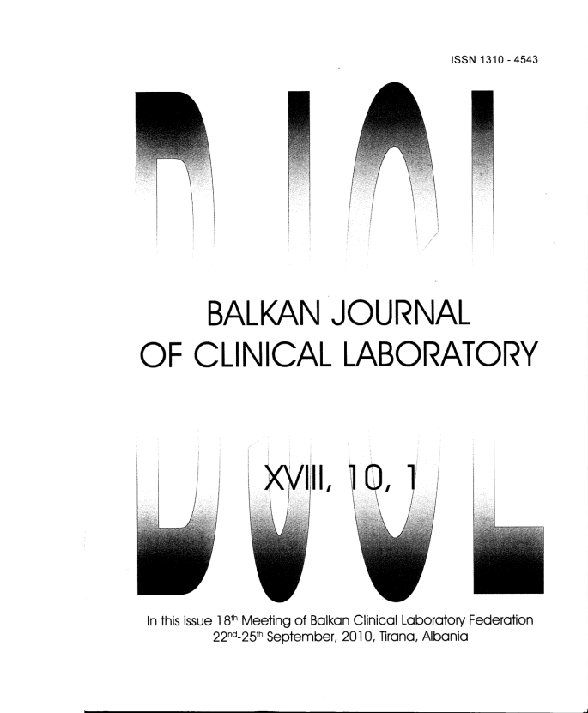

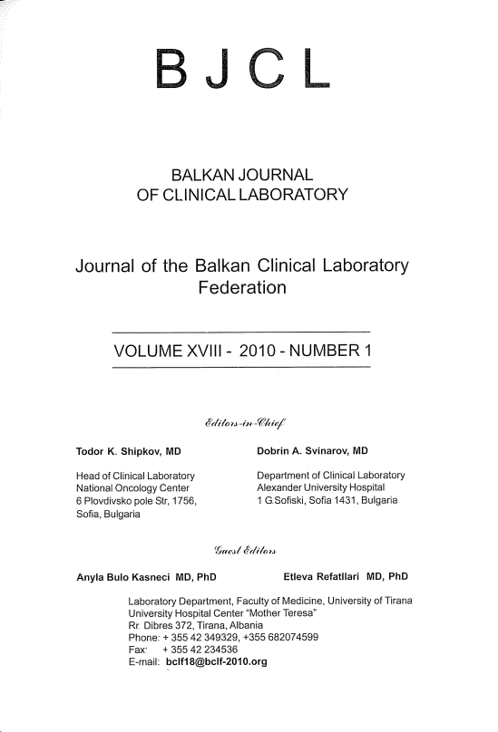

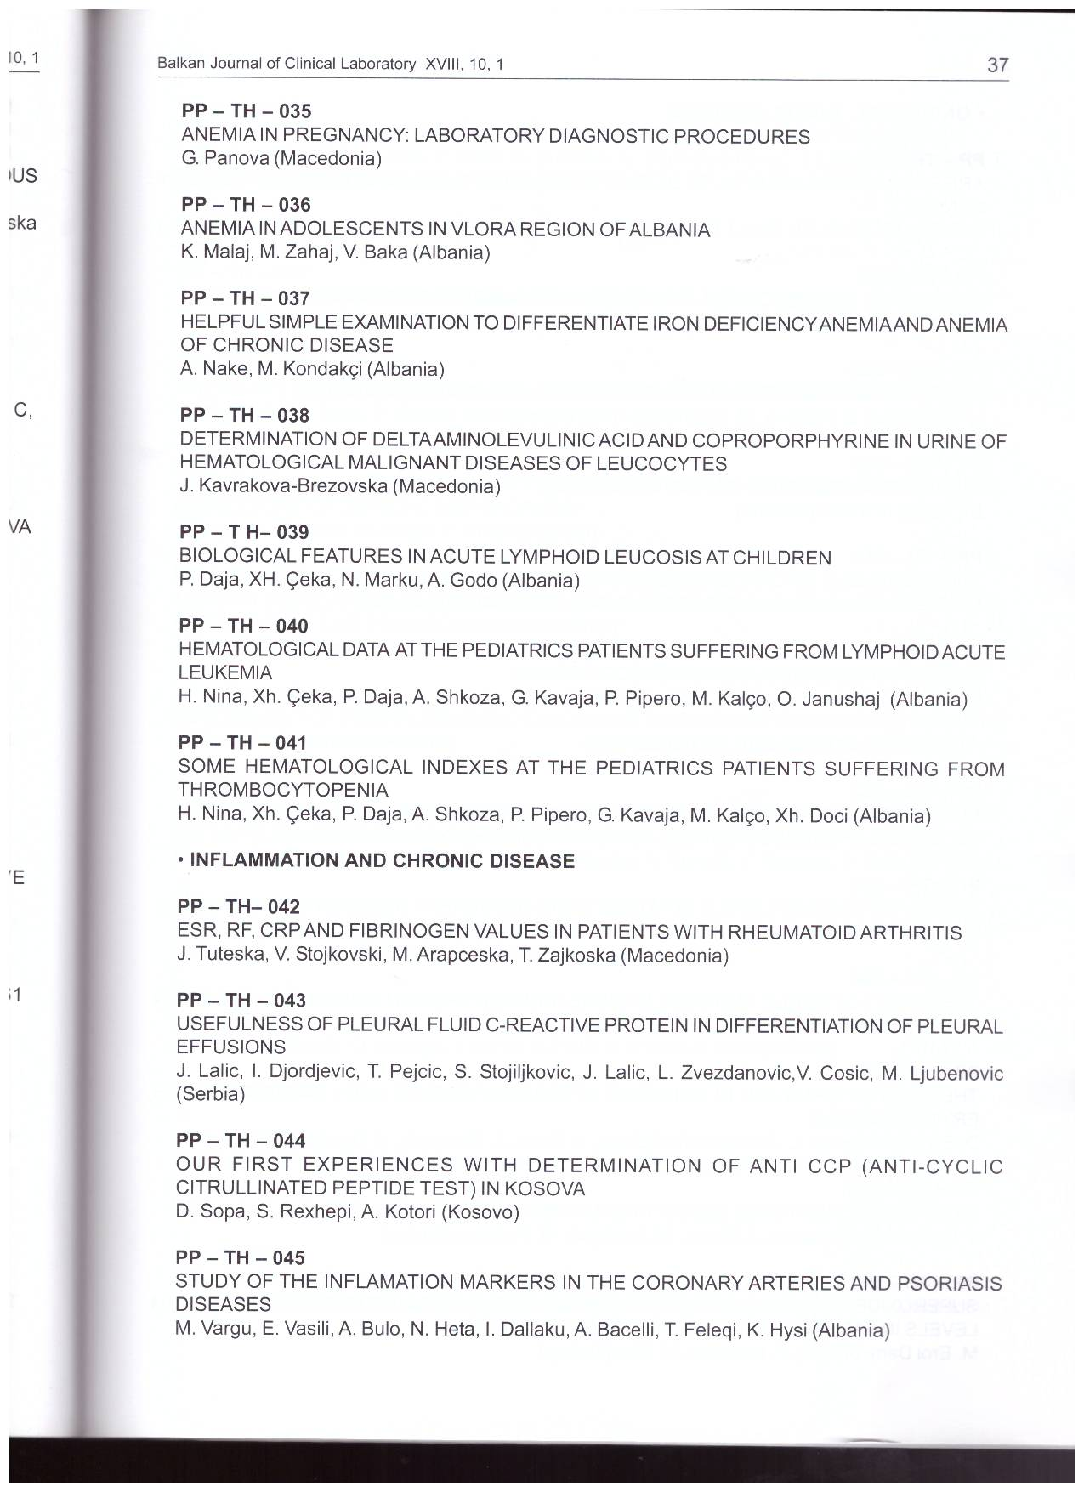

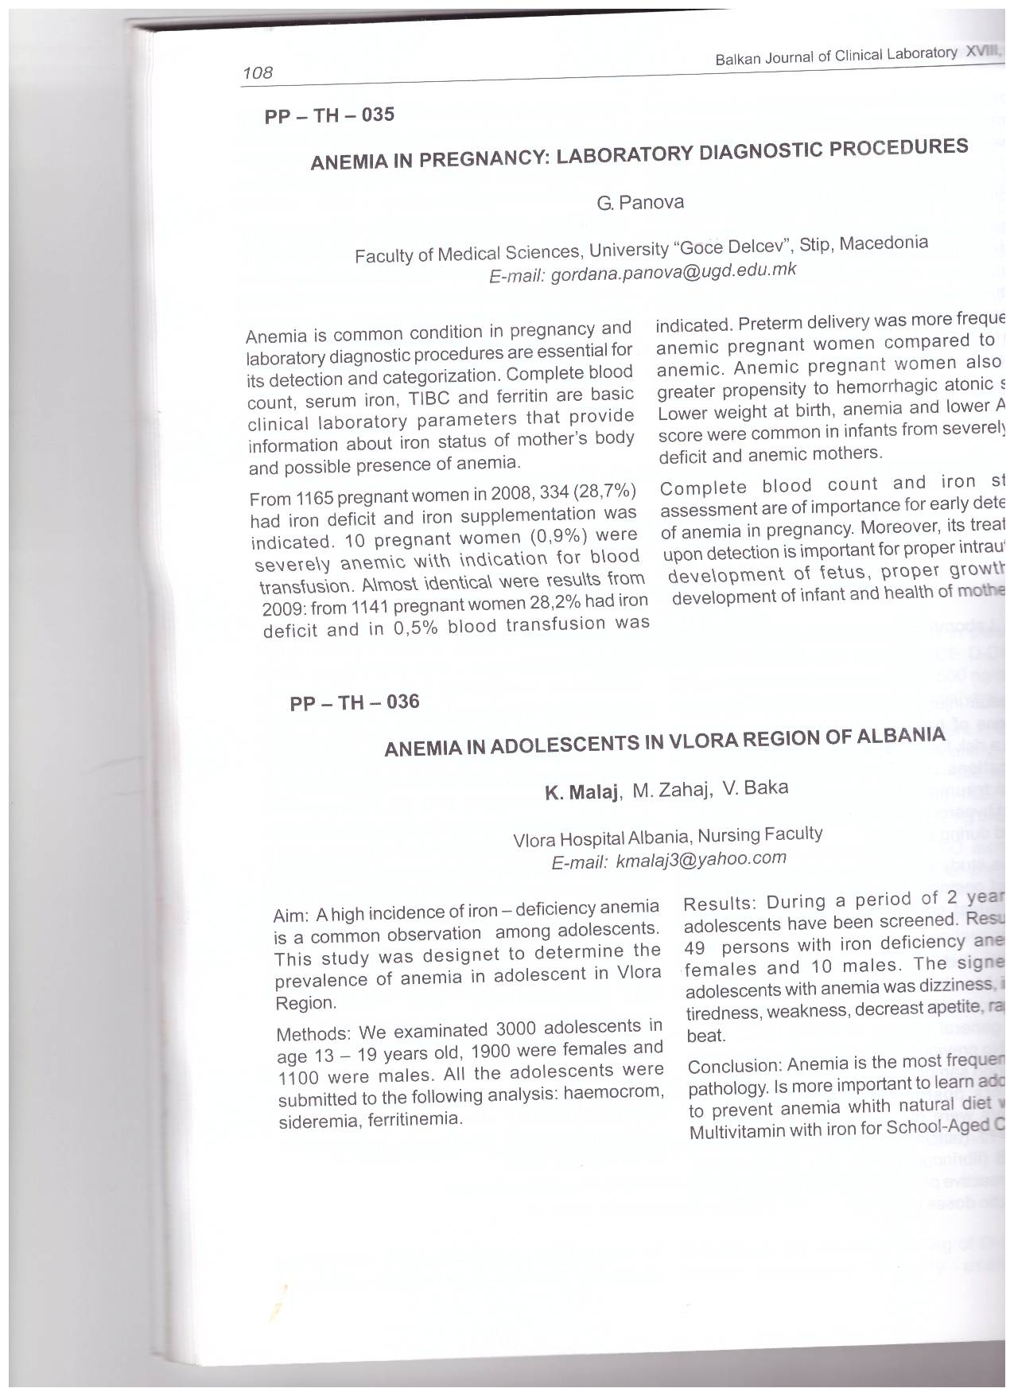

Anemia in pregnancy: laboratory diagnostic procedures

Anemia is common condition in pregnancy and laboratory diagnostic procedures are essential for its detection and categorization.
Complete blood count, serum iron, TIBC and ferritin are basic clinical laboratory parameters that provide information about iron status of mother’s body and possible presence of anemia.
From 1165 pregnant women in 2008, 334 (28,7%) had iron deficit and iron supplementation was indicated. 10 pregnant women (0,9%) were severally anemic with indication for blood transfusion.
Almost identical were results from 2009: from 1141 pregnant women 28,2% had iron deficit and in 0,5% blood transfusion was indicated.
Preterm delivery was more frequent in anemic pregnant women compared to non-anemic. Anemic pregnant women also had greater propensity to hemorrhagic atonic shok.
Lower weight at birth, anemia and lower Apgar score were common in infants from severally iron deficit and anemic mothers.
Complete blood count and iron status assessment are of importance for early detection of anemia in pregnancy. Moreover, its treatment upon detection is important for proper intrauterine development of fetus, proper growth and development of infant and health of mother.

