THE KINETIC MODELLING FROM DOMESTIC ORES USING SOFTWARE TOOLS

Aleksandar KRSTEV¹, Boris KRSTEV², Blagoj GOLOMEOV², Mirjana GOLOMEOVA², Afrodita ZENDELSKA², Zivko GOCEV³, Jordan ZIVANOVIK¹

¹Goce Delcev University, Faculty of Computer Sciences, 2000 Stip, The Republic of Macedonia, aleksandar.krstev@ugd.edu.mk
²Goce Delcev University, Faculty of Natural &Technical Sciences, 2000 Stip, The Republic of Macedonia, boris.krstev@ugd.edu.mk
³Bucim Mine, 2000 Radovis, The Republic of Macedonia, gocevz@yahoo.com
²Goce Delcev University, Faculty of Natural &Technical Sciences, 2000 Stip, The Republic of Macedonia, blagoj.golomeov@ugd.edu.mk
²Goce Delcev University, Faculty of Natural &Technical Sciences, 2000 Stip, The Republic of Macedonia, mirjana.golomeova@ugd.edu.mk
²Goce Delcev University, Faculty of Natural &Technical Sciences, 2000 Stip, The Republic of Macedonia, afrodita.zendelska@ugd.edu.mk

ABSTRACT
To improve kinetic models, many first - order flotation kinetics models with distributions of flotation rate constants were redefined so that they could all be represented by the same set of three model parameters. As a result, the width of the distribution become independent of its mean, and parameters of the model and the curve fitting errors, became virtually the same, independent of the chosen distribution function. In our case, investigations of the chalcopyrite ores are carried out using the existing or mixed model. According to the experimental results obtained in laboratory, the Classical model is most appropriate for presentation of kinetic flotation, especially by means of MATLAB modeling.
KEYWORDS
Flotation, Kinetic, Chalcopyrite, MATLAB, Modeling.

1.General information
With the increasing application of computers in the mineral industry, physical and mathematical models of each operational circuit in the mineral processing plant become elegantly needed. Flotation, as an important process of mineral processing has attracted much attention from researchers, and flotation models have been used as early as the 1930's and todays in XXI century. However due to the complexity of the flotation process and the limitations of the technology required to obtain the necessary information, most of the existing flotation models are still far from perfect.
Although the fundamentals of flotation models, i.e. the first order kinetics, have been developed, detailed information about the factors which affect flotation kinetics has still not been exact obtained. Remaining problems not only include the effect of factors, such as reagent type and concentration, air flow rate and impeller speed etc., on the parameters of flotation models, but also the flotation model itself, since most of the models are not well constructed in representing true flotation behavior.
In general, the models should follows the rules that the parameters in the model should have physical significance and the values of the parameters for one set of flotation conditions should be consistent. Flotation can be affected by many factors. Because of limited time, this research work is only devoted to a small area of flotation kinetics. In order to obtain an applicable flotation model.
2.General information about kinetic flotation models
In the existing equations for flotation kinetic the assumption is such that velocity coefficient for anyones sulphide minerals is the constant k. The number of investigators, as A. Gupta, D.S. Јuan had calculated the of group models cumulative flotation from first order considering the following models:
- Classical kinetic model, I=I_{o}[1-e^{-kt}]
- Klimpel kinetic model, I=I_{o}[1-$\frac{1}{kt}(1-e^{-kt}$)]
- Kelsal kinetic model, I = (i_{o}-ɸ)(1-$e^{-kft}$)+ (1-$e^{-kst}$)
- Modified Kelsal kinetic model – Gama model from Loveday, Innou, I=I_{o}(1-($\frac{k}{k+t}$)^{P})

The mentioned kinetic models are appropriate for presentation the flotation kinetic, very important for everyone project solution or assumption for good and sure flotation performance. According to the previous kinetic investigations for kinetic flotation (Classical kinetic model) for different sulphide minerals for copper mineral will have the following equation (chalcopyrite):
I = I_{o} [1-e^{-kt}] = 89.25 [1 – e^{- 1.025xt}]
According to previous kinetic investigations for kinetic flotation (Classical kinetic model) for different oxide - sulphide minerals constant k for copper mineral will have the following equation (65% chalcopyrite and 35% oxide minerals as cuprite, azurite, malachite):
I = I_{o} [1-e^{-kt}] = 73.5 [1 – e^{- 0.56xt}]
According to the existing kinetic investigations for kinetic flotation (Clasical kinetic model) for different oxide - sulphide minerals constant k for copper mineral will have the following equation (65% chalcopyrite and 35% oxide minerals as cuprite, azurite, malachite), but with application of process of sulphidization with Na₂S, (NH₄)₂SO₄, NH₂SO₄ :
I = I_{o} [1-e^{-kt}] = 74.2 [1 – e^{- 0.61xt}]
3.Kinetic flotation modeling of chalcopyrite using software tools
The software packets for kinetic flotation modeling in MATLAB®(R) GUI, was enabling appropriate tabular or graphic presentation for Classical kinetic model (I. Brezani, F. Zelenek), determining the constant k in the function of the time frequency of the useful reagent addition.

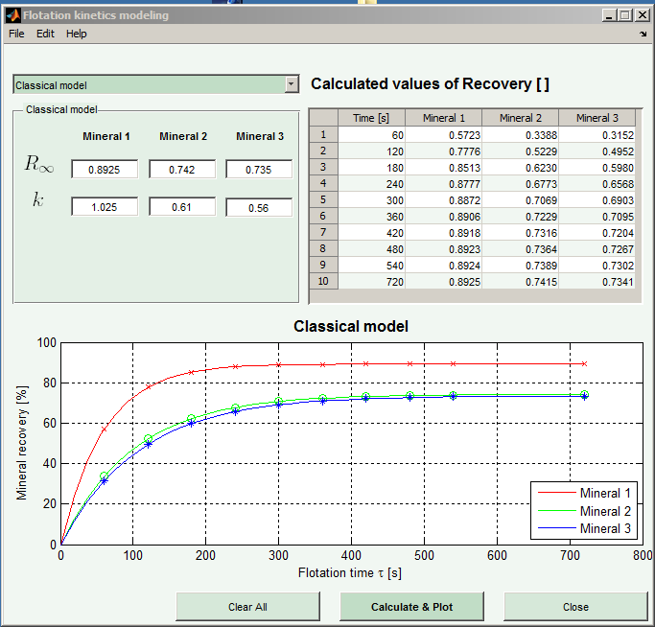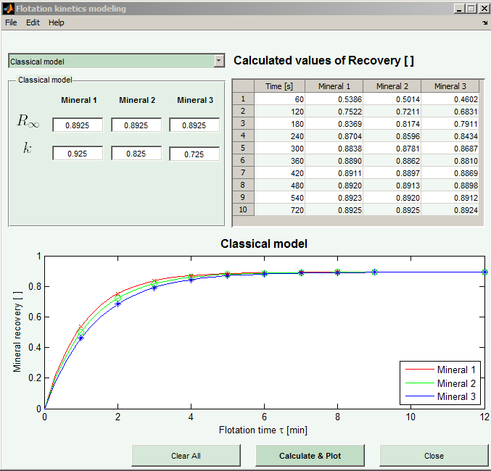
Figure 1. Kinetic presentation by Matlab Figure 2. . Kinetic presentation by Matlab

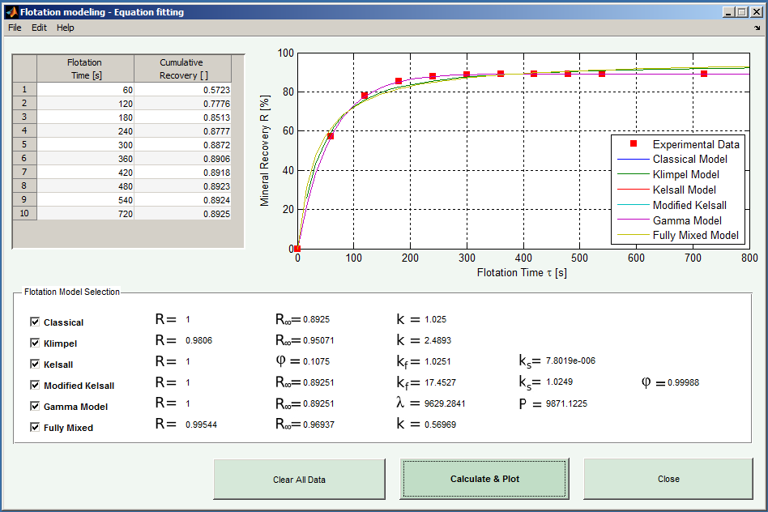
Figure 3. . Kinetic presentation by Matlab

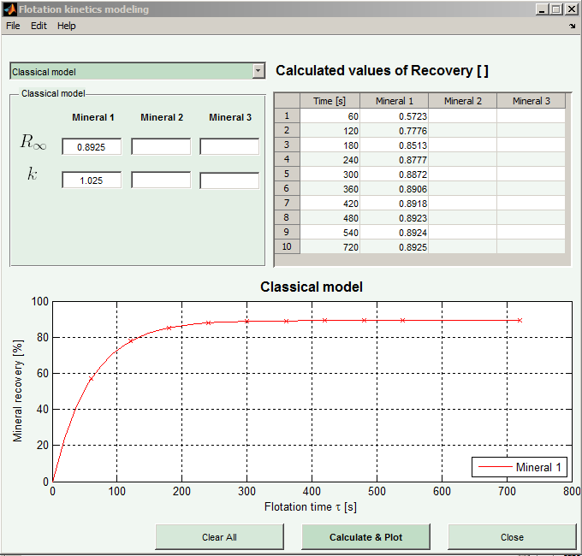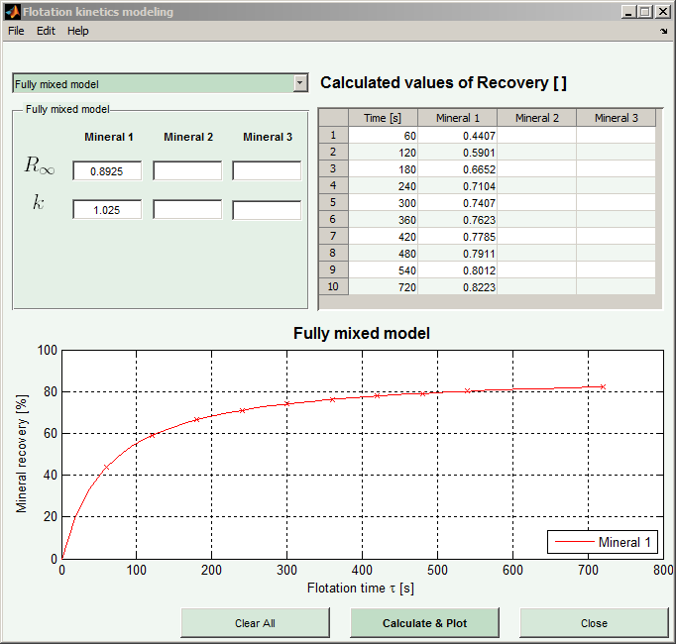
Figure 4. Kinetic presentation by Matlab Figure 5. Kinetic presentation by Matlab

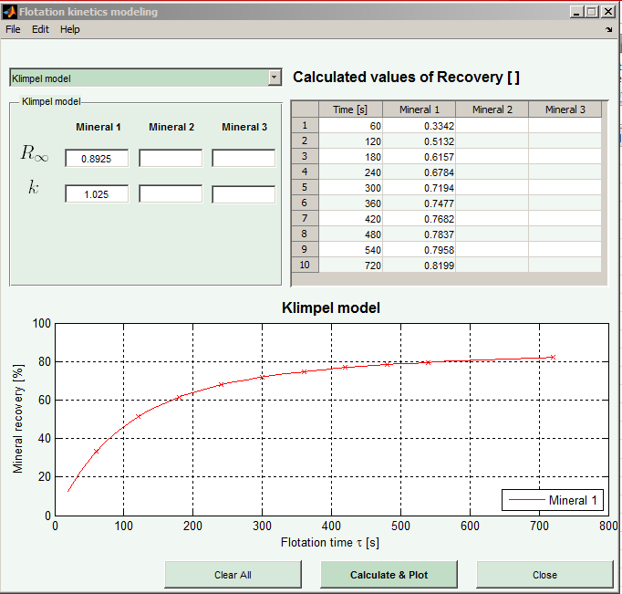
Figure 6. Kinetic presentation by Matlab

CONCLUSION
According to the experimental results obtained in laboratory and industrial conditions, for investigation of the applicable of the existing kinetic equations or models, the Classical model is most appropriate for presentation of kinetic flotation, especially by means of MATLAB modeling.

REFERENCES
[1] Brezani, I. Zelenak, F., (2010). MATLAB® tool for determining first order flotation kinetic constants., Institute of Montanneous Sciences and Environmental Protection. Technical University of Kosice,BERG Faculty,
[2] Brezani, i. Zelenak, f., (2010). Matlab® tool for modeling first order flotation kinetics., Institute of Montanneous Sciences and Environmental Protection. Technical University of Kosice,BERG Faculty,
[3] Evgun L., Ekmekci Z., Gülsoy Ö., Benzur H., (2004). “Modelling and Simulation of Grinding Circuit in Magneuli Copper Concentrator”, Physicochemical Problems in Mineral Proceding, 38(2004), 231-240, USA.
[4] Krstev A. PhD Thessis, 2012.
[5] Herbst, J. A. (1982). “The Application of Modern Control Theory to Mineral Processing Operations”, Proceedings 12th CMMI Congress. H. W. Glen, Editor, South Africa Inst. Min. Metall., Johannesburg, 779-823.

