INFORMATION TECHNOLOGIES AND USING OF THE SOFTWARE TOOLS FOR THE COPPER KINETIC FLOTATION MODELLING
A. Krstev, B. Krstev, Z. Zdravev, D. Krstev, Z. Gocev,J. Zivanovik
Goce Delcev University, Faculty of Natural&Technical Sciences, Mineral Processing Department, 2000 Stip, The Republic of Macedonia
aleksandar.krstev@ugd.edu.mk

ABSTRACT: To improve kinetic flotation models, many first-order flotation kinetics models with distributions of flotation rate constants were redefined so that they could all be represented by the same set of three model parameters. As a result, the width of the distribution become independent of its mean, and parameters of the model and the curve fitting errors, became virtually the same, independent of the chosen distribution function. In our case, investigations of the chalcopyrite ores are carried out using the Classical model, Klimpel Model and Fully mixed model. According to the experimental results obtained in laboratory, the Classical model is most appropriate for presentation of kinetic flotation, especially by means of MATLAB modeling.
Key words: INVESTIGATION, MODELLING, KINETIC, MATLAB, BUCIM

- INTRODUCTION
In the existing equations for flotation kinetic the assumption is such that velocity coefficient for anyones sulphide minerals is the constant k. The number of investigators, as A. Gupta, D.S. Јuan had calculated the of group models cumulative flotation from first order considering the following models:
- Clasical kinetic model, I=I_{o}[1-e^{-kt}]
- Klimpel kinetic model, I=I_{o}[1-$\frac{1}{kt}(1-e^{-kt}$)]
- Kelsal kinetic model, I = (i_{o}-ɸ)(1-$e^{-kft}$)+ (1-$e^{-kst}$)
- Modified Kelsal kinetic model – Gama model from Loveday, Innou, I=I_{o}(1-($\frac{k}{k+t}$)^{P})

The mentioned kinetic models are appropriate for presentation the flotation kinetic, very important for everyone project solution or assumption for good and sure flotation performance. According to the previous kinetic investigations for kinetic flotation (Clasical kinetic model) for different sulphide minerals for copper mineral will have the following equation (chalcopyrite):
I = I_{o} [1-e^{-kt}] = 89.25 [1 – e^{- 1.025xt}]
According to previous kinetic investigations for kinetic flotation (Clasical kinetic model) for different oxide - sulphide minerals constant k for copper mineral will have the following equation (65% chalcopyrite and 35% oxide minerals as cuprite, azurite, malachite):
I = I_{o} [1-e^{-kt}] = 73.5 [1 – e^{- 0.56xt}]
According to the existing kinetic investigations for kinetic flotation (Clasical kinetic model) for different oxide - sulphide minerals constant k for copper mineral will have the following equation (65% chalcopyrite and 35% oxide minerals as cuprite, azurite, malachite), but with application of process of sulphidization with Na₂S, (NH₄)₂SO₄, NH₂SO₄ :
I = I_{o} [1-e^{-kt}] = 74.2 [1 – e^{- 0.61xt}]
- Kinetic flotation modeling of chalcopyrite using software tools
The software packete for kinetic flotation modeling in MATLAB®(R) GUI, was enabling appropriate tabular or graphic presentation for Clasical kinetic model (I. Brezani, F. Zelenek), determining the constant k in the function of the time frequency of the useful reagent addition.
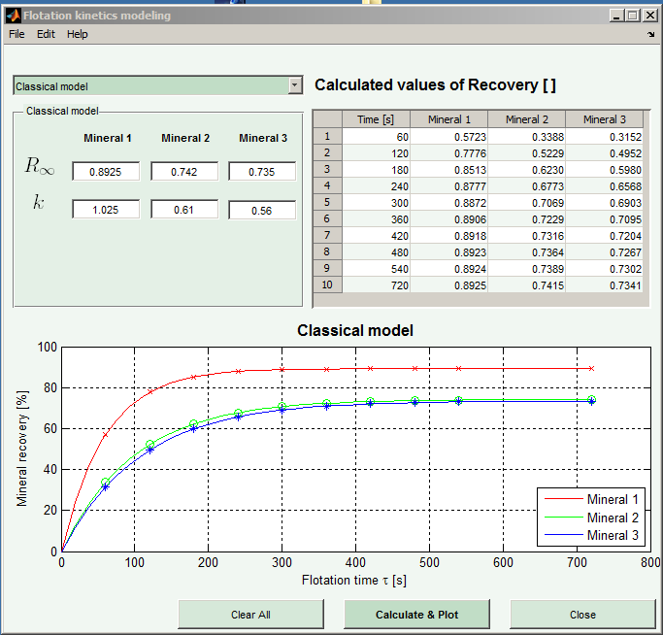
Figure 1. Kinetic presentation by Matlab
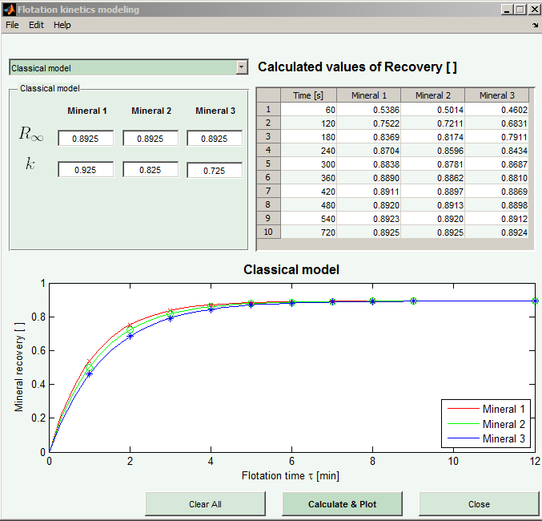
Figure 2. . Kinetic presentation by Matlab
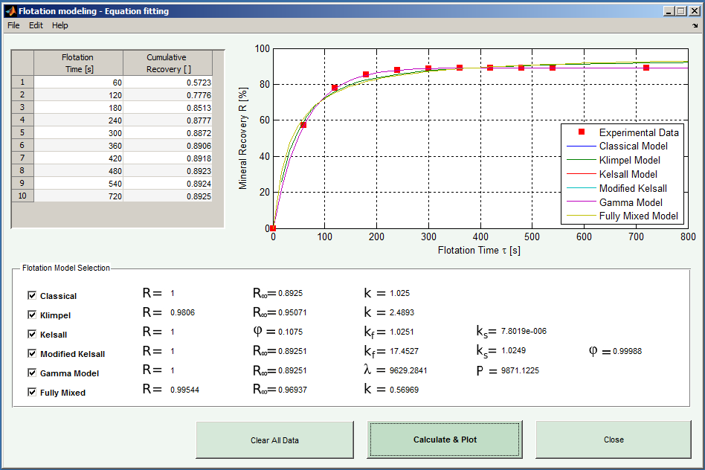
Figure 3. . Kinetic presentation by Matlab
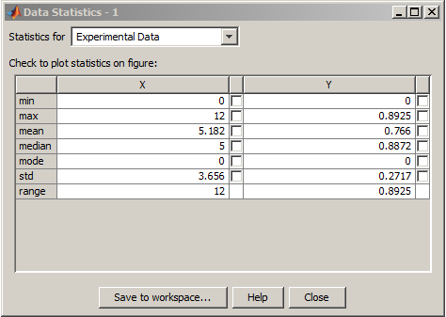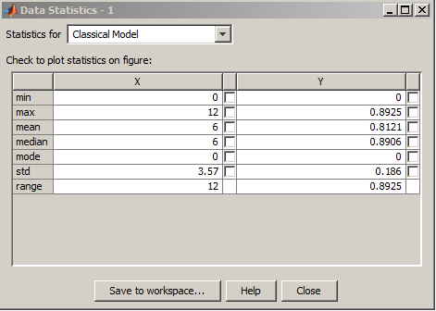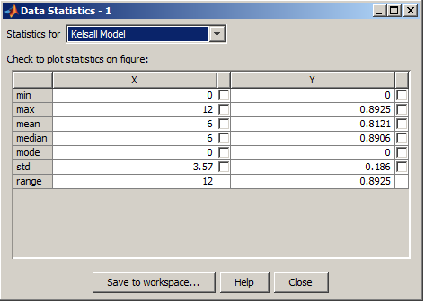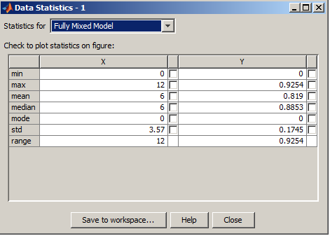
Figure 4.Results in total

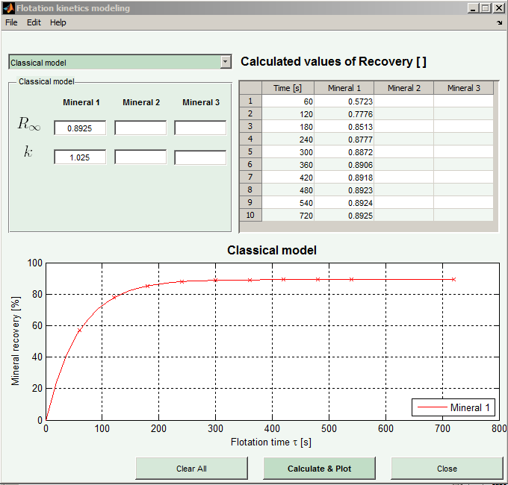
Figure 5. Kinetic presentation by Matlab

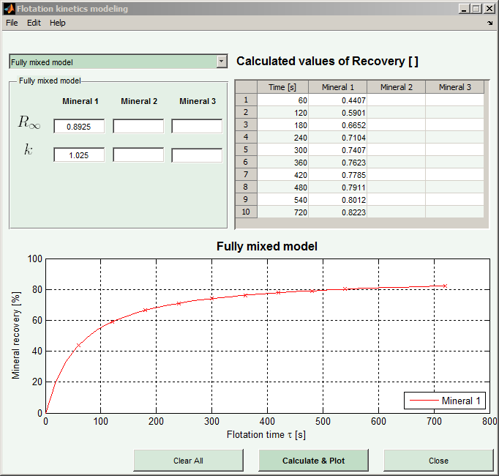
Figure 6. Kinetic presentation by Matlab
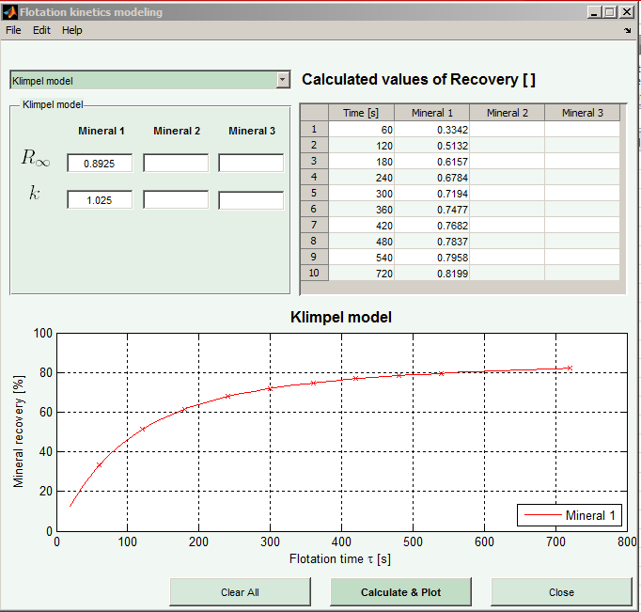
Figure 7. Kinetic presentation by Matlab

CONCLUSION
According to the experimental results obtained in laboratory and industrial conditions, the Classical model is most appropriate for presentation of kinetic flotation, especially by means of MATLAB modeling.

REFERENCES
[1] Brezani, I. Zelenak, F., (2010). MATLAB® tool for determining first order flotation kinetic constants., Institute of Montanneous Sciences and Environmental Protection. Technical University of Kosice,BERG Faculty,
[2] Brezani, i. Zelenak, f., (2010). Matlab® tool for modeling first order flotation kinetics., Institute of Montanneous Sciences and Environmental Protection. Technical University of Kosice,BERG Faculty,
[3] Evgun L., Ekmekci Z., Gülsoy Ö., Benzur H., (2004). “Modelling and Simulation of Grinding Circuit in Magneuli Copper Concentrator”, Physicochemical Problems in Mineral Proceding, 38(2004), 231-240, USA.
[4] Krstev A. PhD Thessis, 2012.
[5] Herbst, J. A. (1982). “The Application of Modern Control Theory to Mineral Processing Operations”, Proceedings 12th CMMI Congress. H. W. Glen, Editor, South Africa Inst. Min. Metall., Johannesburg, 779-823.
.

