TRANSLATION, TORSION, AND WAVE EXCITATION OF A BUILDING DURING SOIL-STRUCTURE INTERACTION EXCITED BY AN EARTHQUAKE SH PULSE
by
Vlado Gičev¹, Mihailo D. Trifunac², and Nebojša Orbović³

¹ Univ. Goce Delčev, Dept. of Computer Science, Tošo Arsov 14, 2000 Štip, R. Macedonia
² Univ. Southern California, Dept. of Civil Eng., Los Angeles, California 90089-2531, USA
³ Canadian Nuclear Safety Commission, 280 Slater St., Ottawa, Ontario, Canada, K1P 5S9

ABSTRACT

A two-dimensional (2-D) model of a building supported by a rectangular, flexible foundation embedded in the soil is analyzed. The building, the foundation, and the soil have different physical properties. The building is assumed to be linear, but the soil and the foundation can experience nonlinear deformations. While the work spent for the development of nonlinear strains in the soil can consume a significant part of the input wave energy—and thus less energy is available for the excitation of the building—the nonlinear response in the soil and the foundation does not signficantly alter the nature of excitation of the base of the building. It is noted that the response of a building can be approximated by translation and torsion of the base for excitation by long, strong motion waves.

Keywords: nonlinear soil-structure interaction; nonlinear waves in the soil; partition of incident earthquake energy into translation, torsion and wave motion.

INTRODUCTION

The classical approach to the analysis and design of earthquake-resistant structures continues to be based on the vibrational solution of the response problem in terms of the Response Spectrum Method (RSM), which was introduced in the early 1930s (Biot 1932, 1933, 1941, 1942; Gupta and Trifunac 1988a; Udwadia and Trifunac 1974). RSM represents a structural system by de-coupled mode shapes of vibration, and the vibration associated with each mode shape is in turn represented by its equivalent single degree of freedom system (SDOF). Excitation is assumed to consist only of the horizontal component of ground motion, which is synchronous at all points of the base of a structure; i.e., the excitation by the wave passage is not considered. The nature of the model of Biot’s SDOF does allow for a response analysis of simultaneous excitation by translational and rotational (torsion and rocking) components of strong ground motion, but as of yet, most RSM engineering applications have ignored the contributions of the rotational excitation.

Corresponding author: M.D. Trifunac, Professor of Civil Eng., Tel: (213) 740-0570, Fax: (213) 744-1426, E-mail: trifunac@usc.edu

Such simplifications do produce reasonable approximations for the response analyses in structural design far away from the faults in regions of moderate and small shaking, and for structures with small plan dimensions. However, for structures with large plan dimensions, or with multiple supports, wave propagation along the base of the structure must be considered.

Figure 1 shows ground displacement at an instant in which the wave is propagating along the base of a structure. For a structure whose base dimensions are an order of magnitude smaller than the wavelengths of ground motion, excitation of the base of the structure can be approximated by the translation and the corresponding rotation. For example, if the motion in Fig. 1 represents the ground motion associated with in-plane motions comprised of P, SV, and Rayleigh waves, the excitation of the base would include horizontal and vertical translations and rocking about the horizontal axis perpendicular to the direction of propagation. If the motion in Fig. 1 represents horizontal out-of-plane motions associated with SH and Love waves, it then also includes torsional excitation about a vertical axis. For a structure with small plan dimensions, these rotations can be approximated by point rotations on the ground surface, and the RSM can be modified to include simultaneously the action of translational and rotational excitations. However, for large or long structures—for example, a large dimension nuclear island or a bridge with columns supported by individual foundations— different columns will be excited by different translational and rotational components. In addition, each span of the bridge will be excited by the cord rotations. Consequently, for structures with large plan dimensions, the differential strong motion (Trifunac and Todorovska 1997; Trifunac and Gičev 2006) or complete wave motion must be considered in the determination of the associated responses (Jalali and Trifunac 2007, 2008, 2009, 2011; Jalai et al. 2007, 2013).

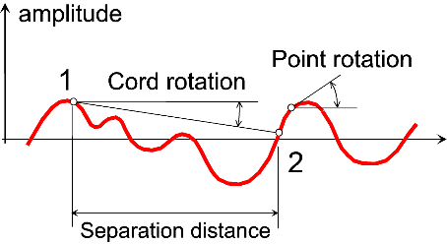

Fig. 1. Point and cord rotations.

The role and the relative contribution of torsional and rocking point excitations to the overall structural response have been studied extensively, and the subject has been reviewed in Trifunac (2006, 2008a, 2009a, b). The quantitative description of its relative role in terms of the probabilistic description of response can be found in Gupta and Trifunac (1987, 1988 b, 1989, 1990a, b, c, 1991, 1999).

It is known from theoretical investigations of soil structure interaction (SSI) that rigid foundations scatter considerable energy of incident seismic waves, and that this scattering depends on the foundation shape and its relative stiffness (Gičev 2005; Hayir et al. 2001; Todorovska and Trifunac 1993; Todorovska et al. 2001; Wong and Trifunac 1974). While this scattered energy is relatively small for actual foundations of buildings, as those are never as rigid as their mathematical models (Lee et al. 1982; Ivanović et al. 2000; Trifunac et al. 1999), the scattering from flexible foundations still plays an important role in bringing about pockets of nonlinear soil deformation, which then leads to increased effective compliances and their asymmetry (Gičev and Trifunac 2012a, b). Observations of the response of full-scale structures to earthquake shaking show how prominent these nonlinearities in the soil structure systems can be (Luco et al. 1987; Trifunac et al. 2001a, b, c, d).

Advanced large-scale numerical simulations have been developed for analyses of dynamic response of soils, including nonlinear representation and complex geometry of foundations (Elgamal et al. 2008; Prevost 1993; Zhang et al. 2008). Large numerical models are necessary for engineering analyses in realistic settings, but detailed interpretations of some of the results becomes a challenge due to simultaneous action of their many complex features. In this paper, with the aim of analysing and interpreting only a subset of the phenomena—which accompany the nonlinear response of soil, foundation, and structure in the presence of soil-structure interaction—but without loss of accuracy and without reducing the completenss in describing the physical phenomenon, we analyze only the most elementary representation of wave motions and adopt a bi-linear yielding model for both the foundation and the soil. With calculations based on finite differences, this model then enables us to study how a wave motion from the foundation enters the building at its base.

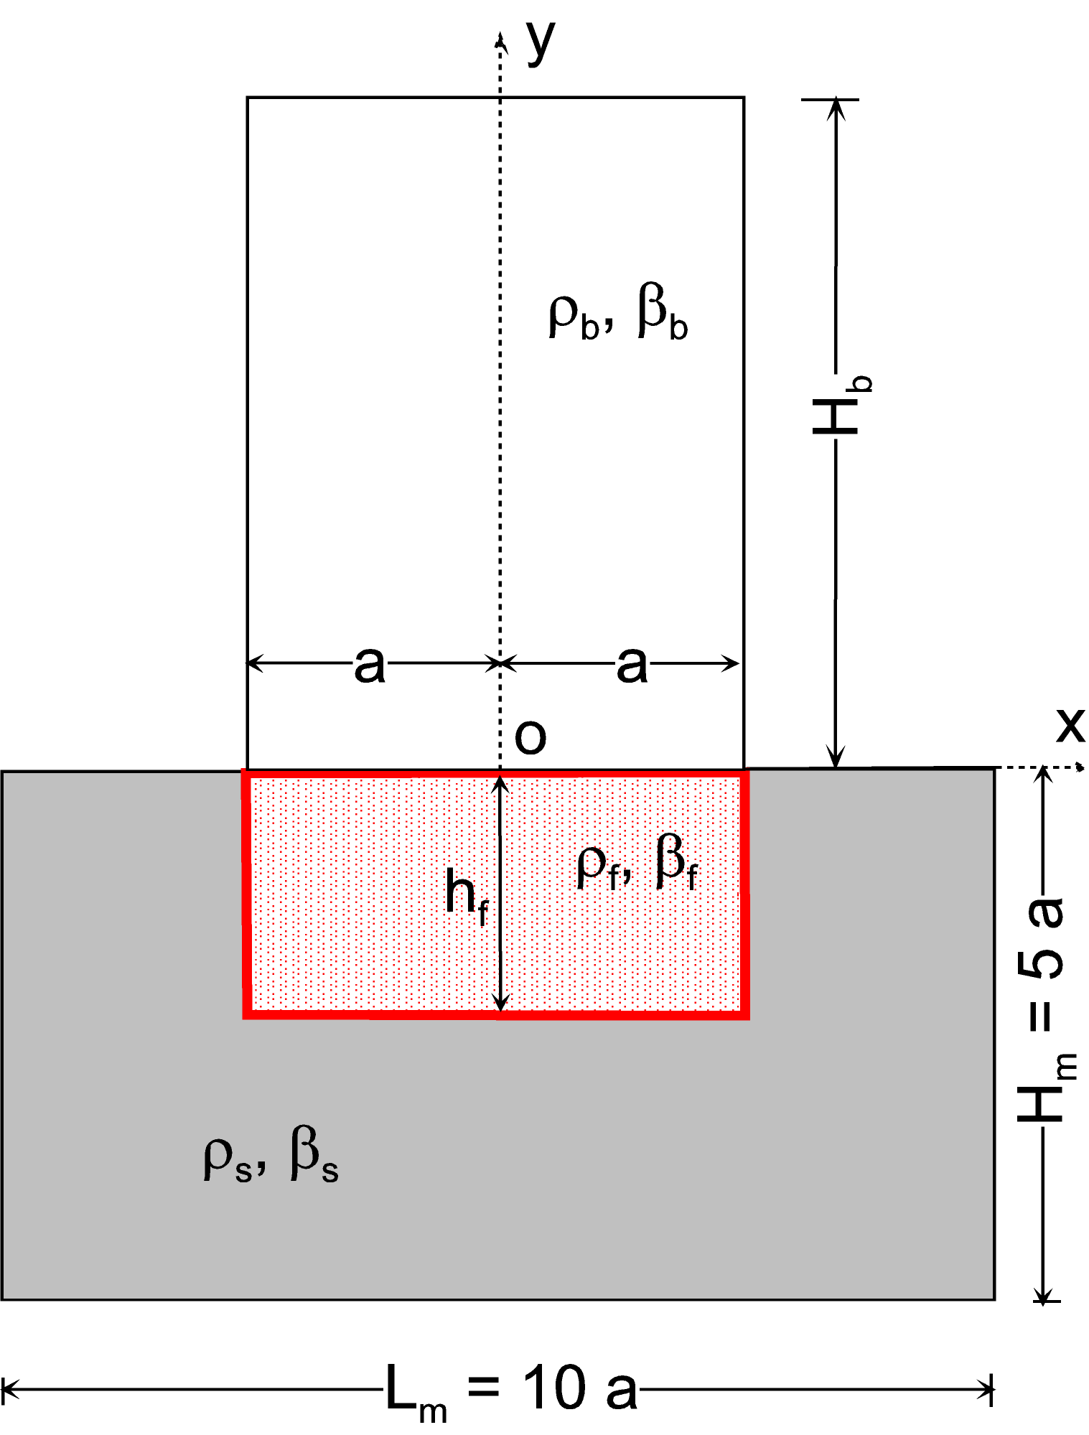

Fig. 2. Soil-flexible foundation-linear structure system with linear or nonlinear soil and foundation.

Nonlinear site response is a complex problem that involves many geometrical and material parameters in the description of the governing models and in which extrapolations are at best very difficult, due to the chaotic nature of large excitation and large nonlinear response (Lee and Trifunac 2010; Gičev and Trifunac 2012b; Gičev et al. 2012; Trifunac 2008b). Hence, in the following, our goal will be to illustrate only what may occur in the presence of nonlinearities in the soil and in the foundation during SSI, while the building remains linear. Comprehensive sensitivity studies of how these results depend on all governing parameters are beyond the scope of this paper. Furthermore, we will consider only the simple site environment in which the excitation consists of a displacement pulse incident through a homogeneous segment of soil near the ground surface. We will not consider complexities that result from site layers, which lead to dispersed incident wave motion, from three-dimensional irregularities of the site properties or from the wave scattering and diffraction by neighboring structures (Lee et al. 2014a,b; Wong and Trifunac 1975).

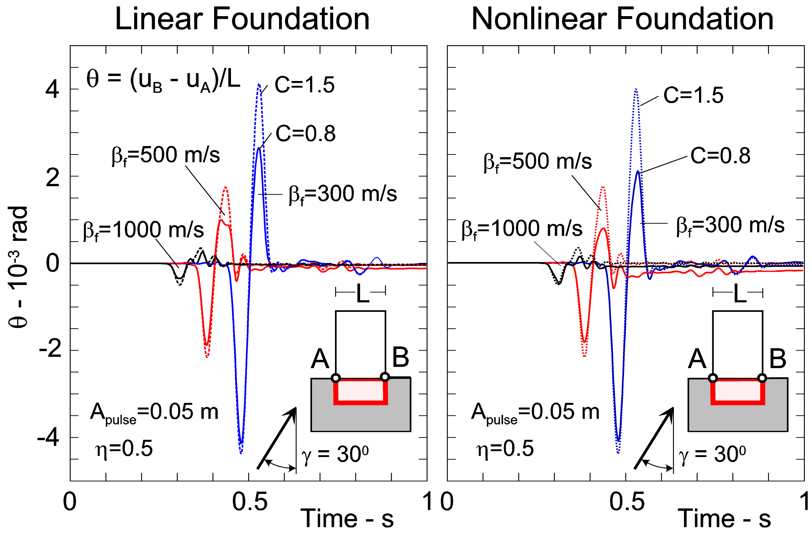

Figure 3. (Left) Cord rotations between points A and B on the building-foundation interface, for intermediate nonlinearity in the soil (C = 1.5, see Appendices A and B), for large nonlinearity in the soil (C = 0.8), and for linear deformations in the foundation. (Right) Corresponding cord rotations for intermediate nonlinearity in the soil (C = 1.5, see Appendices A and B), for large nonlinearity in the soil (C = 0.8), and for nonlinear deformations in the foundation.

The 1-D nature of the building response on the rigid foundation eliminates the possibility of exciting torsion in the building (rotation about the vertical axis in Fig. 2) due to wave passage effects, and for all incident angles. However, the wave passage along the base of the building for flexible foundation deforms the building as the wave propagates along the foundation width. For long waves, this excitation of the building can be approximated by out-of-plane translation combined with torsion of the base. We illustrate this by computing the cord rotation between the two corner points at the base of the building (points A and B in Figs. 3a, b). We show this cord rotation vs. time in Fig. 3a, for the case of nonlinear soil and linear but deformable foundation, and for the case of nonlinear soil and nonlinear foundation in Fig. 3b. As would be expected, this “torsion” becomes small and approaches zero as (i.e., stiffness of the foundation) increases. For the model parameters chosen in this example, and for excitation by long waves, this torsion also decreases with increasing nonlinearity in the soil response and is largest for linear soil response. Comparing Figs. 3a and 3b, we conclude that time histories of the cord rotation of both models are similar. The findings in both figures also show small permanent deformations in the soil, which results in permanent (nonzero) cord rotations between points A and B, after the pulse has gone out from the system.

For the 2-D model shown in Fig. 2, it can be shown (Gičev and Trifunac 2012a, b) that for non-vertical incidence of long SH waves and flexible foundation, the wave motion excites translation and torsion at the base of the building. For dimensionless wavelength ratio, between 0 and ~ 0.25, where is half the width of the building and is the wavelength of incident waves, the motion of the base of the building can be approximated by point translation and point torsion. As increases beyond ~ 0.25, that is as the wave length becomes shorter than four widths of the foundation, and as the soil below the foundation experiences nonlinear deformations, representing excitation by one translation and one torsion at the base of the building ceases to be adequate, and wave propagation must be considered. This is illustrated in Fig. 4, where different foundation stiffness is expressed via shear wave velocity in foundation . The accompanying motion forcing the displacement of the building’s base must also then be described in terms of wave propagation.

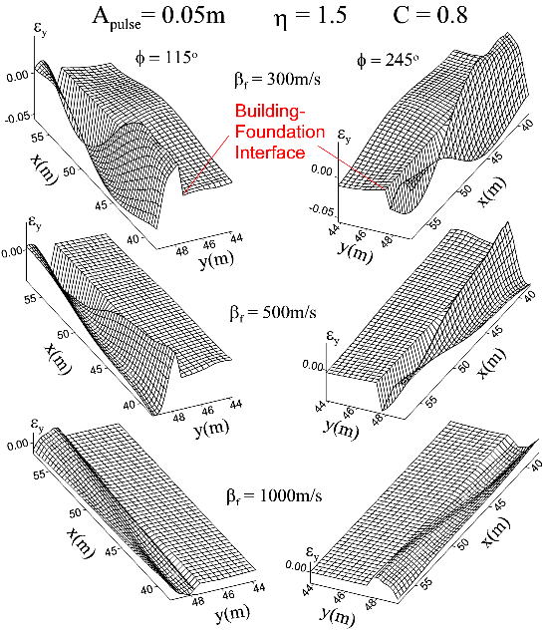

Fig. 4. Distribution of vertical (shear) strains in the narrow strips above and below the building-foundation interface for = 1.5 and large nonlinear response in the soil (C = 0.8, see Appendix A), different rigidities of the foundation expressed via shear wave velocity ( = 300, 500, and 1000 m/s), and for linear deformations of the foundation. Two views are shown for = 115º and 245º, measured clockwise from the vertical axis pointing down (redrawn from Gičev and Trifunac 2012a, b). The building is linear, with = 100 m/s and = 270 kg/m³ for all examples in this paper.

The wave passage along the base of the building will also increase the vertical shear strains at the base of the building, especially near corners (points A and B), and will result in their time and space variations. This increase will depend on the relative stiffness of the building in translation and in torsion, as well as on the horizontal wavelength of the motion propagating from the foundation into the building (Todorovska and Trifunac 1989, 1990). A related discrete model of a rigid long mass (“building”) on multiple columns suggests that this amplification can be considerable (Jalali and Trifunac 2011). We illustrate this qualitatively in Fig. 4, at the time when the wave begins to enter the building. We show the amplitudes of vertical strain in a narrow zone above and below the building- foundation interface. It is seen that while the presence of nonlinear response in the soil and the scattering of incident waves from the flexible foundation contribute to the reduction of seismic wave energy entering the building, the building excitation and its response become more complex and require analysis in terms of 2-D wave propagation (Gičev and Trifunac 2012a, b).

To describe the nature of seismic excitation of the base of a building, and in particular to find the range of dimensionless frequencies for which it can no longer be described by point translation and point torsion, in this paper we investigate the model shown in Fig. 2 for excitation by a displacement pulse consisting of a half-sine wave (Fig. 5). We present all results vs. dimensionless wavelength ratio . We also show the separation of translational and rotational wave energies at the interface of the building and its foundation for in the range between 0 and 2. This interval is sufficient to characterize the response in the range spanning: (1) long wave lengths (when the motions at the base of a structure can be described adequately with translations only) and where the classical RSM can provide good approximations; (2) intermediate range, where point translation and point rotation together can describe the motion at the base of a structure for the RSM, which can give a sufficiently accurate representation of the total response and; and (3) short wave range when the motion at the base of a structure cannot be described by one point translation and one point rotation, so that the RSM cannot be used, and where the wave propagation method of solution is required. Which of these regimes will have to be used in the dynamic response analyses of SSI will also depend upon the spectral content of the entire train of strong motion waves exciting the soil-structure system and on the relative stiffness of the local site conditions. It can be shown that for the local soil conditions for which the shear wave velocity in the soil near ground surface is ~300 m/s and higher, strong motion amplitudes are dominated by intermediate and long waves such that the motion of large areas on the surface of the half-space (e.g., 100 x 100 m) can be described adequately by point translations and rotations only (Ding et al. 2015). For other excitations, such as ground waves generated by explosions, the high-frequency content of strong motion will be considerably higher and the wave method of solution will be required for adequate description of deformations and internal forces in the structure (Negmatullaev et al. 1999).

MODEL

Our numerical model is comprised of a building sitting on a linear or nonlinear rectangular foundation, which is embedded in nonlinear soil (Fig. 2), excited by a half-sine pulse, and incident with angle relative to vertical. It is assumed that all interfaces between the building and foundation, and foundation and soil remain continuous, that is no separation or uplifting are allowed. The height of the building is H_{b}, while the building width is . The building is assumed to remain linear, with shear wave velocity = 100 m/s and material density = 270 kg/m³, for all examples in this paper. The foundation depth is , and its width is the same as building width . The soil island in our model has width and height (Fig. 2). The densities of the building, foundation, and soil are ( = 270 kg/m³, = 2000 kg/m³, and = 2000 kg/m³, while the shear wave velocities are ( = 100 m/s, = 250 to 1000 m/s, and = 250 m/s). In our example, we take that the foundation depth is half of the building width

We stop the computation at time T_{s}, when a complete filtered pulse (Fig. 5) passes the right point on building-foundation interface B (shown in Figs. 3a, b).

, (1)
where and are vertical and horizontal phase velocities of SH wave propagating in soil, and (Fig. 2) are the width and the height of the soil island, is half-width of the building, and is duration of the half-sine pulse. After this time, no more energy enters the building.

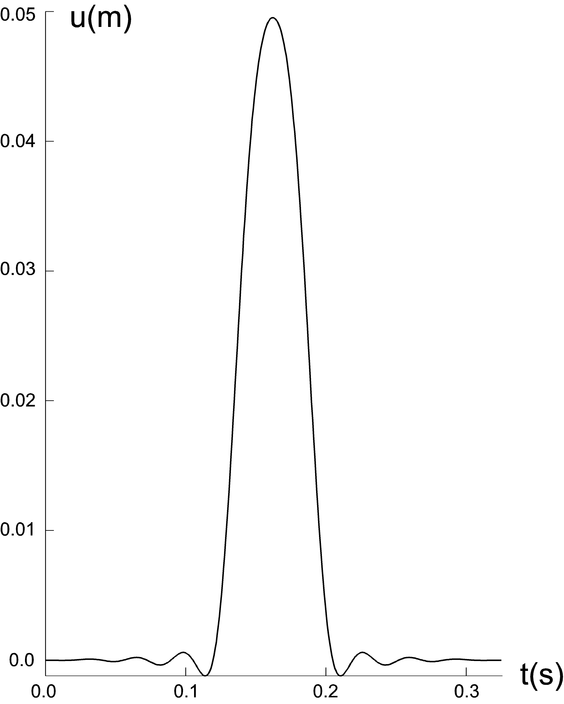

Figure 5. The filtered input displacement pulse.

Because we wish to investigate only the energy entering the building, we vary the height of the building,. This height is computed from the condition that the front of the wave reaching point A (see Figs. 3a, b), going to the top of the building and then coming back, does not reach the building-foundation interface when the complete pulse passes the right point on the building-foundation interface and when we stop the computation. The shortest time the wave needs to come from the left-bottom corner of the model to the left-bottom corner of the building and then reflect from the top and reach the building- foundation interface is:
. (2)

The required condition for computing the height of the building is then , or

. (3)

From (3) and having in mind , we compute the required height of the building as .

The nonlinear parameters of the model are described in Appendices A and B.

To analyze what part of the energy entering the building is associated with translational motion of the foundation-building interface and what part can be represented by torsional motion, as well as for larger by wave motion of this interface, we proceed as described in Appendix C.

RESULTS

As can be seen from Fig. 6, for small angles of incidence and for small dimensionless frequencies η, the translational-motion contribution in the energy entering the building is dominant. For vertical incidence and foundation stiffness equal to soil stiffness, the distribution of energy depends only weakly on . Almost all of the energy entering the building (about 95%) is due to translational motion of the points on the building-foundation interface. A small amount of energy associated with nontranslational motion (about 5%) is associated with lateral changes in the model stiffness at corner points A and B (Figs. 3a, b), which become secondary sources of cylindrical waves. This leads to different displacements at the interface points, which cause some small amount of “non-planar wave” energy entering the building. As the foundation becomes stiffer than the soil, higher frequencies enhance this effect of lateral heterogeneity of motion at the foundation-building interface, and the energy associated with the nontranslational motion increases with increasing .

As the angle of incidence increases, the part of energy due to nontranslational motion increases rapidly. This increase is larger for softer foundations. In models with stiff foundations, due to a high velocity of propagation in the foundation, the effects of wave passage and torsion are smaller than in models with soft foundations, so the amount of “nontranslational” energy in the building is also smaller. From Fig. 6, it can be seen that as becomes large, the contribution of translational energy approaches zero.

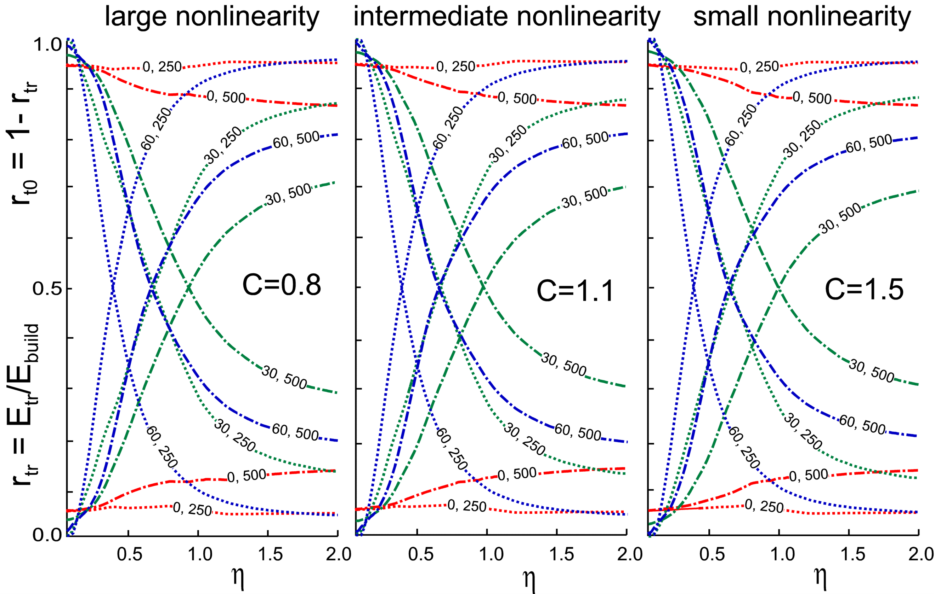

Fig. 6. The contribution of translational (curves emanating from ) and then torsional followed by wave motions (curves emanating from ) to the total energy entering the building for three levels of nonlinearity (C= 0.8, 1.1, and 1.5; see Appendix B) in the soil and three incident angles = 0°, 30°, and 60°. Shear wave velocity in the soil is = 250 m/s. Relative rigidity in the foundation is modeled via shear wave velocity = 250 and 500 m/s. The curves are labeled—for example (0, 500)—for = 0° and = 500 m/s.

Because the translational excitation of the building is mainly due to “rigid part” of motion of the foundation, this motion is progressively less excited as η increases. With this increase, the average motion of the interface points approaches zero and the entire incident energy is carried by the waves.

To further clarify the nature of the excitation and response of the building, in Fig. 7a we show displacements of a nonlinear soil-nonlinear foundation-linear building system with level of nonlinearity C = 1.1 for two angles of incidence, θ = 30⁰ and θ = 60⁰, at three time instances: (1) t1 = , when the initial amplitude of the incident pulse reaches the midpoint on the foundation-building interface, (2) t2 = t1 + , when the initial amplitude of the pulse reaches the top of the building, and (3) t3 = t2 + , when the amplitude of the reflected pulse from the top of the building reaches the foundation-building interface.

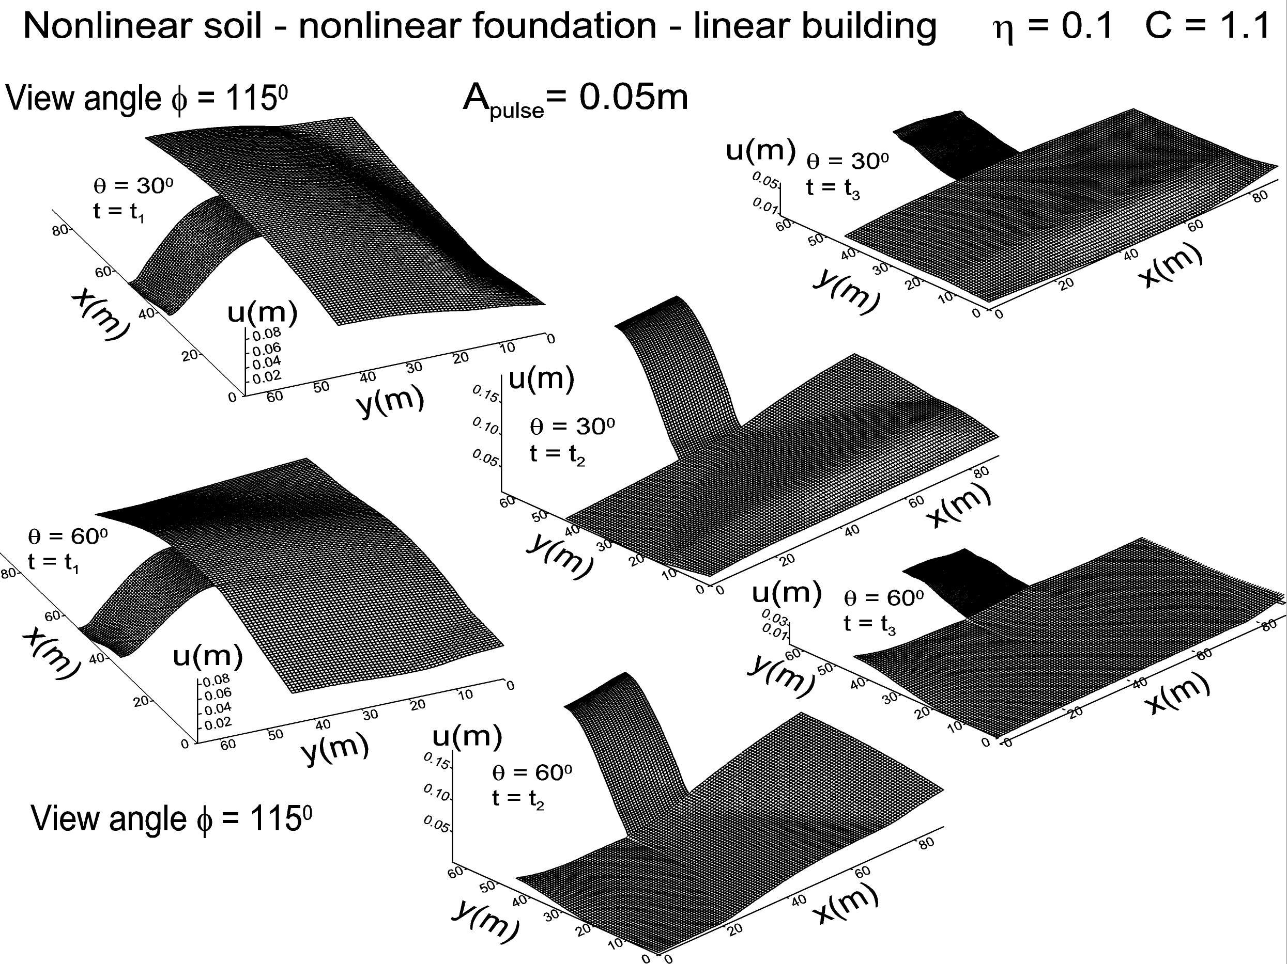

Figure 7a. Displacements in the nonlinear soil-nonlinear foundation-linear building for level of nonlinearity in soil C = 1.1, = 0.1, = 300 m/s for two angles of incidence = 30⁰ and = 60⁰ at three time instances: t = t1, when the pulse reaches the midpoint of the foundation-building interface; t = t2, when the pulse reaches the top of the building; and t = t3, when the reflected pulse from the top reaches the foundation- building interface.

It can be seen that for θ = 30⁰, immediately after reflection of the wave from the free surface, there is permanent displacement on and below the free surface due to large amplitudes of wave motion in the soil caused by incoming and reflected-wave
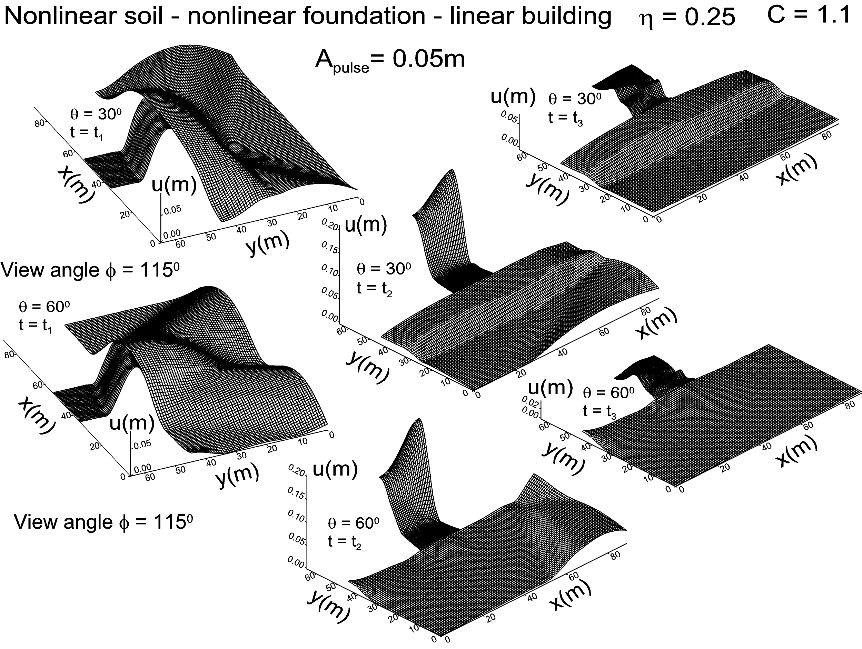

Fig. 7b. The same as in Fig. 7a except for = 0.25.

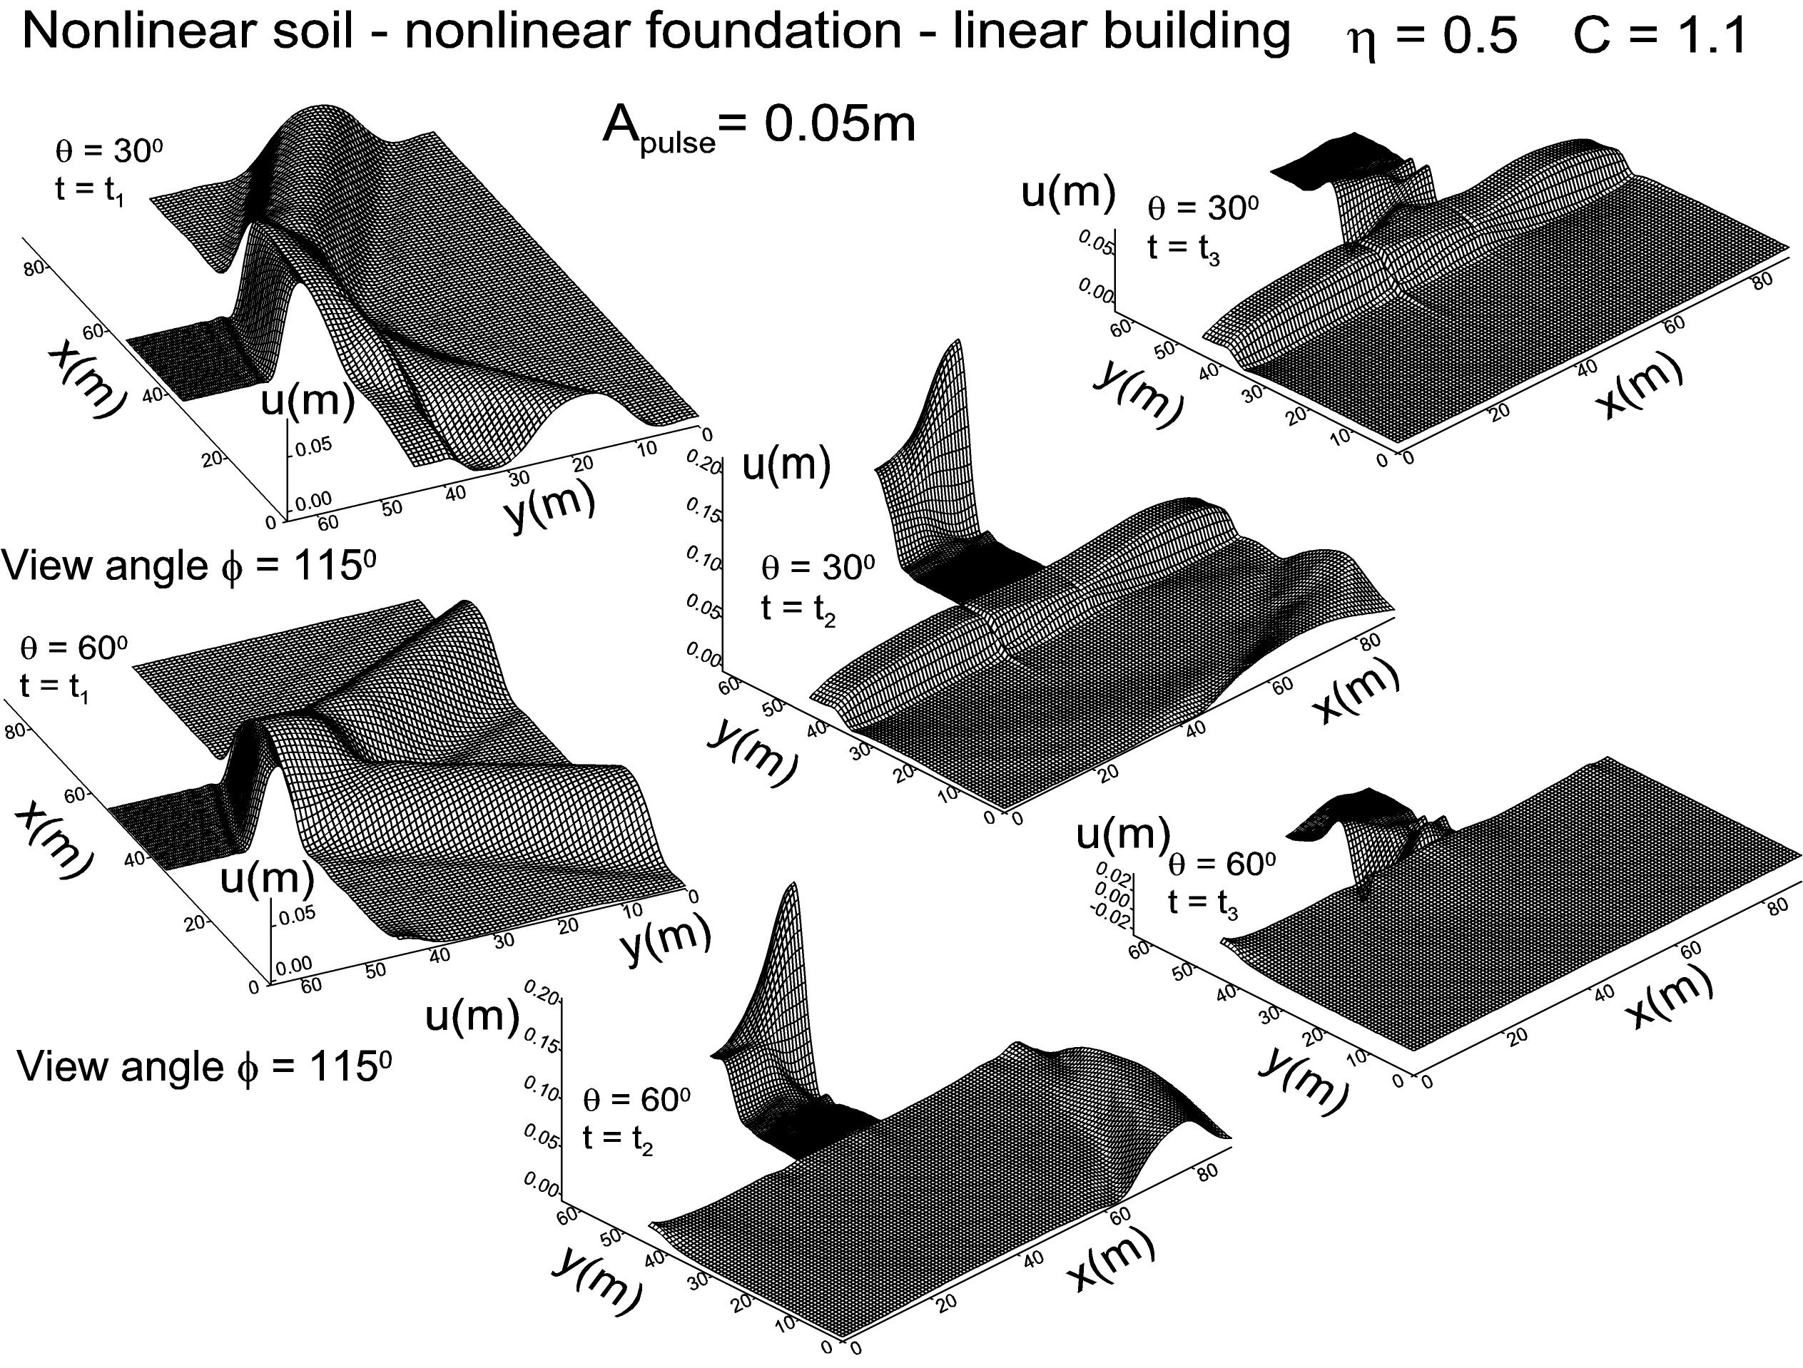

Fig. 7c. The same as in Fig. 7a except for = 0.50.

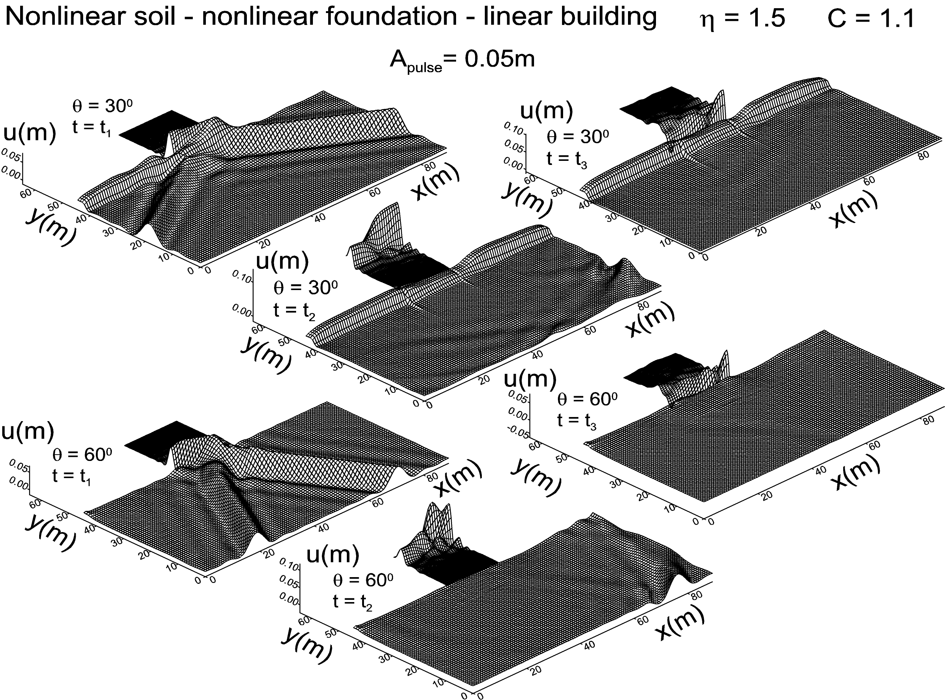

Fig. 7d. The same as in Fig. 7a except for = 1.50.

interference from the left surface of the foundation. For θ = 60⁰, the amplitude of this interference is smaller and thus causes smaler, permanent strains. Also, at time t1, it is obvious that “nontranslational-motion” contribution for θ = 60⁰ is higher due to lower phase velocity of waves along the building-foundation interface.

A comparison of the results in Figs. 7a–7d shows that the response of the building can be approximated by excitation of the base comprised of translation and torsion when is smaller than about 0.25—i.e., when the length of incident motion is longer than four widths of the base of the building ().

The largest torsional excitation of the building occurs near . This is confirmed in Fig. 8, which shows the vertical (shear) strains at the left- and right-bottom ends of the building. The consequences of this can also be seen in numerous photographs of buildings damaged by earthquakes that show a large shear deformation in corner columns.

DISCUSSION AND CONCLUSIONS

In this paper we illustrated a 2-D phenomenon associated with propagation of a displacement pulse through linear and nonlinear foundations. In contrast to the simplified SSI analyses, which assume rigid foundations, it is seen that flexible foundations allow the intermediate and short waves to enter the foundation-building interface and to carry the short wave energy into the building. The consequence of this is that the building response becomes spatially complex to a degree that it is no longer possible to use the RSM to describe the largest deflections, shears, and moments required for engineering design. As can be seen from Figs. 7a–7d, an equivalent SDOF oscillator can approximate the building deformations only for very small values of .

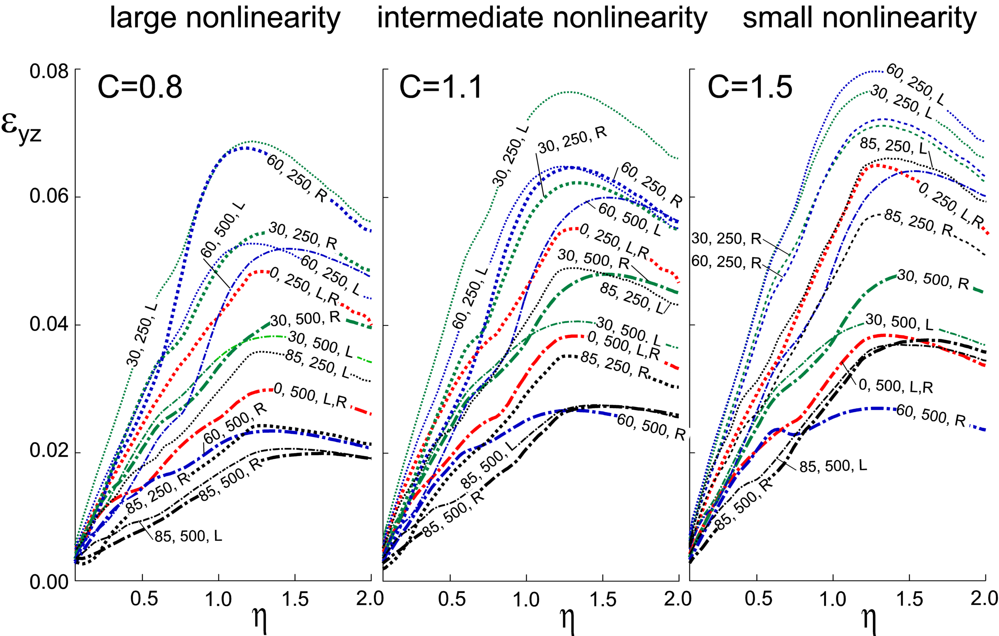

Fig. 8. Vertical (shear) strains at the left- and right-bottom ends of the building vs. for three levels of nonlinearity (C=0.8, 1.1, and 1.5; see Appendix B) in the soil and four incident angles = 0°, 30°, 60°, and 85°. Shear wave velocity in the soil is = 250 m/s. Relative rigidity in the foundation is modeled via its shear wave velocity of= 250 and 500 m/s. The curves are labeled—for example, (85, 500, L)—for = 85°, = 500 m/s, and at the left-bottom corner of the building.

We selected the range of dimensionless frequencies to illustrate the transition from an essentially 1-D response, when and when the foundation is rigid, to a 2-D response as increases. However, the extent to which short waves contribute to the overall response will be determined by their presence and by their relative amplitudes in the strong ground motion during earthquakes. Excitation of buildings by short waves will be strong for flexible foundations on very soft soils, when the motion of soil over the area covered by the foundation departs significantly from the rigid body translation and rotation of a flat surface with dimensions of the foundation. Synthetic modeling of strong ground motion for such surfaces on top of the layered half-space shows that the translations combined with torsion and rocking describes the incident motion of typical large foundations quite well for typical site conditions (Ding et al. 2015). For excitation by waves that carry significant energy in the domain of (excitation in soft soils and sediments), the response analyses will have to be formulated in terms of the wave-propagation approach.

ACKNOWLEDGEMENT
The work presented in this paper was supported in part by the Canadian Nuclear Safety Commission (CNSC). This support is gratefully acknowledged.

APPENDIX A – The Model and Finite Difference Formulation

The incoming wave is taken to be a half-sine pulse (Fig. 5) of a plane SH wave, which is intended to model strong motion pulses observed in the ground motion near faults (Housner and Trifunac 1967). A dimensionless frequency, , will be used as a measure of the pulse duration (wavelength), where a is half the width of the foundation, is the wavelength of the incident wave, $β_{s}$ is the shear wave velocity in the soil, and $t_{d0}$ is the duration of the pulse.

For completeness of this presentation, we summarize briefly the finite difference model and its characteristics, following Gičev and Trifunac (2012b). To set up the grid spacing in the finite difference representation of the model, the pulse is analysed in space domain (s), and the displacement in the points occupied by the pulse is

, (A1)

where A is the amplitude of the pulse and s is the distance of the considered point to the wave front in initial time, and in the direction of propagation. Using the fast Fourier transform, the half-sine pulse (Eq. A1) is transformed into wave number domain () as follows:

. (A2)

The maximum response occurs for = 0 (rigid-body motion). As increases, the response decreases and diminishes toward zero as k approaches infinity. We selected the largest wave number to be considered in this analysis, $k=k_{\text{max}}$, for which the k-response is at least 0.03 of the maximum response (Gičev 2008). Then, for this value of, the corresponding frequencies and the corresponding wavelengths are

and , (A3)

where is the shear wave velocity in the soil.

Accuracy of the finite difference (FD) grid depends on the ratio of the numerical and physical velocities of propagation, which ideally should be 1. The parameters that influence this accuracy are: (1) the density of the grid $m=λ/{Δx}$ (m is the number of points per wavelength , and is the spacing between the grid points); (2) the Courant number, ( is time step); and (3) the angle of the wave incidence, $θ$. It has been shown by Alford et al. (1974), Dablain (1986), and Fah (1992) that the error increases when m decreases, $χ$ decreases, and $θ$ is close to 0 or $π/2$. For second-order approximation, the above authors recommend m = 12.

To model the soil response numerically, we chose a rectangular soil box with dimensions $L_{m}=\text{10}⋅a$ and (Fig. 1). For practical reasons, the maximum number of space intervals in the grid in the horizontal (x) direction is set at 250 and in the vertical (y) direction at 400 (125 in the soil box and 275 in the building). The minimum spatial interval for this setup is. For a finer grid, the computational time increases rapidly. With this limitation in mind, and for $η=2$, the largest response is about 3% of the maximum response and has frequency $ω_{\text{max}}=\text{980} {\text{rad}}/s$ (Gičev 2008). From Eq. A3, the shortest wavelength is $λ_{\text{min}}=1\text{.}\text{603} m$, and the finest grid density is . This corresponds to about for this wavelength. Our numerical scheme is $O\left({Δt}^{2},{Δx}^{2}\right)$, so we need at least m = 12 points/$λ_{\text{min}}$ to resolve the shortest wavelength, $λ_{\text{min}}$. For $η=2$, our grid cannot resolve the shortest wavelength when we only have four spatial grid points, which implies that the pulse should be low-pass filtered. A cut-off frequency $ω_{c}=\text{200} {\text{rad}}/s$ was chosen, and the pulse was low-pass filtered. This implies that $λ_{\text{min}}=7\text{.}\text{854} m$ and the grid density is

. (A4)

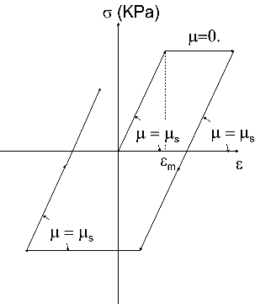

Fig. A1. The constitutive law, , for the soil and foundation.

It can be shown that for $η=0\text{.}5$, only a negligible amount of the total power is filtered out, while for $η=2$, a considerable amount is filtered out. Also, it can be shown that for $η=2$, the amplitude of the filtered pulse is smaller than the amplitude of the non-filtered pulse, which we chose to be A = 0.05 m, while for $η=0\text{.}5$, the amplitude is almost equal to the amplitude of the non-filtered pulse (Gičev 2008). Numerical tests have shown that the viscous-absorbing boundary rotated toward the middle of the foundation-building interface reflects only a negligible amount of energy back into the model (Gičev 2005).

For 2-D problems, the numerical scheme is stable if the time increment (Mitchell 1969) is

, (A5)

where the set () is different for different media constituting the model.

We assume that the shear stress in the x direction depends only upon the shear strain in the same direction and is independent of the shear strain in the y direction. The motivation for this assumption comes from our simplified representation of layered soil, which is created by deposition (floods and wind) into more or less horizontal layers. The foundation and the soil are assumed to be ideally elasto-plastic, and the constitutive $σ−ε$ relationship is shown in Fig. A1. Further, it is assumed that the contact points between the soil and foundation remain bonded during the analysis and that the contact cells remain linear, as does the zone next to the artificial boundary (the bottom four rows and the left-most and right-most four columns of points in the Fig. 1 soil box).

For our problem, the system of three partial differential equations in x, y, and z directions (for $u$,$v$, and $w$) describing the dynamic equilibrium of an elastic body is reduced to one equation only (because $u=$$v$). Neglecting the body forces in the z direction (F_{z} = 0), this equation is:

$ρ\frac{∂^{2}w}{∂t^{2}}=\left(\frac{∂τ_{\text{xz}}}{∂x}+\frac{∂τ_{\text{yz}}}{∂y}\right)$, (A6)
where is material density at the considered point, is out-of-plane displacement, and and are shear stresses in the z direction in planes normal with the x and y axes.
Introducing the new variables $v=\frac{∂w}{∂t}$, $ε_{\text{xz}}=\frac{∂w}{∂x}$, and $ε_{\text{yz}}=\frac{∂w}{∂y}$, where is particle velocity in the z direction, while and are shear strains in the z direction in planes normal with the x and y axes, and dividing (A6) with $ρ$, the order of (A6) is reduced to the system of three first-order partial differential equations:

$\underline{U},_{t}=\underline{F},_{x}+\underline{G},_{y}$, (A7)

where
$\underline{U}=\left\{\begin{matrix}v \\ ε_{\text{xz}} \\ ε_{\text{yz}}\end{matrix}\right\}$ $\underline{F}=\underline{F}(\underline{U})=\left\{\begin{matrix}\frac{1}{ρ}τ_{\text{xz}} \\ v \\ 0\end{matrix}\right\}$ $\underline{G}=\underline{G}(\underline{U})=\left\{\begin{matrix}\frac{1}{ρ}τ_{\text{yz}} \\ 0 \\ v\end{matrix}\right\}$. (A8)

The first equation in (A7) is the dynamic equilibrium of forces in the z direction with neglected body force F_{z}. The second and third equations give the relations between the strains and the velocity. The abbreviations $ε_{x}=ε_{\text{xz}}$, $σ_{x}=τ_{\text{xz}}$, $ε_{y}=ε_{\text{yz}}$, and $σ_{y}=τ_{\text{yz}}$ will be used in the calculations. The Lax-Wendroff computational scheme (Lax and Wendroff 1964) is used for solving Eq. (A7) (Gičev 2005).

APPENDIX B - Energy and Strains

In the examples shown in this paper, we are guided by the properties of the Holiday Inn hotel in Van Nuys, California (Blume and Assoc. 1973) to describe realistic properties of a building, and its response in east-west (longitudinal) direction only. This building was studied extensively using different models and representations (Gičev and Trifunac 2007; Ivanović et al. 2000), and the body of those results can be used to complement future comparisons and interpretations of its response.

A question arises as to how to choose the yielding strain $ε_{m}$ (Fig. A1) to study strain distribution in the system. The displacement, the velocity, and the linear strain in the soil ($β_{s}$= 250 m/s) during the passage of a plane wave in the form of a half-sine pulse are:

(B1)

, (B2)
, (B3)

where is displacement in the z direction, is particle velocity in the z direction, A is amplitude, is duration of the half-sine pulse, and is the maximum value (amplitude) of the particle velocity of the input pulse.

If, for a given input plane wave, we choose the yielding strain $ε_{m}$ given by (B3) multiplied by some constant between 1 and 2, the strains in both directions will remain linear before the wave reaches the free surface or the foundation for any incident angle. This case can be called “intermediate nonlinearity.” If we want to analyse only the nonlinearity due to scattering and radiating from the foundation, we should avoid the occurrence of the nonlinear strains caused by reflection from the half-space boundary. Then we may choose , where is the angle of incidence. We call this case “small nonlinearity.”

If the soil is allowed to undergo permanent strains due to wave passage of incident waves in the full space, then we may choose the yielding strain $ε_{m}<\text{max}\left(\frac{πA\text{sin}γ}{β_{s}t_{d0}};\frac{πA\text{cos}γ}{β_{s}t_{d0}}\right)$. This condition guarantees that in either the x or y direction, the soil will undergo permanent strains during the passage of the plane wave.

Generally, the yielding strain can be written as

, (B4)

where C is a constant that controls the yielding stress (strain) in the soil. We then consider the following cases of nonlinearity, depending upon C (see Gičev and Trifunac 2012b):

- $C≥2$: Small nonlinearity. Permanent strain does not occur until the wave hits the foundation.
- $1≤C<2$: Intermediate nonlinearity. Permanent strain does not occur until the wave is reflected from the free surface or is scattered from the foundation. Permanent strain will or will not occur after the reflection of the incident wave from the free surface, depending upon the angle of incidence.
- $C<1$: Large nonlinearity. Permanent strain occurs after reflection from the free surface. Permanent strain may or may not occur before the wave reflects from the foundation surface.

To study the model with nonlinear foundation, it is necessary to select its level of yielding. Usually the foundation is stiffer than the surrounding soil, so its yielding strain can be chosen smaller than the yielding strain of soil.

To allow for the model with a nonlinear foundation to yield, we choose the yielding strain of the foundation, , in a way that preserves continuity of stresses on soil-foundation interfaces. At the state of yielding, the continuity of stresses is and from which we compute the yielding strain in the foundation as .

Energy Distribution in the System

The energy flow through a given area can be defined, in terms of a plane-wave approximation (Aki and Richards, 1980), as

, (B5)

where and are the density and shear wave velocity in the soil and is a particle velocity which, for the excitation considered in this paper, is given by Eq. (B2). $A_{\text{sn}}$ is the area (normal to the direction of the ray) through which the wave is passing. For our geometrical setting (Fig. 2), the area normal to the wave passage is:

. (B6)

where and are the height and the width of the soil island in our model (Fig. 2).
Inserting and integrating Eqs. (B2) and (B6) into (B5), the analytical solution for the input wave energy into the model is

. (B7)

As can be seen from Eq. (B7), for the defined size of soil island and defined angle of incidence $γ$, the input energy is reciprocal with the duration of the pulse, which means it is a linear function of dimensionless frequency $η$. As short pulses in our example calculations are low-pass filtered up to $ω_{c}=\text{200} {\text{rad}}/s$, the analytical and the numerical solutions (B5) for input wave energy will not coincide.

Since our system is conservative, the input energy is balanced by:

- Cumulative energy going out from the model, $E_{\text{out}}$, computed using Eq. (B5).

- Cumulative hysteretic energy (energy spent for creation and development of permanent strains in the soil), computed from:

$E_{\text{hys}}=\sum_{t=0}^{T_{\text{end}}}{Δt⋅\sum_{i=1}^{N}{\left(σ_{\text{xi}}({Δε}_{\text{xpi}}+0\text{.}5⋅{Δε}_{\text{xei}})+σ_{\text{yi}}({Δε}_{\text{ypi}}+0\text{.}5⋅{Δε}_{\text{yei}})\right)}}$, (B8)
where is the time at the end of the analysis; N is the total number of points; $σ_{\text{xi}},σ_{\text{yi}}$ are the stresses at the point i in the x and y directions, respectively; ${Δε}_{\text{xpi}}=ε_{\text{xpi}}^{t+Δt}−ε_{\text{xpi}}^{t}$ is the increment of the permanent strain in the x direction at point i; is the increment of the elastic strain in the x direction at point i; ${Δε}_{\text{ypi}}=ε_{\text{ypi}}^{t+Δt}−ε_{\text{ypi}}^{t}$ is the increment of the permanent strain in the y direction at point i; and is the increment of the elastic strain in the y direction at point i.
- Instantaneous energy in the building, consisting of kinetic and potential energies, which can be computed from:

, (B9)

where and are horizontal- and vertical-grid spacing in the building, and are density and shear modulus in the building, and is particle velocity, while and are shear strains in point in the building. This balance was discussed in Gičev (2008) for a semi-cylindrical foundation, a pulse with $η=1\text{.}5$, for incident angle $γ={\text{30}}^{0}$, and a yielding strain defined by C = 1.5 (Eq. B4), and it will be assumed to hold here as well for the rectangular foundation.

To study just the effect of scattering by the foundation, Gičev and Trifunac (2012a, b) assumed the building to be high enough so that the reflected wave from the top of the building cannot reach the building-foundation contact during the time of analysis. The analysis was terminated when the wave completely exited the soil island. In this paper, the hysteretic energy in the soil and the energy in the building are the subjects of interest. Gičev (2008) studied these two types of energy as functions of the dimensionless frequency for a semi-circular foundation, and showed that as the foundation becomes stiffer, a larger part of the input energy is scattered and less energy enters the building.

APPENDIX C – Torsional and Wave Energies Vs.Translational Energies

To study what part of the energy entering the building is associated with translational motion of the foundation-building interface and what part is caused by torsional, and subsequently wave motion of this interface, we proceed as follows:

- Using FD, we compute velocities, displacements, and strains in time step k+1 using the results in time step k.

- We then compute cumulative displacements and at the interface points in time steps k and k+1 respectively, as
and , (C1)
where is the column of spatial points at the left and at the right ends of the building. Then average displacements at time steps k and k+1 (t and t+ are:
and , (C2)
and the increment of the average displacement in time step k (or more precisely, k+1/2) is:
. (C3)
- The forces on the interface cells or the average force on the whole interface are:
, (C4)
(the upper limit above is instead of )
where and (C5)
are shear stresses on vertical and horizontal walls of the cell in time respectively.
Above: is the initial shear modulus in the building; are shear strains at time step k in direction z in planes normal to the x and y axes; are shear strains at time step k + 1 in direction z in planes normal to the x and y axes.
- We can then compute the increment of the translational energy in time as:
. (C6)
The total translational energy at the building-foundation interface is due to the work of average stresses at the interface on the increment of the average interface displacement,
. (C7)
- The energy flow through the interface due to wave propagation is:
, (C8)
where assuming that the wave field propagates upward only,
(C9)
is the estimated incident angle at interface point , and
(C10)
is the particle velocity in point in time step k + 1/2.
- The proportion (ratio) of the translational energy (i.e., for a rigid foundation) in the total energy entering the building is:
, (C11)
while the participation of the torsional (wave) energy is
. (C12)

REFERENCES

Aki, K., and Richards, P. (1980). Quantitative seismology, theory and methods. W.H. Freeman & Co., San Francisco.

Alford, R.M., Kelly, K.R., and Boore, D.M. (1974). Accuracy of finite-difference modeling of the acoustic wave equation. Geophysics, 39, 834–842.

Biot, M.A. (1932). Vibrations of buildings during earthquake, Chapter II in Ph.D. Thesis No. 259, entitled Transient Oscillations in Elastic Systems, Aeronautics Department, Calif. Inst. of Tech., Pasadena, CA.

Biot, M.A. (1933). Theory of elastic systems vibrating under transient impulse with an application to earthquake-proof buildings, Proc. National Academy of Sciences, Vol. 19, No. 2, 262–268.

Biot, M.A. (1934). Theory of vibration of buildings during earthquakes, Zeitschrift für. Angewandte Matematik und Mechanik, Vol. 14, No. 4, 213–223.

Biot, M.A. (1941). A mechanical analyzer for the prediction of earthquake stresses, B Seismol Soc Am 31, 151–171.

Biot, M.A. (1942). Analytical and experimental methods in engineering seismology, ASCE Transactions, Vol. 108, 365–408.

Blume and Assoc. (1973). Holiday Inn, in San Fernando, California, earthquake of February 9, 1971. (L.M. Murphy, Ed.). U.S. Dept. of Commerce, National Oceanic and Atmospheric Administration, Washington, D.C.

Dablain, M.A. (1986). The application of high-order differencing to the scalar wave equation. Geophysics, 51(1), 54–66.

Ding, H., M.D. Trifunac, M.I. Todorovska and N. Orbović (2015). Coherence of dispersed strong earthquake ground motion at small separation distances, Soil Dyns Earthq Eng 70, 1–10.

Elgamal, A., Linjun, Y., Zaohui, Y., and Conte, J.P. (2008). Three-dimensional seismic response of Humboldt Bay Bridge-foundation-ground system, J Struct Eng-ASCE (7), 1165–1176.

Fah, D.J. (1992). A hybrid technique for the estimation of strong ground motion in sedimentary basins. Dissertation, Swiss Federal Institute of Technology, Zurich, Switzerland.

Gičev, V. (2005). Investigation of soil-flexible foundation-structure interaction for incident plane SH waves. Ph.D. Dissertation, Dept. of Civil Engineering, Univ. Southern California, Los Angeles, CA.

Gičev, V. (2008). Soil-structure interaction in nonlinear soil, Izgradnja 62(12), 555–566.

Gičev, V., and Trifunac, M.D. (2007)¹. Energy and power of nonlinear waves in a seven story reinforced concrete building, Indian Society of Earthquake Technology Journal 44(1), 305–323.

Gičev, V., and Trifunac, M.D. (2012a). Asymmetry of nonlinear soil strains during soil-structure interaction excited by SH pulse, Izgradnja 66(5-6) 252-268.

Gičev, V., and Trifunac, M.D. (2012b). Energy dissipation by nonlinear soil strains during soil-structure interaction excited by SH pulse, Soil Dyns Earthq Eng 43, 261-270.

Gičev, V., Trifunac, M.D. and Todorovska, M.I. (2012). Reduction of Seismic Wave Energy of SH ulse by Nonlinear Soil, Proc. 15WCEE, Lisbon, Portugal , Paper # 3315.

Gupta, I.D. and Trifunac, M.D. (1987). A note on contribution of torsional excitation to earthquake response of simple symmetric buildings, Earthq Eng Eng Vib 7(3), 27-46.

Gupta, I.D. and Trifunac M.D. (1988a). Order statistics of peaks in earthquake response, J Eng Mech-ASCE 114(10), 1605–1627.

Gupta, I.D. and Trifunac M.D. (1988b)¹. A note on computing the contribution of rocking excitation to earthquake response of simple buildings, Bull Indian Soc Earthq Tech 25(2), 73–89.

Gupta, V.K. and Trifunac M.D. (1989)* Investigation of Building Response to Translational and Rotational Earthquake Excitations, Report 89-02, Dept. Civil Eng., Univ. Southern California, Los Angeles, CA.

Gupta, I.D. and Trifunac, M.D. (1990a). Probabilistic spectrum superposition for response analysis including the effects of soil-structure interaction, J Probabilistic Eng Mech 5, 9–18.

Gupta, V.K. and Trifunac M.D. (1990b). Response of multistoried buildings to ground translation and rocking during earthquakes, J Probabilistic Eng Mech 5, 138–145.

Gupta, V.K. and Trifunac M.D. (1990c). Response of multistoried buildings to ground translation and torsion during earthquakes, European Earthq Eng, IV(1), 34-42.

Gupta, V.K. and Trifunac M.D. (1991). Effects of ground rocking on dynamic response of multistoried buildings during Eearthquakes, Struct Eng/Earthq Eng-JSCE 8(2), 43–50.

Gupta, I.D. and Trifunac, M.D. (1999). Statistics of ordered peaks in the response of non-classically damped structures, Probabilistic Eng. Mechanics 14(4), 329–337.

Hayir, A., Todorovska, M.I., & Trifunac, M.D. (2001). Antiplane response of a dike with flexible soil-structure interface to incident SH waves. Soil Dyns Earthq Eng 21, 603–613.

Housner, G.W., and Trifunac, M.D. (1967). Analysis of accelerograms - Parkfield earthquake, B Seismol Soc Am 57(6), 1193–1220.

Ivanović, S.S., Trifunac, M.D., Novikova, E.I., Gladkov, A.A., and Todorovska, M.I. (2000). Ambient vibration tests of a seven-story reinforced concrete building in Van Nuys, California, damaged by the 1994 Northridge Earthquake, Soil Dyns Earthq Eng 19(6), 391–411.

Jalali, R.S. and Trifunac, M.D. (2007)¹. Strength-reduction factors for structures subjected to differential near-source ground motion, Indian Society of Earthquake Technology Journal, 44(1), 285–304.

Jalali, R.S. and Trifunac, M.D. (2008). A Note on strength reduction factors for design of structures near earthquake faults, Soil Dyns Earthq Eng 28(3), 212–222.

Jalali, R.S. and Trifunac, M.D. (2009). Response spectra for near-source, differential and rotational strong motion, B Seismol Soc Am 99(2B), 1404-1415. See also Erratum: B Seismol Soc Am 99(5), 3094-3095.

Jalali, R.S. and Trifunac, M.D. (2011). A note on the wave-passage effects in out-of-plane response of long structures to strong earthquake pulses, Soil Dyns Earthq Eng 31(4), 640-647.

Jalali, R.S., Trifunac, M.D., Ghodrati, G.A. and Zahedi, M. (2007). Wave-passage effects on Strength-reduction factors for design of structures near earthquake faults, Soil Dyns Earthq Eng, 27(8), 703-711.

Jalali, R.S., Azgoni M.N. and Trifunac, M.D. (2013). In-plane response of two-story structures to near-fault ground motion, Soil Dyns Earthq Eng, 55, 263-274.

Lax, P.D., and Wendroff, B. (1964). Difference schemes for hyperbolic equations with high order of accuracy. Comm Pur Appl Math XVII, 381–398.

Lee, V.W. and Trifunac, M.D. (2010). Should average shear wave velocity in the top 30 m of soil be the only local site parameter used to describe seismic amplification?, Soil Dyns Earthq Eng, 30(11), 1250-1258.

Lee, V.W., Trifunac, M.D. and Feng, C.C. (1982). Effects of Foundation Size on Fourier Spectrum Amplitudes of Earthquake Accelerations Recorded in Building, Soil Dynamics and Earthquake Engineering, 1(2), 52-58.
Lee, V.W., Liu, W.Y., Trifunac, M.D. and Orbović, N. (2014a). Scattering and Diffraction of Earthquake Motions in Irregular Elastic Layers, I: Love and SH Waves, Soil Dyns Earthq Eng, 66, 125-134.

Lee, V.W., Liu, W.Y., Trifunac, M.D. and Orbović, N. (2014b). Scattering and Diffraction of Earthquake Motions in Irregular, Elastic Layers, II: Rayleigh and Body P and SV Waves, Soil Dyns Earthq Eng, 66, 220-23.

Luco, J.E., Trifunac, M.D., and Wong, H.L (1987). On the apparent changes in dynamic behavior of a nine-story reinforced concrete building, B Seismol Soc Am, 77(6), 1961–1983.

Mitchell, A.R. (1969). Computational methods in partial differential equations. New York: John Willey & Sons.

Negmatullaev, S. K, M.I. Todorovska and M.D. Trifunac (1999). Simulation of strong earthquake ground motion by explosions - experiments at the Lyaur testing range in Tajikistan, Soil Dyns Earthq Eng 18(3), 189-207.

Prevost, J.H. (1993). Nonlinear Dynamic Response Analysis of Soil and Soil-Structure Interaction systems, Seminar on Soil Dynamics and Geotechnical Earthquake Engineering, Editors: Seco, E. and Pinto, P., Soil Dyns Earthq Eng, Balkema, Rotterdam, 49-126.

Todorovska, M.I, and Trifunac, M.D. (1989). Antiplane earthquake waves in long structures, J. Eng Mech-ASCE. 115(12), 2687-2708.

Todorovska, M.I. and Trifunac, M.D. (1990). A note on excitation of long structures by ground waves. J Eng Mech-ASCE, 116(4), 952-964.

Todorovska, M.I., and Trifunac, M.D. (1993)*. The effects of wave passage on the response of base-isolated buildings on rigid embedded foundations, Dept. of Civil Eng. Report CE 93-10, Univ. of Southern California, Los Angeles, California, 1993.

Todorovska, M.I., Hayir, A., & Trifunac, M.D. (2001). Antiplane response of a dike on flexible embedded foundation to incident SH-waves. Soil Dyns Earthq Eng, 21, 593–601.

Trifunac, M.D. (2006). Effects of Torsional and Rocking Excitations on the Response of Structures, Ch. 39 in Earthquake Source Asymmetry, Structural Media and Rotation Effects, Edited by R. Teisseyre, M. Takeo, and E. Majewski, Springer, Heidelberg, Germany, 569–582.

Trifunac, M.D. (2008a). Buildings as Sources of Rotational Waves, Chapter I.3 in Physics of Asymmetric Continua: Extreme and Fracture Processes, edited by R. Teisseyre, H. Nagahama, and E. Majewski, Springer, Heidelberg, Germany, 49–66.

Trifunac, M.D. (2008b). The Nature of Site Response During Earthquakes, Proc. NATO ARW Workshop in Borovec, 30 August–3 September, 2008, Bulgaria, published in Coupled Site and Soil-Structure Interaction effects with Applications to Seismic Risk Mitigation (T. Schantz and R.Iankov editors), NATO Science for Piece and Security Series C: Environmental Security, 3-31, Springer Science + Business Media, B. V. 2009.

Trifunac, M.D. (2009a). Rotations in structural response, B Seismol Soc Am, 99(2B), 968–979.
Trifunac, M.D. (2009b). The role of strong motion rotations in the response of structures near earthquake faults,Soil Dyns Earthq Eng., 29(2), 382–393.

Trifunac, M.D. and Gičev, V. (2006). Response spectra for differential motion of columns, Paper II: Out-of-plane response, Soil Dyns Earthq Eng, 26(12), 1149–1160.

Trifunac, M.D., & Todorovska, M.I. (1997). Response spectra and differential motion of columns, Earthq Eng and Struct D, 26(2), 251–268.

Trifunac, M.D., Hao, T.Y., and Todorovska, M.I. (2001a)*. On energy flow in earthquake response, Dept. of Civil Engrg., Report CE 01-03, Univ. of Southern California, 2001.

Trifunac, M.D., Ivanović, S.S., and Todorovska, M.I. (2001b). Apparent periods of a building I: Fourier analysis, J of Struct Eng-ASCE 127(5), 517–526.

Trifunac, M.D., Ivanović, S.S., and Todorovska, M.I. (2001c). Apparent periods of a building II: time-frequency analysis, J Struct Eng-ASCE ASCE, 127(5), 527–537.

Trifunac, M.D., Todorovska, M.I., and Hao, T.Y. (2001d). Full-scale experimental studies of soil-structure interaction—A review, Proc. 2nd U.S.-Japan Workshop on Soil-Structure Interaction, March 6–8, 2001, Tsukuba City, Japan, (CD available from Building Research Institute of Japan, Tsukuba City, Japan), pp. 52.

Trifunac, M.D., Ivanović, S.S., Todorovska, M.I., Novikova, E.I., and Gladkov, A.A. (1999). Experimental evidence for flexibility of a building foundation supported by concrete friction piles, Soil Dyns Earthq Eng, 18(3), 169–187.

Udwadia, F.E., and Trifunac, M.D. (1974). Characterization of response spectra through statistics of oscillator response, B Seismol Soc Am 64(1), 205–219.

Wong, H.L., and Trifunac, M.D. (1974). Interaction of a shear wall with the soil for incident plane sh-waves: elliptical rigid foundation, B Seismol Soc Am 64(6), 1825–1842.

Wong, H.L. and Trifunac, M.D. (1975). Two-dimensional, antiplane, building – soil - building interaction for two or more buildings and incident plane SH-waves, B Seismol Soc Am, 65(6), 1863–1885.

Zhang, Y., Conte, J.P., Yang, Z., Elgamal, A., Bielak, J., and Acero, G. (2008). Two-dimensional nonlinear earthquake response analysis of bridge-foundation-ground system, Earthq Spectra 24(2), 343–386.

* Can be downloaded from: http://www.usc.edu/dept/civil_eng/Earthquake_eng/
¹ Can be downloaded from http://home.iitk.ac.in/~vinaykg/iset.html

