THE PRINCIPLES AND EXAMPLES OF LEACHING AND BIO-LEACHING USING SIMPLEX EVOP

Aleksandar KRSTEV¹, Boris KRSTEV²

¹Goce Delcev University, Faculty of Computer Sciences, 2000 Stip, The Republic of Macedonia, aleksandar.krstev@ugd.edu.mk
²Goce Delcev University, Faculty of Natural &Technical Sciences, 2000 Stip, The Republic of Macedonia, boris.krstev@ugd.edu.mk

ABSTRACT
The refractory or low grade lead/zinc domestic ores in Republic of Macedonia are investigated by conventional separation technology or flotation separation. In the mean time, investigations are directed to the new possibilities of leaching by microorganisms – bioleaching. The paper is result of these technologies and investigations carried out for recovery of in the mentioned ores. Using Simplex EVOP and computer program Multisimplex performances are appropriate and most acceptable and excellent way for presentation of the leaching and bioleaching.

KEYWORDS
Bioleaching, Evolutive Operativity, Leaching, Simplex, Software.

1.General principles
Simplex EVOP was proposed as an alternative to the original Box EVOP. The Simplex requires much less experimentation and reaches the optimum of a process much more quickly. Instead of factorial experimentation, Simplex EVOP uses a succession of experimental designs in the form of a regular Simplex.
The regular Simplex is the first-order design which requires the smallest number of experimental points; for n factors (n-dimensional), (n+1) experimental points are required. Thus for two factors the regular Simplex design is an equilateral triangle requiring three points; for three factors the design is a regular tetrahedron requiring four points. As in other forms of EVOP, more than three factors can be handled but the designs cannot be shown diagrammatically. Fixing the number of measured intervals of each factor to the unit length of the Simplex side is important for all moves from the initial cycles. The regular Simplex design permits estimation of the first order effects in any number of factors. The direction of steepest ascent leading out of the Simplex is through the side or face (or hyper-plane) opposite the lowest value of response. The deletion of one old point and the introduction of one new point in this most favorable direction of movement leads to the formation of a new Simplex.

2.1 Advantages of Simplex EVOP
The advantages of Simplex EVOP are:
1. in many processes the optimum tends to move with time. Responses may indicate a moving optimum even though the true optimum does not change. It is unrealistic, and may be useless, to make process changes on the basis of out-of-date and irrelevant information; only the most recent observations should be used.
2. Simplex provides a rigorous definition of the frequency and extent of the changes to be made. Each move is from one Simplex to the adjacent Simplex. The least acceptable set of operating condition and is replaced by its mirror image in the plane (hyper-plane) of the remaining points. 3. When the real effects are small compared with the observational errors they may be obscured and a false move may be made. As long as the change made is small compared with the changes in the basic design, no great harm will result. In any case, since any decision taken is reviewed and corrected continuously, the greater any adverse effect may be then the more rapidly will it be detected and eliminated.
4. The use of such a precise pattern of experimentation eliminates the need for statistical analysis of the data. The arithmetic involved is trivial and at no stage is it necessary to calculate the direction of steepest ascent. Although this procedure is ideal for control by means of a digital computer, plant supervisors optimizing a process with Simplex EVOP are under no disadvantage without a digital computer, an appropriate worksheet can be made.
5. The direction of advance depends only on the ranking of the responses and not on their scalar values. Thus Simplex EVOP may be used when a response can be arranged in order of preference for a combination of responses, and the least preferable combination dropped every time.
  - Disadvantages of Simplex EVOP
The disadvantages of Simplex EVOP are:
1. All factors must be quantitative,
2. In order to minimize wrongful elimination of points due to imprecise measurement of response, either the measurement techniques must be precise, or the Simplex points chosen must be far enough apart to outweigh the imprecision of measurement.
3.Future techniques development and recoveries of metal bearing ores
Future sustainable development requires measures to reduce the dependence on nonrenewable raw materials and the demand for primary resources. New resources for metals must be developed with the aid of novel technologies, in addition, improvement of already existing mining techniques can result in metal recovery from sources that have not been of economic interest until today. Metal-winning processes based on the activity of microorganisms offer a possibility to obtain metals from mineral resources not accessible by conventional mining. Microbes such as bacteria and fungi convert metal compounds into their water-soluble forms and are biocatalysts of these leaching processes. Generally speaking, bioleaching is a process described as being “the dissolution of metals from their mineral sources by certain naturally occurring microorganisms” or “the use of microorganisms to transform elements so that the elements can be extracted from a material when water is filtered through it”. Another major problem is environmental costs due to the high level of pollution from these techniques. Environmental standards continue to stiffen, particularly regarding toxic wastes, so costs for ensuring environmental protection will continue to rise.
Biotechnology is regarded as one of the most promising and certainly the most solution to these problems, compared to pyro metallurgy or chemical metallurgy. It holds the promise of dramatically reducing the capital costs. It also offers the opportunity to reduce environmental pollution. Biological processes are carried out under mild conditions, usually without addition of toxic chemicals. The products of biological processes end up in aqueous solution which is more amenable to containment and treatment then gaseous waste. Bacterial leaching is a revolutionary technique used to extract various metals from their ores. Bacterial leaching is possible with low concentrations and requires little energy inputs. The process is environment friendly even while giving extraction yields of over 85-90%. For the metallurgical calculation nickel in the oxide-silicate minerals may be shown by means of the general formula:

NiSiO₃. m MgSiO₃ . n H₂O
(Si₂O₅)²⁻ (SiO₄)²⁻ → (SiO₃)²⁻
NiO.2SiO₂ → 2NiO.SiO₂ → NiO.SiO₂
Olivine → Piroxen

The amorphous crystal structure is transformed to the stable crystal structure. The iron in the Ni- bearing minerals and ores is appeared as Fe₂O₃.nH₂O and as a nontronite (Fe/Al)₂(Si₄O₁₀)(OH₂).nH₂O. The oxide-laterite ores are with low Ni-content. The generally, nickel and iron are as Ni-Fe- limonite (Fe, Ni)O(OH).nH₂O, garnierite or in the talc form (Mg, Ni, Fe)₃Si₄O₁₀(OH)₂.nH₂O.
Laterite ore is one of the mineral resources containing several kinds of metal elements, such as nickel, cobalt, iron, silicon, aluminum and chromium. While the Ni-less laterite ore has never been used effectively, in spite of its huge deposit, it sometimes has high content of iron of about 50 mass%.

  - Experimental part

It’s fact that the hydrometallurgy processes are more applicable to the limonitic laterites or garnierite's. Although the saprolit laterites are often richer in nickel than the limonitic ores, the high Mg content results in higher acid consumption. The theory confirmed that primary hydrometallurgy processes are the Caron process, HPAL (high-pressure acid leaching) or atmospheric-pressure acid leaching process.
In the investigated HPAL, limonitic mixture ores are leached at high pressure (33-35 bars) and temperature (240-270ºC) in autoclave, with slurry densities of about 20%, and acid consumption or acid to ore ratio of 200-500 kg/t ores. The (temperature 250-270 ºC interaction effect of one factor on the response of another, generally A (temperature 250 ºC) by B (or acid to ore ratio of 200-500 kg/t ores) effect is the change in the effect of A as B goes from – to + values. The bio-hydrometallurgy, especially bioleaching, bacterial leaching or microbial technology is a promising novel technology for recovering the nickel from nickel bearing laterites (valuable minerals traditionally difficult-to-process ores) using chemolithotrophic microorganisms.

Table 1. Investigation by HPAL process Table 2. Investigation by bioleachiing process

SAMPLE | A | B | R_{Ni}% | SAMPLE | Adding % | Days | R_{Ni}%
1 | 250 | O.24 | 78,50 | 1 | 1.50 | 30 | 83.50
2 | 250 | 0.40 | 91,10 | 2 | 1.50 | 45 | 92.90
3 | 270 | 0.24 | 82,35 | 3 | 1.70 | 30 | 90.35
4 | 270 | 0.40 | 94,55 | 4 | 1.65 | 45 | 93.55
5 | 260 | 0.32 | 91.50 | 5 | 1.65 | 30 | 91.09
6 | 260 | 0.40 | 92.75 | 6 | 1.70 | 45 | 92.75
7 | 255 | 0.32 | 82.10 | 7 | 1.60 | 30 | 93.30
8 | 255 | 0.40 | 92.00 | 8 | 1.60 | 40 | 94.55
9 | 265 | 0.24 | 90.50 | 9 | 1.60 | 50 | 91.10
10 | 265 | 0.28 | 90.80 | 10 | 1.60 | 60 | 92.70
11 | 265 | 0.32 | 91.70 | 11 | 1.65 | 40 | 93.00
12 | 265 | 0.36 | 91.90 | 12 | 1.65 | 50 | 93.50
13 | 270 | 0.35 | 92.30 | 13 | 1.70 | 30 | 92.50
14 | 270 | 0.40 | 93.30 | 14 | 1.70 | 40 | 92.75
15 | 270 | 0.45 | 94.75 | 15 | 1.70 | 50 | 93.35
16 | 270 | 0.50 | 95.10 | 16 | 1.70 | 60 | 94.70

Table 3. Investigation by HPAL process Table 4. Investigation by bioleachiing process
SAMPLE | A | B | R_{Ni}% | SAMPLE | Adding % | Days | R_{Ni}%
1 | 250 | O.24 | 70,00 | 1 | 1.50 | 30 | 85.50
2 | 250 | 0.40 | 90,00 | 2 | 1.50 | 45 | 92.90
3 | 270 | 0.24 | 80,50 | 3 | 1.70 | 30 | 92.50
4 | 270 | 0.40 | 93,50 | 4 | 1.65 | 45 | 93.50
5 | 260 | 0.32 | 90.50 | 5 | 1.65 | 30 | 91.50
6 | 260 | 0.40 | 92.50 | 6 | 1.70 | 45 | 92.50
7 | 255 | 0.32 | 80.10 | 7 | 1.60 | 30 | 94.00
8 | 255 | 0.40 | 92.00 | 8 | 1.60 | 40 | 94.50
9 | 265 | 0.24 | 90.00 | 9 | 1.60 | 50 | 91.00
10 | 265 | 0.28 | 90.50 | 10 | 1.60 | 60 | 93.00
11 | 265 | 0.32 | 92.50 | 11 | 1.65 | 40 | 93.00
12 | 265 | 0.36 | 92.00 | 12 | 1.65 | 50 | 93.50
13 | 270 | 0.35 | 92.50 | 13 | 1.70 | 30 | 92.50
14 | 270 | 0.40 | 93.00 | 14 | 1.70 | 40 | 93.50
15 | 270 | 0.45 | 95.75 | 15 | 1.70 | 50 | 94.50
16 | 270 | 0.50 | 96.50 | 16 | 1.70 | 60 | 96.00

There have been many attempts to develop processes known as alternative processes which have included: Nitric Acid Leaching, Chlorine Leaching, Acid Pugging and Sulfation Roasting, especially Segregation Process with combination of Flotation, Magnetic Separation or Leaching etc. The experimenting between leaching and bacterial leaching have showed the following results: leaching with HPAL process and recoveries from R_{Ni}% (78-95%) and bacterial leaching with chemolithotrophic microorganisms recoveries from R_{Ni}% (70-96,5%). The experimenting between leaching and bacterial leaching for Indonesian ores have showed the following results: leaching with HPAL process and recoveries from R_{Ni}% (70-96,5%) and bacterial leaching with chemolithotrophic microorganisms recoveries from R_{Ni}% (85-96%). The ores as Ni-Fe limonite (Fe, Ni)O(OH).nH₂O contain 1.0-1.2% Ni and recoveries by HPAL or bioleaching are from 78%-95%%. The ores of garnierite or in the talc form (Mg, Ni, Fe)₃Si₄O₁₀(OH)₂.nH₂O contain 1,5-2,0% Ni and recoveries by HPAL or bioleaching are from 70%-96.5%%.

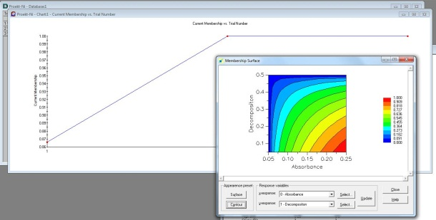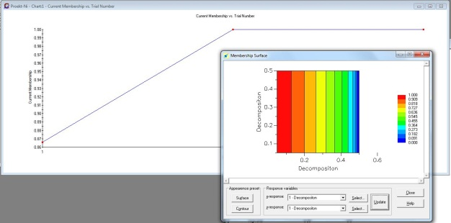
Figure 1. Graphic display leaching
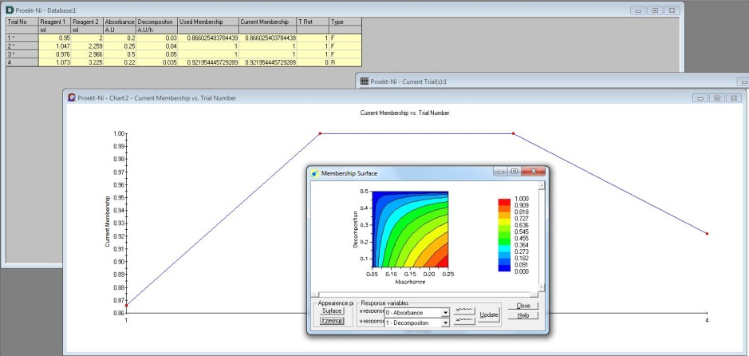
Figure 3. Graphic display
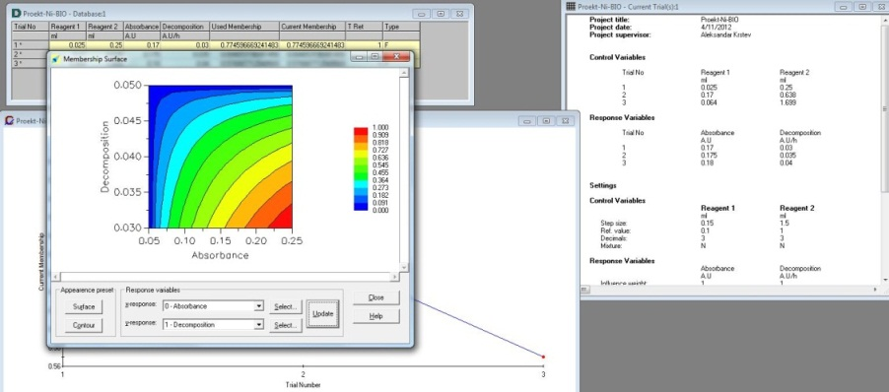
Figure 4. Graphic display bacterial leaching
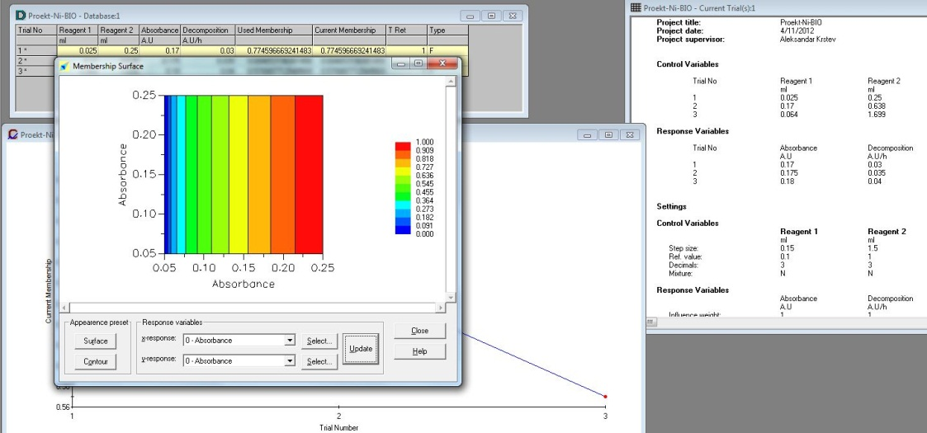
Figure 5. Graphic display bacterial leaching

Literature:
Journal:
[1] A.D. Dalvi, W.G. Bacon and R.C.Osborne, “The past and future of nickel laterites”, PDAC 2004 International Convention, March 7-10, 2004, pp 1-27
[2] D. Gerorgiou and V.G. Papangelakis, “Sulphuric acid pressure leaching of a limonitic laterite: chemistry and kinetics”, Hidrometallurgy, 49, 1998, pp 23-46
[3] D. Gerorgiou and V.G. Papangelakis, “Sulphuric acid pressure leaching of laterites – speciation and prediction of metal solubilities at temperature”, Hidrometallurgy, 58, 2000, pp 13-26
[4] S. Stopic, B. Friedrich and R. Fuchs, “Kineteics of sulphuric acid leaching of the Serbian nickel lateritic ore under atmospheric pressure”, 2001, MJoM, Erzmetall, pp 235-244
[5] S. Stopic, B. Friedrich, N. Anastasijevic and A. Onjia, “Experimental design approach regarding kinetics of high pressure atmospheric leaching”, 2002,MJoM, Erzmetall, pp 273-282
Patents:
[6] J.C. Arroyo and D.A. Neudorf, “Atmospheric leach process for the recovery of nickel and cobalt from limonite and saprolite ores”, US Patent 6, 680, 035, Jan 20, 2004
[7] W.P.C. Duyvesteyn, D.A. Neudorf and E.M. Weeniink, “Resin-in-pulp method for recovery of nickel and cobalt”, US Patent 6, 350, 420, Feb 26, 2002

